






Provide a lost and found facility
D1.HSS.CL4.09
Trainer Guide

Provide a lost and found facility

D1.HSS.CL4.09

Trainer Guide





Project Base
William Angliss Institute of TAFE
555 La Trobe Street
Melbourne 3000 Victoria
Telephone: | (03) 9606 2111
Facsimile: | (03) 9670 1330
Acknowledgements
Project Director: | Wayne Crosbie
Chief Writer: | Alan Hickman
Subject Writer: | Alan Hickman
Project Manager/Editor: | Alan Maguire
DTP/Production | Daniel Chee, Mai Vu, Kaly Quach

The Association of Southeast Asian Nations (ASEAN) was established on 8 August 1967. The Member States of the Association are Brunei Darussalam, Cambodia, Indonesia, Lao PDR, Malaysia, Myanmar, Philippines, Singapore, Thailand and Viet Nam.
The ASEAN Secretariat is based in Jakarta, Indonesia.
General Information on ASEAN appears online at the ASEAN Website: www.asean.org.
All text is produced by William Angliss Institute of TAFE for the ASEAN Project on “Toolbox Development for Priority Tourism Labour Division”.
This publication is supported by the Australian Government’s aid program through the ASEAN-Australia Development Cooperation Program Phase II (AADCP II).
Copyright: Association of Southeast Asian Nations (ASEAN) 2012.
All rights reserved.
Disclaimer
Every effort has been made to ensure that this publication is free from errors or omissions. However, you should conduct your own enquiries and seek professional advice before relying on any fact, statement or matter contained in this book. The ASEAN Secretariat and William Angliss Institute of TAFE are not responsible for any injury, loss or damage as a result of material included or omitted from this course. Information in this module is current at the time of publication. Time of publication is indicated in the date stamp at the bottom of each page.
Some images appearing in this resource have been purchased from stock photography suppliers Shutterstock and iStockphoto and other third party copyright owners and as such are non-transferable and non-exclusive. Clip arts, font images and illustrations used are from the Microsoft Office Clip Art and Media Library. Some images have been provided by and are the property of William Angliss Institute.
Additional images have been sourced from Flickr and SXC and are used under Creative Commons licence: http://creativecommons.org/licenses/by/2.0/deed.en

File name: TG_Provide_lost_&_found _refined.docx





Table of contents
Competency Based Training (CBT) and assessment an introduction for trainers 1
Competency Standard 11
Notes and PowerPoint slides 19
Recommended training equipment 145
Instructions for Trainers for using PowerPoint – Presenter View 147
Appendix – ASEAN acronyms 149

Competency Based Training (CBT) and assessment an introduction for trainers

Competency
Competency refers to the ability to perform particular tasks and duties to the standard of performance expected in the workplace.
Competency requires the application of specified knowledge, skills and attitudes relevant to effective participation, consistently over time and in the workplace environment.
The essential skills and knowledge are either identified separately or combined.
Knowledge identifies what a person needs to know to perform the work in an informed and effective manner.
Skills describe the application of knowledge to situations where understanding is converted into a workplace outcome.
Attitude describes the founding reasons behind the need for certain knowledge or why skills are performed in a specified manner.
Competency covers all aspects of workplace performance and involves:
- Performing individual tasks
- Managing a range of different tasks
- Responding to contingencies or breakdowns
- Dealing with the responsibilities of the workplace
- Working with others.

Unit of Competency
Like with any training qualification or program, a range of subject topics are identified that focus on the ability in a certain work area, responsibility or function.
Each manual focuses on a specific unit of competency that applies in the hospitality workplace.
In this manual a unit of competency is identified as a ‘unit’.
Each unit of competency identifies a discrete workplace requirement and includes:
- Knowledge and skills that underpin competency
- Language, literacy and numeracy
- Occupational safety and health requirements.
Each unit of competency must be adhered to in training and assessment to ensure consistency of outcomes.

Element of Competency
An element of competency describes the essential outcomes within a unit of competency.
The elements of competency are the basic building blocks of the unit of competency. They describe in terms of outcomes the significant functions and tasks that make up the competency.
In this manual elements of competency are identified as an ‘element’.

Performance criteria
Performance criteria indicate the standard of performance that is required to demonstrate achievement within an element of competency. The standards reflect identified industry skill needs.
Performance criteria will be made up of certain specified skills, knowledge and attitudes.

Learning
For the purpose of this manual learning incorporates two key activities:
- Training
- Assessment.
Both of these activities will be discussed in detail in this introduction.
Today training and assessment can be delivered in a variety of ways. It may be provided to participants:
- On-the-job – in the workplace
- Off-the-job – at an educational institution or dedicated training environment
- As a combination of these two options.
No longer is it necessary for learners to be absent from the workplace for long periods of time in order to obtain recognised and accredited qualifications.

Learning Approaches
This manual will identify two avenues to facilitate learning:
Competency Based Training (CBT)
This is the strategy of developing a participant’s competency.
Educational institutions utilise a range of training strategies to ensure that participants are able to gain the knowledge and skills required for successful:
- Completion of the training program or qualification
- Implementation in the workplace.
The strategies selected should be chosen based on suitability and the learning styles of participants.

Competency Based Assessment (CBA)
This is the strategy of assessing competency of a participant.
Educational institutions utilise a range of assessment strategies to ensure that participants are assessed in a manner that demonstrates validity, fairness, reliability, flexibility and fairness of assessment processes.

Flexibility in Learning
It is important to note that flexibility in training and assessment strategies is required to meet the needs of participants who may have learning difficulties. The strategies used will vary, taking into account the needs of individual participants with learning difficulties. However they will be applied in a manner which does not discriminate against the participant or the participant body as a whole.
Catering for Participant Diversity
Participants have diverse backgrounds, needs and interests. When planning training and assessment activities to cater for individual differences, trainers and assessors should:
- Consider individuals’ experiences, learning styles and interests
- Develop questions and activities that are aimed at different levels of ability
- Modify the expectations for some participants
- Provide opportunities for a variety of forms of participation, such as individual, pair and small group activities
- Assess participants based on individual progress and outcomes.
The diversity among participants also provides a good reason for building up a learning community in which participants support each other’s learning.
Participant Centred Learning
This involves taking into account structuring training and assessment that:
- Builds on strengths – Training environments need to demonstrate the many positive features of local participants (such as the attribution of academic success to effort, and the social nature of achievement motivation) and of their trainers (such as a strong emphasis on subject disciplines and moral responsibility). These strengths and uniqueness of local participants and trainers should be acknowledged and treasured
- Acknowledges prior knowledge and experience – The learning activities should be planned with participants’ prior knowledge and experience in mind
- Understands learning objectives – Each learning activity should have clear learning objectives and participants should be informed of them at the outset. Trainers should also be clear about the purpose of assignments and explain their significance to participants
- Teaches for understanding – The pedagogies chosen should aim at enabling participants to act and think flexibly with what they know
- Teaches for independent learning – Generic skills and reflection should be nurtured through learning activities in appropriate contexts of the curriculum. Participants should be encouraged to take responsibility for their own learning
- Enhances motivation – Learning is most effective when participants are motivated. Various strategies should be used to arouse the interest of participants
- Makes effective use of resources – A variety of teaching resources can be employed as tools for learning
- Maximises engagement – In conducting learning activities, it is important for the minds of participants to be actively engaged
- Aligns assessment with learning and teaching – Feedback and assessment should be an integral part of learning and teaching
- Caters for learner diversity – Trainers should be aware that participants have different characteristics and strengths and try to nurture these rather than impose a standard set of expectations.
Active Learning
The goal of nurturing independent learning in participants does not imply that they always have to work in isolation or solely in a classroom. On the contrary, the construction of knowledge in tourism and hospitality studies can often best be carried out in collaboration with others in the field. Sharing experiences, insights and views on issues of common concern, and working together to collect information through conducting investigative studies in the field (active learning) can contribute a lot to their eventual success.
Active learning has an important part to play in fostering a sense of community in the class. First, to operate successfully, a learning community requires an ethos of acceptance and a sense of trust among participants, and between them and their trainers. Trainers can help to foster acceptance and trust through encouragement and personal example, and by allowing participants to take risks as they explore and articulate their views, however immature these may appear to be. Participants also come to realise that their classmates (and their trainers) are partners in learning and solving.
Trainers can also encourage cooperative learning by designing appropriate group learning tasks, which include, for example, collecting background information, conducting small-scale surveys, or producing media presentations on certain issues and themes. Participants need to be reminded that, while they should work towards successful completion of the field tasks, developing positive peer relationships in the process is an important objective of all group work.

Competency Based Training (CBT)
Principle of Competency Based Training
Competency based training is aimed at developing the knowledge, skills and attitudes of participants, through a variety of training tools.
Training Strategies
The aims of this curriculum are to enable participants to:
- Undertake a variety of subject courses that are relevant to industry in the current environment
- Learn current industry skills, information and trends relevant to industry
- Learn through a range of practical and theoretical approaches
- Be able to identify, explore and solve issues in a productive manner
- Be able to become confident, equipped and flexible managers of the future
- Be ‘job ready’ and a valuable employee in the industry upon graduation of any qualification level.
To ensure participants are able to gain the knowledge and skills required to meet competency in each unit of competency in the qualification, a range of training delivery modes are used.
Types of Training
In choosing learning and teaching strategies, trainers should take into account the practical, complex and multi-disciplinary nature of the subject area, as well as their participant’s prior knowledge, learning styles and abilities.
Training outcomes can be attained by utilising one or more delivery methods:
Lecture/Tutorial
This is a common method of training involving transfer of information from the trainer to the participants. It is an effective approach to introduce new concepts or information to the learners and also to build upon the existing knowledge. The listener is expected to reflect on the subject and seek clarifications on the doubts.
Demonstration
Demonstration is a very effective training method that involves a trainer showing a participant how to perform a task or activity. Through a visual demonstration, trainers may also explain reasoning behind certain actions or provide supplementary information to help facilitate understanding.
Group Discussions
Brainstorming in which all the members in a group express their ideas, views and opinions on a given topic, is a free flow and exchange of knowledge among the participants and the trainer. The discussion is carried out by the group on the basis of their own experience, perceptions and values. This will facilitate acquiring new knowledge. When everybody is expected to participate in the group discussion, even the introverted persons will also get stimulated and try to articulate their feelings.
The ideas that emerge in the discussions should be noted down and presentations are to be made by the groups. Sometimes consensus needs to be arrived at on a given topic. Group discussions are to be held under the moderation of a leader guided by the trainer. Group discussion technique triggers thinking process, encourages interactions and enhances communication skills.
Role Play
This is a common and very effective method of bringing into the classroom real life situations, which may not otherwise be possible. Participants are made to enact a particular role so as to give a real feel of the roles they may be called upon to play. This enables participants to understand the behaviour of others as well as their own emotions and feelings. The instructor must brief the role players on what is expected of them. The role player may either be given a ready-made script, which they can memorise and enact, or they may be required to develop their own scripts around a given situation. This technique is extremely useful in understanding creative selling techniques and human relations. It can be entertaining and energising and it helps the reserved and less literate to express their feelings.

Simulation Games
When trainees need to become aware of something that they have not been conscious of, simulations can be a useful mechanism. Simulation games are a method based on "here and now" experience shared by all the participants. The games focus on the participation of the trainees and their willingness to share their ideas with others. A "near real life" situation is created providing an opportunity to which they apply themselves by adopting certain behaviour. They then experience the impact of their behaviour on the situation. It is carried out to generate responses and reactions based on the real feelings of the participants, which are subsequently analysed by the trainer.
While use of simulation games can result in very effective learning, it needs considerable trainer competence to analyse the situations.
Individual /Group Exercises
Exercises are often introduced to find out how much the participant has assimilated. This method involves imparting instructions to participants on a particular subject through use of written exercises. In the group exercises, the entire class is divided into small groups, and members are asked to collaborate to arrive at a consensus or solution to a problem.
Case Study
This is a training method that enables the trainer and the participant to experience a real life situation. It may be on account of events in the past or situations in the present, in which there may be one or more problems to be solved and decisions to be taken. The basic objective of a case study is to help participants diagnose, analyse and/or solve a particular problem and to make them internalise the critical inputs delivered in the training. Questions are generally given at the end of the case study to direct the participants and to stimulate their thinking towards possible solutions. Studies may be presented in written or verbal form.
Field Visit
This involves a carefully planned visit or tour to a place of learning or interest. The idea is to give first-hand knowledge by personal observation of field situations, and to relate theory with practice. The emphasis is on observing, exploring, asking questions and understanding. The trainer should remember to brief the participants about what they should observe and about the customs and norms that need to be respected.
Group Presentation
The participants are asked to work in groups and produce the results and findings of their group work to the members of another sub-group. By this method participants get a good picture of each other's views and perceptions on the topic and they are able to compare them with their own point of view. The pooling and sharing of findings enriches the discussion and learning process.
Practice Sessions
This method is of paramount importance for skills training. Participants are provided with an opportunity to practice in a controlled situation what they have learnt. It could be real life or through a make-believe situation.

Games
This is a group process and includes those methods that involve usually fun-based activity, aimed at conveying feelings and experiences, which are everyday in nature, and applying them within the game being played. A game has set rules and regulations, and may or may not include a competitive element. After the game is played, it is essential that the participants be debriefed and their lessons and experiences consolidated by the trainer.
Research
Trainers may require learners to undertake research activities, including online research, to gather information or further understanding about a specific subject area.

Competency Based Assessment (CBA)
Principle of Competency Based Assessment
Competency based assessment is aimed at compiling a list of evidence that shows that a person is competent in a particular unit of competency.
Competencies are gained through a multitude of ways including:
- Training and development programs
- Formal education
- Life experience
- Apprenticeships
- On-the-job experience
- Self-help programs.
All of these together contribute to job competence in a person. Ultimately, assessors and participants work together, through the ‘collection of evidence’ in determining overall competence.
This evidence can be collected:
- Using different formats
- Using different people
- Collected over a period of time.
The assessor, who is ideally someone with considerable experience in the area being assessed, reviews the evidence and verifies the person as being competent or not.
Flexibility in Assessment
Whilst allocated assessment tools have been identified for this subject, all attempts are made to determine competency and suitable alternate assessment tools may be used, according to the requirements of the participant.
The assessment needs to be equitable for all participants, taking into account their cultural and linguistic needs.
Competency must be proven regardless of:
- Language
- Delivery Method
- Assessment Method.
Assessment Objectives
The assessment tools used for subjects are designed to determine competency against the ‘elements of competency’ and their associated ‘performance criteria’.
The assessment tools are used to identify sufficient:
- Knowledge, including underpinning knowledge
- Skills
- Attitudes
Assessment tools are activities that trainees are required to undertake to prove participant competency in this subject.
All assessments must be completed satisfactorily for participants to obtain competence in this subject. There are no exceptions to this requirement, however, it is possible that in some cases several assessment items may be combined and assessed together.
Types of Assessment
Allocated Assessment Tools
There are a number of assessment tools that are used to determine competency in this subject:
- Work projects
- Written questions
- Oral questions
- Third Party Report
- Observation Checklist.
Instructions on how assessors should conduct these assessment methods are explained in the Assessment Manuals.
Alternative Assessment Tools
Whilst this subject has identified assessment tools, as indicated above, this does not restrict the assessor from using different assessment methods to measure the competency of a participant.
Evidence is simply proof that the assessor gathers to show participants can actually do what they are required to do.
Whilst there is a distinct requirement for participants to demonstrate competency, there are many and diverse sources of evidence available to the assessor.
Ongoing performance at work, as verified by a supervisor or physical evidence, can count towards assessment. Additionally, the assessor can talk to customers or work colleagues to gather evidence about performance.
A range of assessment methods to assess competency include:
- Practical demonstrations
- Practical demonstrations in simulated work conditions
- Problem solving
- Portfolios of evidence
- Critical incident reports
- Journals
- Oral presentations
- Interviews
- Videos
- Visuals: slides, audio tapes
- Case studies
- Log books
- Projects
- Role plays
- Group projects
- Group discussions
- Examinations.
Recognition of Prior Learning
Recognition of Prior Learning is the process that gives current industry professionals who do not have a formal qualification, the opportunity to benchmark their extensive skills and experience against the standards set out in each unit of competency/subject.
Also known as a Skills Recognition Audit (SRA), this process is a learning and assessment pathway which encompasses:
- Recognition of Current Competencies (RCC)
- Skills auditing
- Gap analysis and training
- Credit transfer.
Assessing competency
As mentioned, assessment is the process of identifying a participant’s current knowledge, skills and attitudes sets against all elements of competency within a unit of competency. Traditionally in education, grades or marks were given to participants, dependent on how many questions the participant successfully answered in an assessment tool.
Competency based assessment does not award grades, but simply identifies if the participant has the knowledge, skills and attitudes to undertake the required task to the specified standard.
Therefore, when assessing competency, an assessor has two possible results that can be awarded:
- Pass Competent (PC)
- Not Yet Competent (NYC).
Pass Competent (PC)
If the participant is able to successfully answer or demonstrate what is required, to the expected standards of the performance criteria, they will be deemed as ‘Pass Competent’ (PC).
The assessor will award a ‘Pass Competent’ (PC) if they feel the participant has the necessary knowledge, skills and attitudes in all assessment tasks for a unit.
Not Yet Competent’ (NYC)
If the participant is unable to answer or demonstrate competency to the desired standard, they will be deemed to be ‘Not Yet Competent’ (NYC).
This does not mean the participant will need to complete all the assessment tasks again. The focus will be on the specific assessment tasks that were not performed to the expected standards.
The participant may be required to:
a) Undertake further training or instruction
b) Undertake the assessment task again until they are deemed to be ‘Pass Competent’.

Competency Standard
UNIT TITLE: PROVIDE A LOST AND FOUND FACILITY |  |  |  | NOMINAL HOURS: | 15
UNIT NUMBER: D1.HSS.CL4.09
UNIT DESCRIPTOR: This unit deals with skills and knowledge required to manage lost property in an accommodation facility
ELEMENTS AND PERFORMANCE CRITERIA | UNIT VARIABLE AND ASSESSMENT GUIDE
Element 1: Establish lost and found facility  - Name properties that may have a lost and found facility  - Identify appropriate location for lost and found facility  - Develop in-house lost and found policies and procedures  - Identify the legal requirements that apply to lost and found items  - Communicate the location and function of the lost and found facility to guests and staff  - Establish lost and found register  Element 2: Deal with lost and found items  - Check items for safety and legality and take appropriate action  - Record found items in lost and found register  - Record items reported lost in lost and found register  - Tag the found item  - Store the found item appropriately  - Notify owner, if known  - Notify internal establishment staff to facilitate return of found item to owner  Element 3: Deal with claims for lost items  - Assist claimant to identify lost property  - Verify ownership of property claimed  - Obtain identification from owner  - Complete lost and found register  - Assist claimants who contact the establishment from another country, or distant area, to claim lost items  Element 4: Deal with unclaimed items  - Comply with establishment policies  - Comply with legal obligations  - Remove items from storage and complete lost and found register to record movement and disposal of items | Unit Variables  The Unit Variables provide advice to interpret the scope and context of this unit of competence, allowing for differences between enterprises and workplaces. It relates to the unit as a whole and facilitates holistic assessment.  This unit applies to all industry sectors that provide a lost and found facility within the labour divisions of the hotel and travel industries and may include:  - Front Office  - Housekeeping.  Properties may include:  Hotels and motels  Pubs  Commercial catering facilities  Convention centres  Casinos  Clubs  Restaurants  Resorts  Theme parks  Tourist attractions.  Appropriate location will depend on the size and layout of the facility and may include:  Manager’s office  Housekeeper’s office  Linen room  Front office  Central stores area.  Lost and found policies and procedures may be related to:  Description of items that will be kept and those that will be discarded by description and value  Length of time items will be kept before being designated as unclaimed and disposed of  How items will be disposed of when unclaimed  Description of how to treat dangerous or suspicious items  Procedures for lodging found items  Procedures for guests to claim lost items  Circumstances when known owner of lost property will be contacted by the establishment  Procedures for claiming lost property  Procedures for returning items to owner, including payment for same.  Legal requirements should include:  Duty of care  Bailment  Concept of receiving stolen property.  Lost and found items will include:  Inexpensive items  Expensive items, including cameras, computers, money, jewellery, clothing, phones, keys and wallets  Documentation, including business papers, passports, visas, travel documents, licenses and credit cards  Dangerous or illegal items, including drugs, contraband, explosives, firearms, unusual and unidentified packages.  Communicate the location and function should include:  Posters and signage  In-room advice in the compendium  Advising staff at meetings and briefings.  Lost and found register is a bound register that contains information regarding:  Date and time item was found  Description of the item  Name of the person who found the item  Location in which item was found  Number allocated to the found item  Space to insert details of claimant  Place for claimant to sign to acknowledge receipt of lost item.  Take appropriate action in relation to unsafe or illegal items may involve:  Reporting any illegal or suspicious items to internal security, management or the authorities  Removing items from the premises  Packaging the items to prevent damage or danger  Handling packages with care  Leaving packages alone.  Record found items should include:  Identifying person who found the item  Identifying where the item was found by room and location within the room  Identifying when item was found by day, date and time  Describing the item that was found  Allocating the found item a number for tagging and identification purposes  Signing the found item into the lost and found register.  Record items reported lost may include:  Identifying person who lost the item  Identifying where the item was lost or its last known location  Identifying when item was lost  Describing the item that was lost  Obtaining contact details of the person who lost the item.  Tag the found item may include:  Placing a tag on the found item that matches the number allocated to the item in the lost and found register  Completing the details of the tag in accordance with details in the lost and found register.  Store the found item may include:  Placing food under refrigeration  Placing valuable items into secure storage, including storage in a safe  Ensuring items are secure from public and general staff access  Placing general items onto designated lost and found shelves, cabinets, cupboards or drawers  Ensuring damage does not occur to the property that is being stored.  Notify owner may include:  Observing company policy where sensitive items are involved  Making personal or telephone contact with owner as opposed to mail contact  Enquiring if owner wants to claim the item or not.  Notify internal establishment staff may include:  Contacting front office staff  Contacting concierge  Contacting security  Contacting floor supervisor.  Assist claimant may include:  Identifying item lost, including date, time and location where item was lost  Obtaining lost property for claimant to view  Identifying item in the lost and found register.  Ownership of property may be proved by:  Obtaining accurate description of item from claimant  Matching photographs in documents to visual observation of claimant  Sighting ownership documents, including receipts.  Identification from owner may include:  Sighting driver’s license  Sighting passport.  Complete lost and found register may include:  Filling in details of claimant  Getting claimant to sign the register to acknowledge receipt of the item.  Assist claimants who contact the establishment from another country may include:  Determining the legitimate ownership of items claimed  Determining guest’s preferred method of having the item returned  Quoting cost for returning item to guest  Processing the return of the item.  Establishment policies may include:  Maximum length of time items are to be kept in storage  Items that can be given to finder  Items that must be passed on to the authorities.  Legal obligations may include:  Considering legal ramifications of theft by finding.  Assessment Guide  The following skills and knowledge must be assessed as part of this unit:  The enterprise’s policies and procedures in regard to lost and found items  The enterprise’s policies and procedures in regard to handling suspicious and/or dangerous items and packages  Legal principles regarding theft by finding  Ability to use systems commonly applied to lost and found facilities  Ability to value and describe items  Knowledge of layout of host premises  Identification of illegal and dangerous items.  Linkages To Other Units  Establish and maintain a safe and secure workplace  Clean and prepare rooms for in-coming guests.  Critical Aspects of Assessment  Evidence of the following is essential:  Demonstrated ability to comply with host establishment lost and found policies and procedures  Demonstrated ability to process a found item  Demonstrated ability to process a face-to-face claim for a lost item  Demonstrated ability to process notification that an item has been lost  Demonstrated ability to process unclaimed items.  Context of Assessment  This unit may be assessed on or off the job:  Assessment should include practical demonstration either in the workplace or through a simulation activity, supported by a range of methods to assess underpinning knowledge  Assessment must relate to the individual’s work area or area of responsibility.
Resource Implications
Training and assessment to include access to a real or simulated workplace; and access to workplace standards, procedures, policies, guidelines, tools and equipment.
Assessment Methods
The following methods may be used to assess competency for this unit:
Observation of practical candidate performance
Practical exercises
Case studies
Role plays
Oral and written questions
Third party reports completed by a supervisor
Project and assignment work.
Key Competencies in this Unit
Level 1 = competence to undertake tasks effectively
Level 2 = competence to manage tasks
Level 3 = competence to use concepts for evaluating
 | Key Competencies | Level | Examples
 | Collecting, organising and analysing information | 1 | Determine identity of claimants
 | Communicating ideas and information | 2 | Notify guests of location and operation of lost and found facility
 | Planning and organising activities | 3 | Develop lost and found policies and procedures; establish and organise lost and found facility
 | Working with others and in teams | 1 | Cooperate with in-house staff to return items
 | Using mathematical ideas and techniques | 1 | Determine value of items
 | Solving problems | 2 | Deal with suspicious and/or dangerous items; ensure lost property is returned to overseas guests
 | Using technology | 1 | Use safes to store items

Notes and PowerPoint slides
Slide
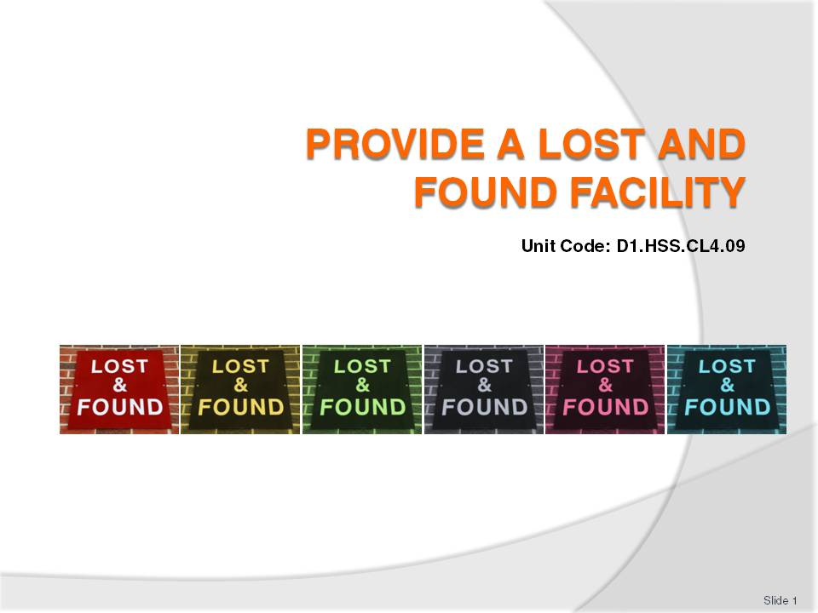
Slide No | Trainer Notes
 | Trainer welcomes trainees to class.

Slide
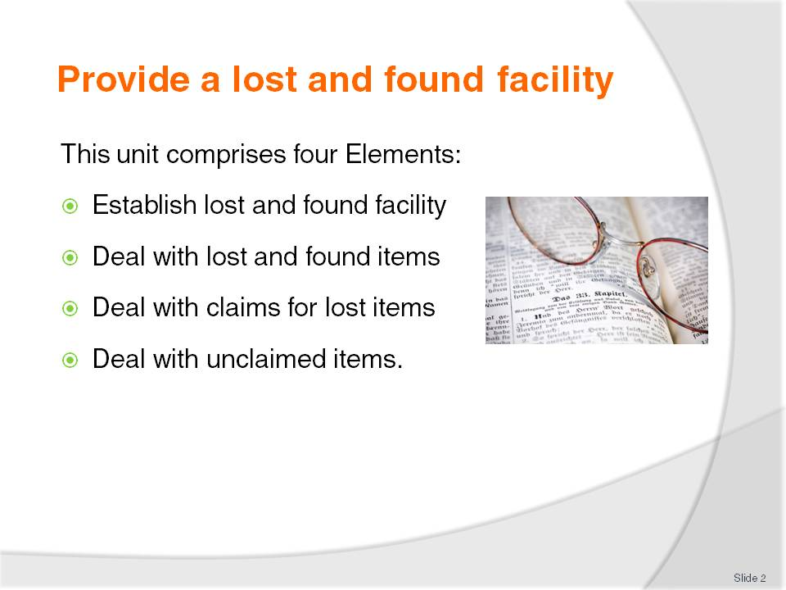
Slide No | Trainer Notes
Trainer advises trainees this Unit comprises four Elements, as listed on the slide explaining:
Each Element comprises a number of Performance Criteria which will be identified throughout the class and explained in detail
Trainees can obtain more detail from their Trainee Manual
At times the course presents advice and information about various protocols but where their workplace requirements differ to what is presented, the workplace practices and standards, as well as policies and procedures must be observed.

Slide
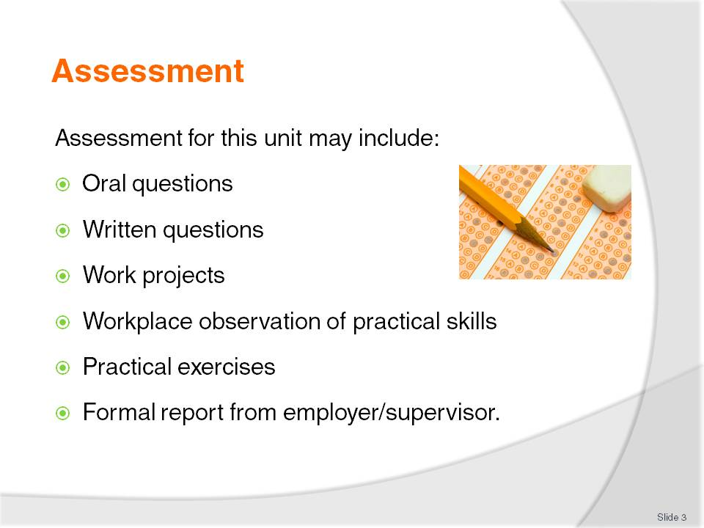
Slide No | Trainer Notes
Trainer advises trainees that assessment for this Unit may take several forms all of which are aimed at verifying they have achieved competency for the Unit as required.
Trainer indicates to trainees the methods of assessment that will be applied to them for this Unit.

Slide
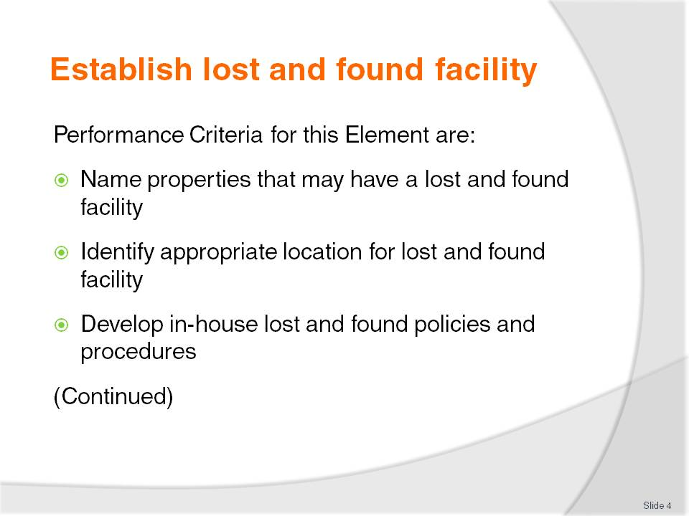
Slide No | Trainer Notes
 | Trainer identifies for trainees the Performance Criteria for this Element, as listed on the slide.

Slide
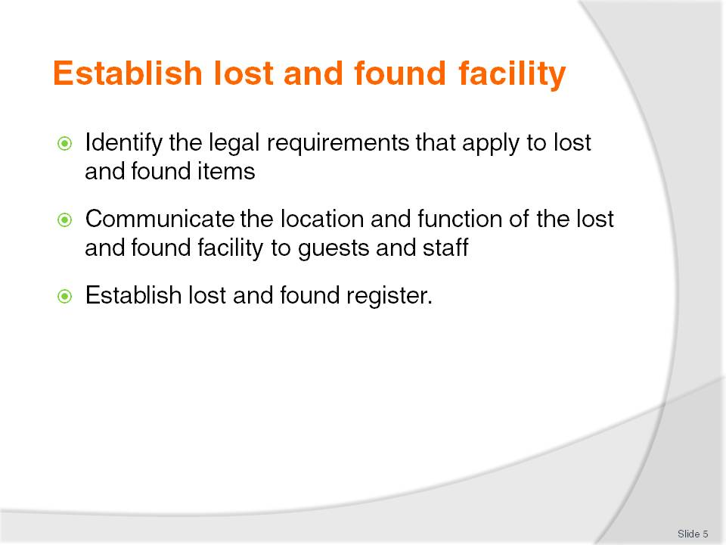
Slide No | Trainer Notes
Trainer continues to identify for trainees the Performance Criteria for this Element, as listed on the slide.
Class Activity – General Discussion
Trainer leads a general class discussion on Lost and Found facilities asking questions such as:
What types of establishments/venues have a Lost and Found facility?
Why do they have them?
What is their role/function?
What sort of items are lost and found?
What house policies might apply to the operation of the Lost and Found facility in a venue?
What legal obligations do you think apply to the operation of the Lost and Found facility?
What experience have you had with Lost and Found?
What do you think a Lost and Found Register is?
What information would it contain and when would it be used?

Slide
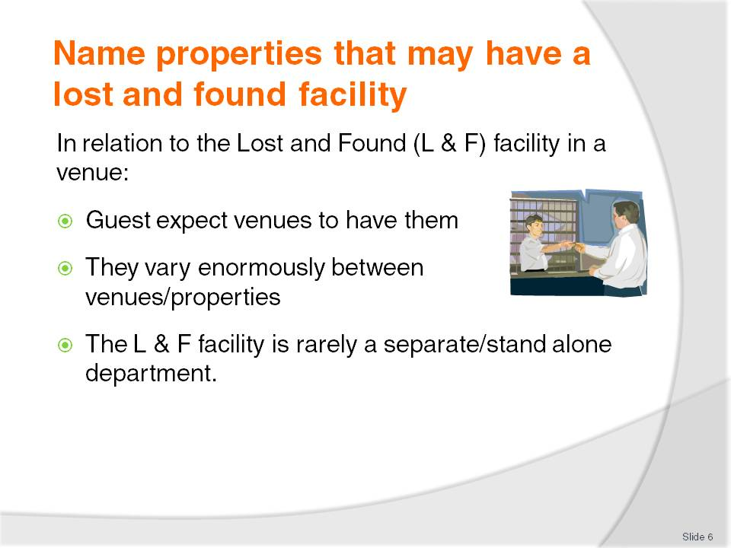
Slide No | Trainer Notes
Trainer presents to trainees all guests expect venues to provide a formal, structured Lost and Found facility highlighting:
The exact nature of each Lost and Found service can vary enormously, and the systems employed to support them can also vary widely
In most cases properties will not have a separate, stand-alone Lost and Found facility within the venue. The facility is commonly integrated into Housekeeping (or some other department – more on this on later slides). This is because no charge is made for lost and found services (so there is no revenue from it), and generally there are not many items processed through the Lost and Found area.

Slide
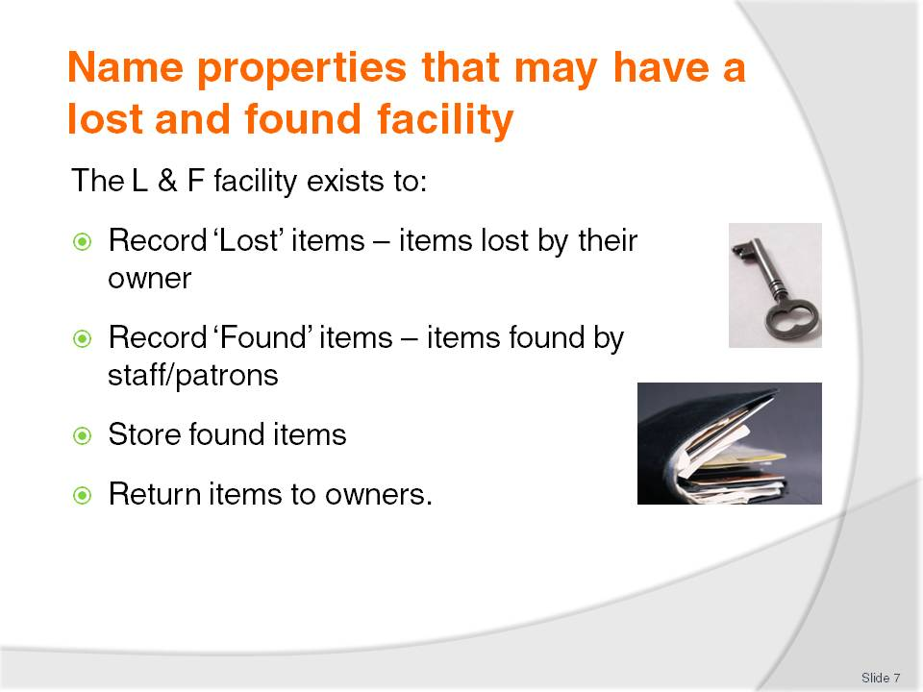
Slide No | Trainer Notes
Trainer explains to trainees the term ‘Lost and Found facility’ is a generic term referring to the service and protocols provided by a venue to:
Record lost and found items in the Lost and Found Register (more on later slides about this Register)
Store found items according to the nature and value of each item: more on later slides
Facilitate the return of lost and found items to their rightful owners.

Slide
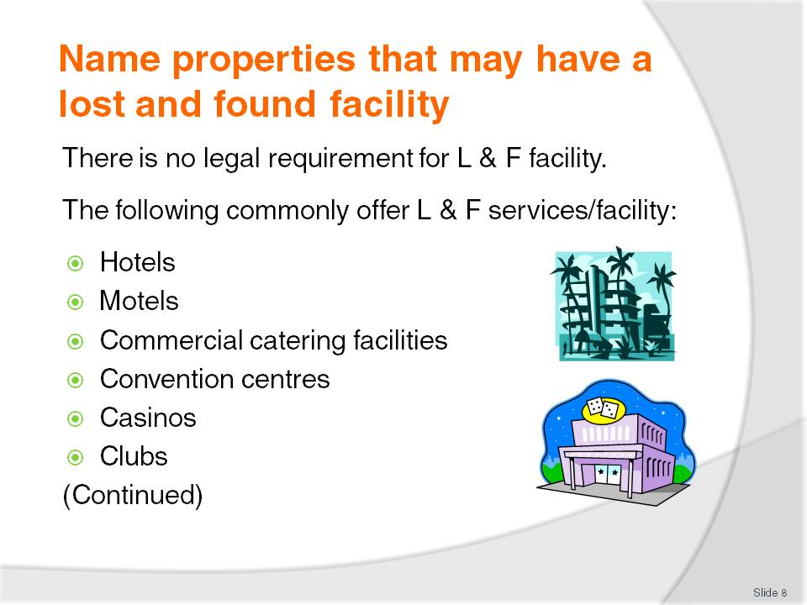
Slide No | Trainer Notes
Trainer highlights to trainees there is no legal requirement for properties to have a Lost and Found facility but they are common in the following venues:
Hotels – all standards and types
Motels – as for hotels (Motel = Motor hotel)
Commercial catering facilities where guests attend functions at the facility
Convention centres where guests attend conventions, seminars, meetings, events
Casinos – Lost and Found applies to gamblers on the floor (at tables and gaming machines) as well as at all casino facilities (such as accommodation/guest rooms, dining areas, spa facilities)
Clubs – all types; licensed clubs and unlicensed clubs.

Slide
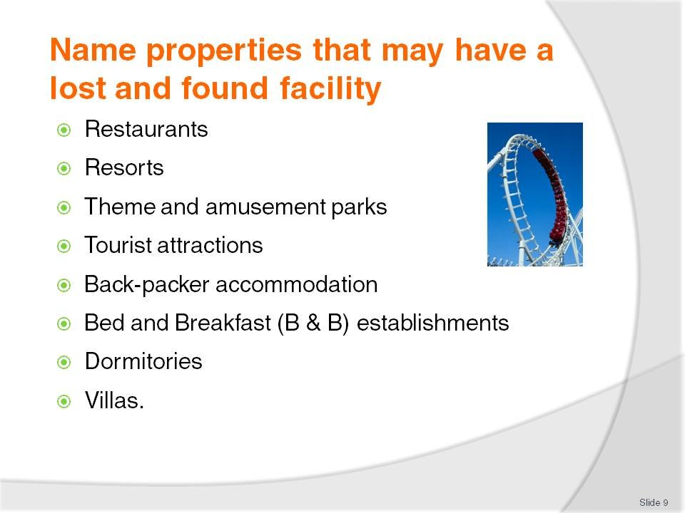
Slide No | Trainer Notes
Trainer continues to identify for trainees the businesses/properties traditionally offering L & F services/facilities;
Restaurants – to handle items left or lost by patrons/diners
Resorts – many found items are discovered in external locations (around pools, on the beach and at or near sporting areas)
Theme and amusement parks – to handle items dropping from people’s pockets and bags as they ride on rides or participate in activities
Tourist attractions – of any type, as people explore/’interact with the environment
Back-packer accommodation – same as for hotels
Bed and Breakfast establishments – same as for hotels
Dormitories – same as for hotels
Villas – same as for hotels.

Slide
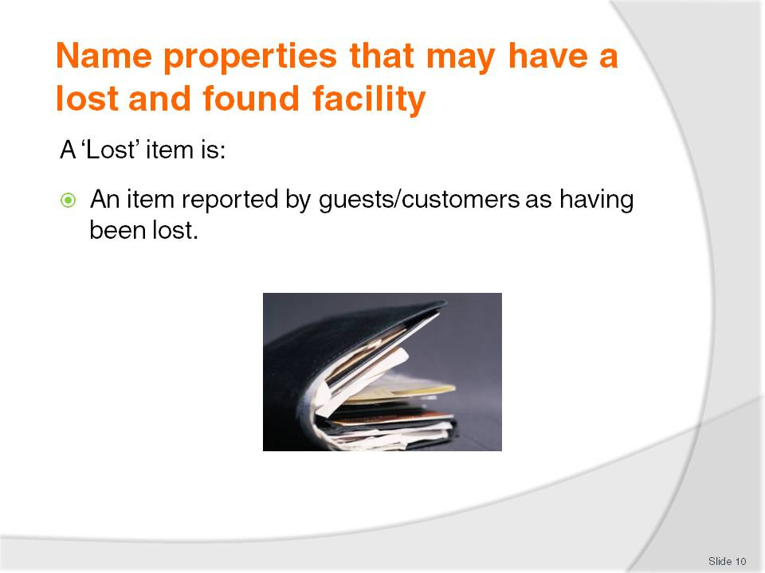
Slide No | Trainer Notes
Trainer explains to trainees the difference between ‘Lost’ items and Found items explaining that ‘Lost’ items are:
Items reported by guests/customers as having been lost. In most cases these items may have been left in a room, forgotten, or stolen.

Slide
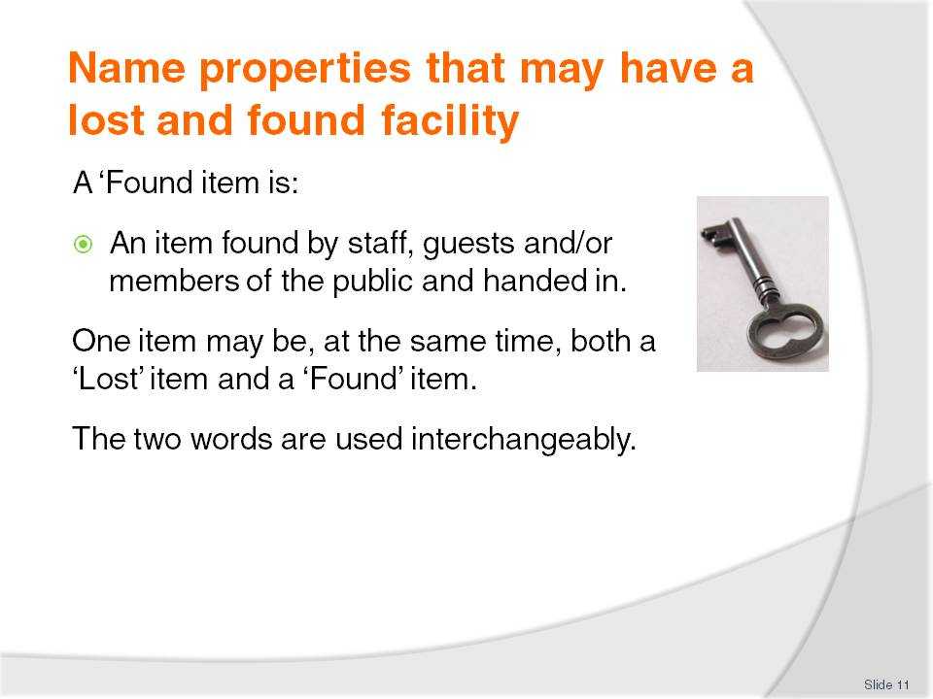
Slide No | Trainer Notes
Trainer explains a ‘Found’ item is:
An item found by staff or guests/customers and handed in to venue staff.
Trainer indicates to trainees it is possible one item can be, at the same time, both a lost and found item. It may have been identified as being lost by a guest while having been found and handed in by a staff member.

Slide
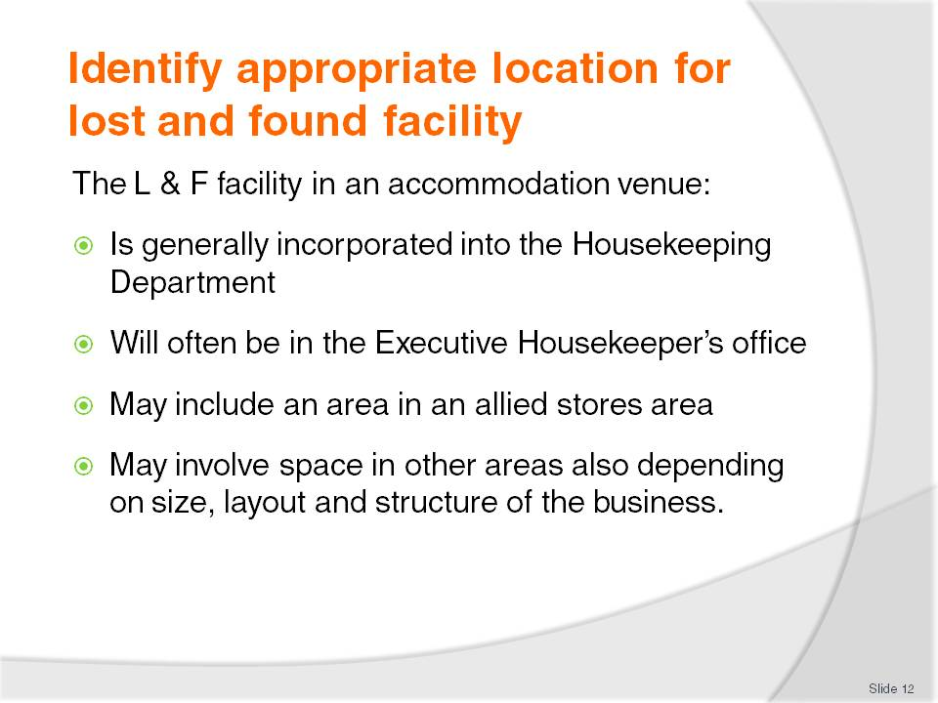
Slide No | Trainer Notes
Trainer reminds trainees most properties will not have a separate, stand-alone Lost and Found facility within the venue advising:
In hotels and other accommodation venues the Lost and Found facilities are generally incorporated within another area/department usually Housekeeping (Rooms Division)
The physical Lost and Found area will therefore usually be within the Executive Housekeeper’s office, or – for larger ‘found’ items – within an allied stores area, such as the linen store
Depending on the size, layout and structure of the business, Lost and Found facility may be located in:
- Manager’s office
- Front office/reception
- Central stores area –in the Store Person’s office.

Slide
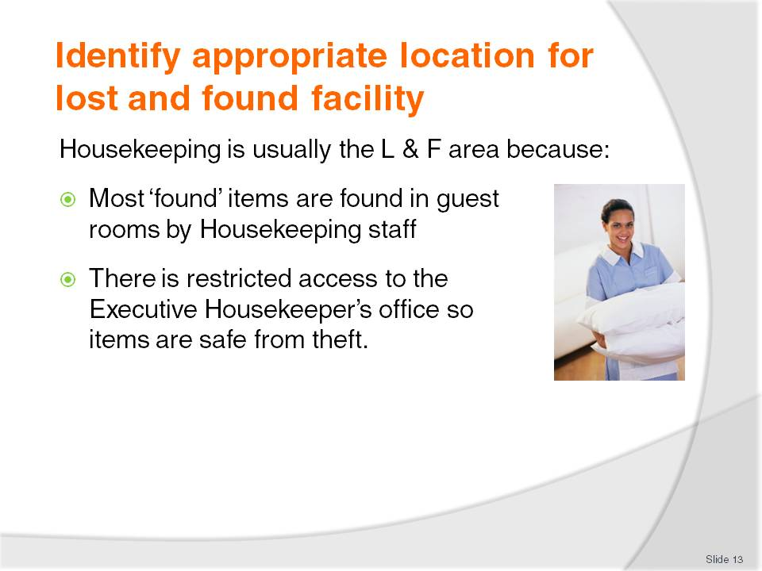
Slide No | Trainer Notes
Trainer explains to trainees ‘Housekeeping’ is commonly the location for the Lost and Found facility for two main reasons:
Most ‘found’ items are found by housekeeping staff and come from rooms where in-house guests have departed. Many items found are never claimed, perhaps because the guest does not know where they lost the item, or perhaps the item has been deliberately left behind because the guest does not want to take it with them. In addition perhaps the value of the item is such the guest is not worried about it, or perhaps simply believes it could not have been found, or handed in, so why bother
The Housekeeper’s office is a restricted access area and is not generally a high guest-traffic area. This enables increased security and safety for the items not available in some other areas such as, for instance, the baggage room.

Slide
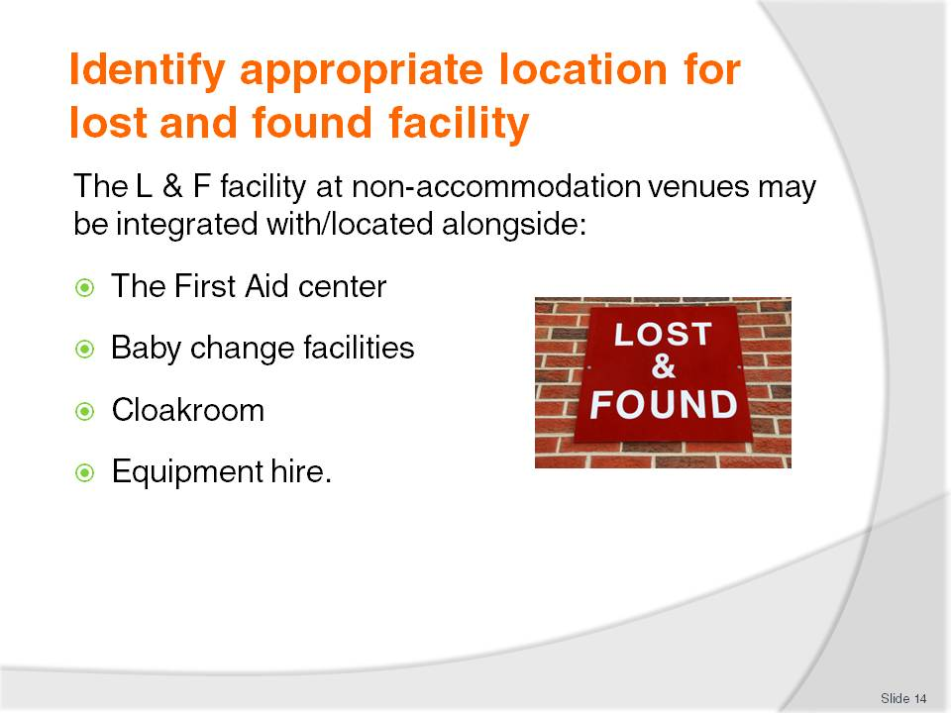
Slide No | Trainer Notes
Trainer also identifies the Lost and Found area in non-accommodation properties (such as theme and amusement parks, tourist attractions) may have their Lost and Found facility located:
At the ticket sales area/counter.
In a ‘guest service’ location. This is common at an amusement/theme park where the ‘office’ also provides a range of other services such as:
First aid
Baby change facilities
Cloakroom
Hire of equipment.

Slide
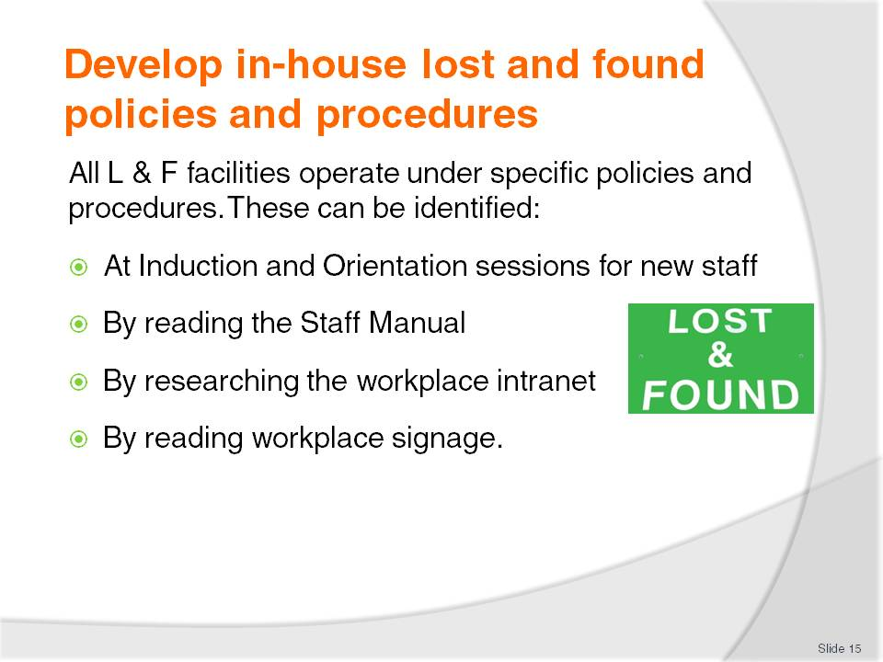
Slide No | Trainer Notes
Trainer states to trainees that all properties offering formal Lost and Found facilities will have developed a set of policies and procedures to guide implementation of the service and it is important they read and understand all relevant policies and procedures as applicable to individual workplaces.
Trainer indicates to trainees they will be able to learn about their workplace Lost and Found policies and procedures through a combination of methods:
At Induction and Orientation where the Supervisor advises about what applies and where supporting information is located
Staff manual will contain a section entitled Lost and Found
Venue intranet. Larger businesses will feature an intranet facility which will enable access to all policies and procedures
Workplace signs including:
- Information posters
- Directional signage pointing to the location of the Lost and Found facility
- ‘Lost and Found’ signs.
Class Activity – Excursion
Trainer arranges to visit one or more venues with a Lost and Found facility to:
View facilities
Talk to staff who operate the facility
Meet with and talk to supervisors with responsibility for the facility
Obtain sample Lost and Found policies and procedures
Obtain sample Lost and Found documentation.

Slide
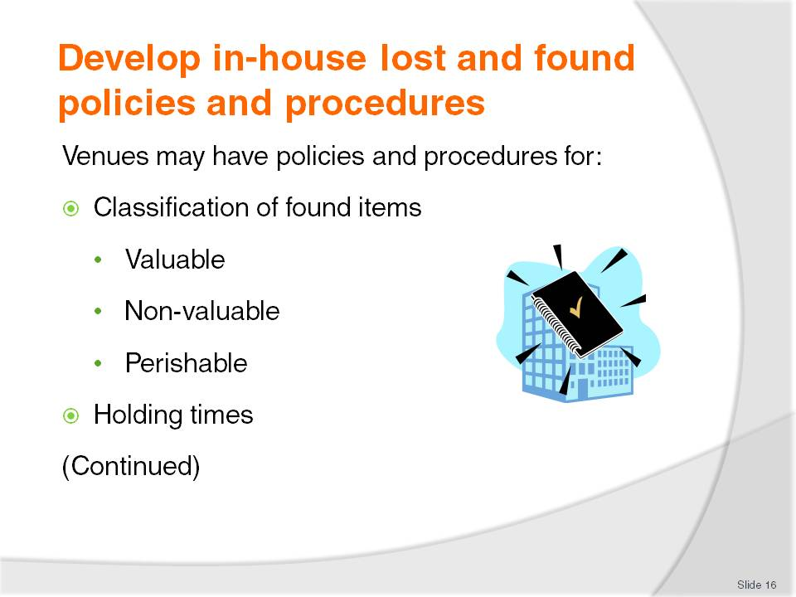
Slide No | Trainer Notes
Trainer introduces to trainees sample Lost and Found policies and procedures applicable to a Lost and Found facility:
Classification of items
Trainer explains to trainees that businesses will provide information regarding a description of items that will be kept and those that will be discarded. Properties often classify found items into one of three categories:
Valuable items which include:
- Cell phones
- Cash over a certain amount as nominated by the venue
- Laptop computers and accessories
- Cameras
- Watches
- Jewellery
- Car or house keys
- Handbags and wallets
- Travel documentation – passports, visas, tickets
- Business documentation – reports, notes, business papers, plans
- Personal items – credit cards, driver’s licence
Non-valuable items such as:
- Magazines
- Make-up and cosmetics
- Old or damaged clothing
- Stationery
Perishables items:
- Food
- Drinks
- Partly consumed items and unopened items.
Holding times
Trainer tells trainees these specify the length of time a property will retain an item before disposing of it (more on this on later slides: including industry standard ‘holding times’ for valuable, non-valuable and perishable items).
Class Activity – Examination of Lost and Found Policies and Procedures
Trainer obtains sample Lost and Found policies and procedures (as identified on the slide) from local venues and:
Distributes to trainees
Discusses each document explaining inherent requirements.

Slide
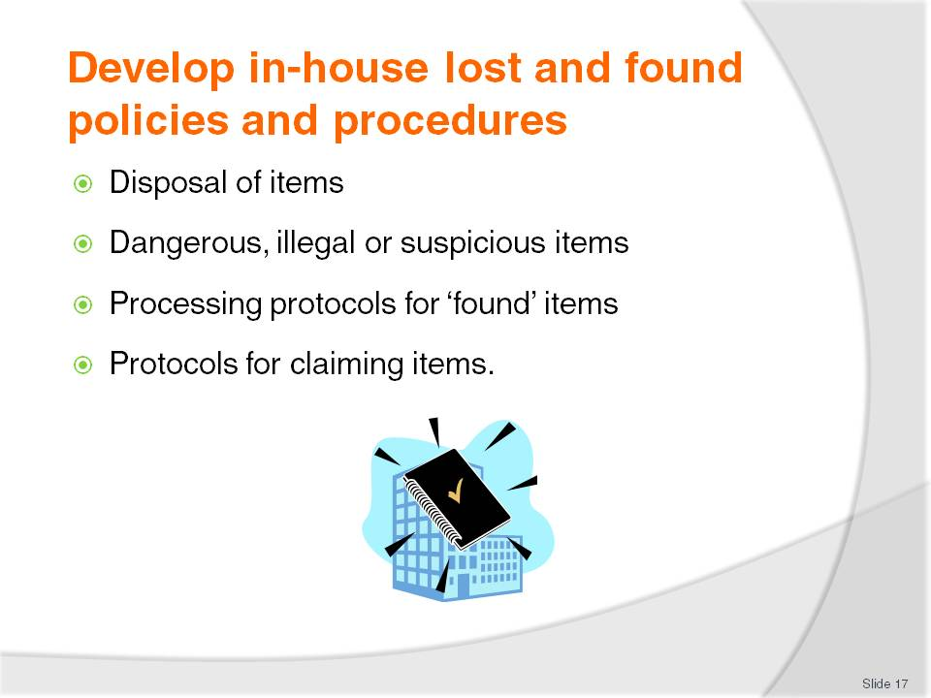
Slide No | Trainer Notes
Trainer continues to advise trainees regarding sample Lost and Found policies and procedures applicable to a Lost and Found facility:
Disposal of items
Trainer explains to trainees that this policy dictates what happens to found items if they are not claimed: more on this in later slides.
Dangerous, illegal or suspicious items
Trainer explains to trainees that in order to protect the property and staff, there will nearly always be directions about action to take to ensure correct treatment of dangerous, illegal or suspicious items to guard against unsafe/illicit items being taken into Lost and Found storage: more on this in later slides.
Processing for found items
Trainer states to trainees these protocols will describe the procedures for receiving, recording and storing/securing items handed in by staff and guests as ‘found’ items. Policies and procedures in this regard will address:
Staff with responsibility for processing items
Documentation to be completed such as Lost and Found Slip/Tag and Found Register/Lost and Found Register
Location for storage of items
Notifications – internally to other staff/departments and guests and externally to departed guests
Disposal of items when their storage period has elapsed and items have not been claimed.
Claiming items
Trainer explains to trainees that these are the house requirements to be followed when a person makes a claim on a Lost and Found item highlighting
Standard procedures require the person claiming the item to be able to describe the item or furnish reliable proof of ownership
It is imperative items are never simply handed over to people making a claim without proof of ownership
Relevant documentation must also be completed to track or record the return of the item.
Class Activity – Examination of Lost and Found Policies and Procedures
Trainer obtains sample Lost and Found policies and procedures (as identified on the slide) from local venues and:
Distributes to trainees
Discusses each document explaining inherent requirements.

Slide
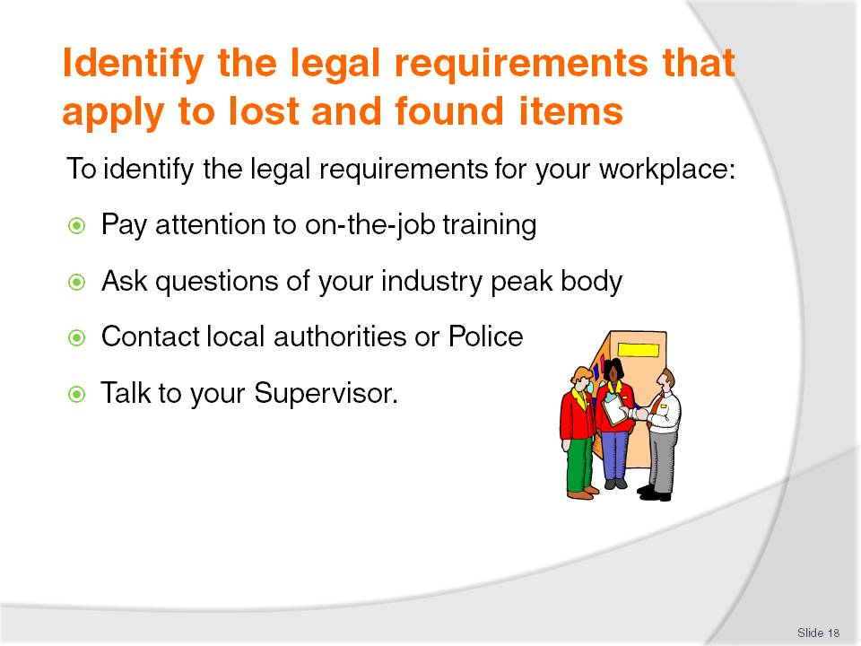
Slide No | Trainer Notes
Trainer informs trainees all properties have some form of legal obligation and responsibility when found items are handed in and stored for return to the person who lost them.
Trainer stresses trainees must identify the Lost and Found legal requirements applying in their country and their workplace, and they can do this through:
On-the-job training. All training (as well as policies and procedures) will reflect what the law requires
Contacting industry peak bodies who will provide relevant in-country advice
Contacting local authorities who will explain the legal requirements applicable
Talking to their Supervisor to gain the benefit of their knowledge and experience.

Slide
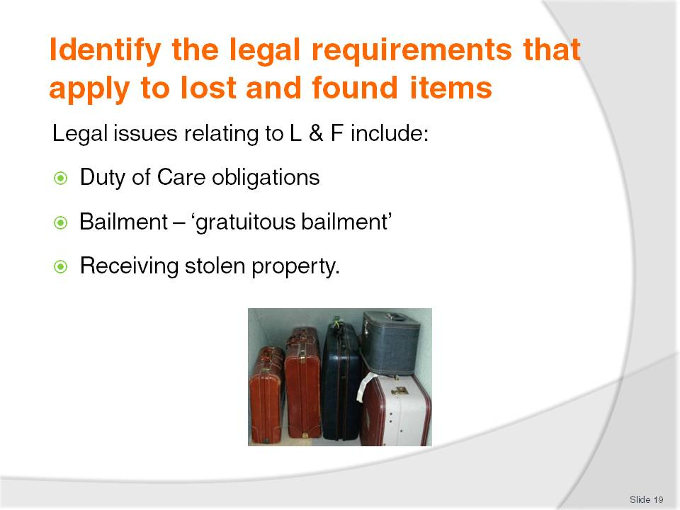
Slide No | Trainer Notes
Trainer identifies to trainees legal issues in Lost and Found involve:
Duty of Care
Trainer explains to trainees this requires a venue to take whatever action is necessary, given the circumstances applying at the time, to ensure the found item:
Does not come to any harm while in storage
Is returned to the rightful owner if and when a claim is made.
Bailment
Trainer defines ‘bailment’ for trainees stating ‘Bailment’ refers to the act of temporarily transferring custody or control of an item to someone else or a business. For example, if people leave their car in a car park, bailment has been created. A person pays a fee to park and then comes back at a later time to pick the car up. The same applies when people take clothes to be laundered or dry cleaned – bailment again exists.
Trainer informs trainees ‘gratuitous bailment’ is created when a hotel looks after lost property and when no charge is made for the service of looking after the item. This form of bailment means the hotel/venue:
Cannot use the items for its own purposes
Must take care of the item. The intention is the item should be returned in the same condition it was found in
Need only prove the extent of the care provided for the item was ‘low’. If they were sued the venue is not obliged to provide any higher level of care for the items
Can be sued by the person who lost the item if the item is returned in a damaged condition (or has been lost by the property) if – and only if – the person who lost the item can prove the hotel was ‘grossly’ negligent.
Receiving stolen property
Trainer advises trainees it is possible someone taking possession of an item for processing as ‘found’ property may be charged with ‘receiving stolen property’ if:
The items were, in fact, stolen
The person knew, or ought reasonable be aware, they were stolen
The person who received the items deliberately intended to receive the items and have them under their control.
Trainer informs trainees where the person had no intent to receive the stolen goods, did not know they were stolen or the goods were not, in fact, stolen it is highly unlikely a prosecution would be commenced or succeed. Trainer stresses trainees must refuse to accept any items into the Lost and Found facility if they believe the item to be stolen.
Class Activity – Guest Speaker
Trainer arranges for a representative from local authorities/Police or industry peak body to attend and discuss legal issues relating to dealing with Lost and Found items in regard to:
Duty of Care – identifying obligations on the venue and individual staff
Bailment – identifying requirements relating to gratuitous bailment as it applies to lost and found items
Receiving stolen property – identifying the evidence required before a prosecution can be launched.

Slide
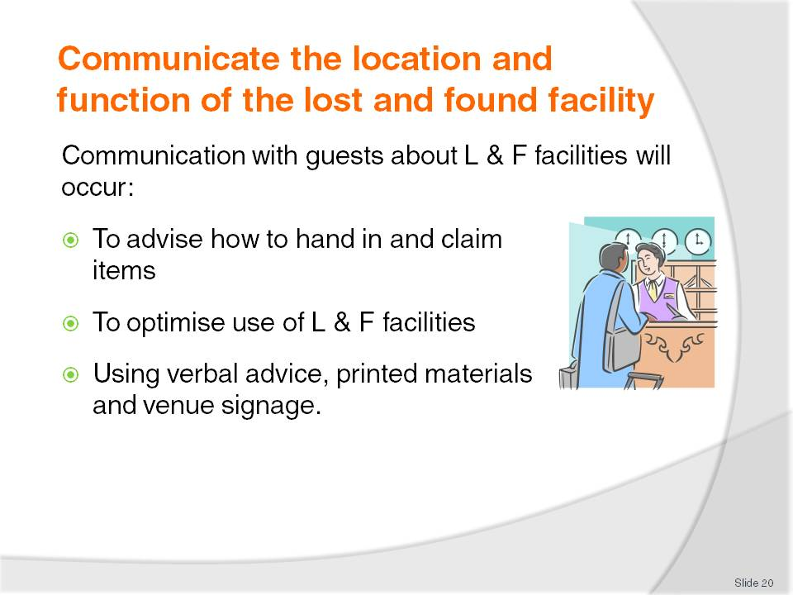
Slide No | Trainer Notes
Trainer suggests to trainees where formal Lost and Found services are available, the venue will seek to inform guests/customers about them. This communication will occur to optimise its use both by staff and guests, and ensure lost items are returned to their owners.
This communication can occur verbally, in print, or via signage – see following slides.

Slide
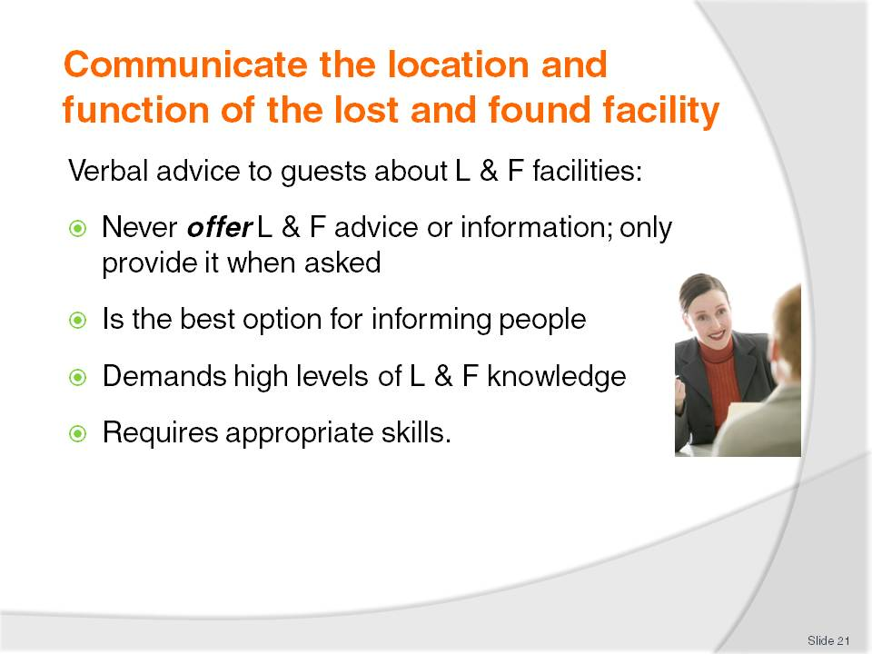
Slide No | Trainer Notes
Trainer notes to trainees the following points apply to the provision of Lost and Found information to guests:
Staff should never offer Lost and Found advice to guests/customers. Information should only be provided when:
- Specifically asked a question – perhaps because the person has an item to hand in or they have lost something
- There is a situation where the advice is appropriate. For example, a person states they cannot find their watch but are not certain at this stage it is actually ‘lost’
- One guest/customer advises someone else in the venue has lost or found an item
Advising people verbally is an excellent option for sharing information as it allows:
- Verification people have understood what has been said to them
- Follow-up with other help such as escorting people to the Lost and Found service area
Demands excellent levels of knowledge about:
- Establishment Lost and Found policies and procedures
- Lost and Found documentation
- Location of the Lost and Found facility
- Authorised Lost and Found personnel
Requires effective interpersonal and communication skills – see next two slides.

Slide
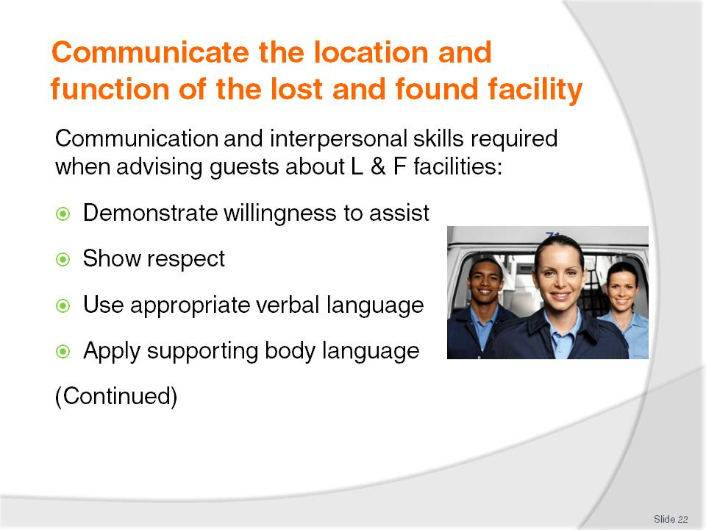
Slide No | Trainer Notes
Trainer instructs trainees when communicating with guests/customers about Lost and Found facilities and protocols the following interpersonal and communication skills should be applied:
Demonstrate a willingness to help/communicate. Never treat these situations as an imposition
Show respect for the person and concern for their situation or loss
Use appropriate verbal language as appropriate to the person’s age and race
Use non-verbal communication to support the spoken word and other action taken. Ensure body language matches the verbal language.

Slide
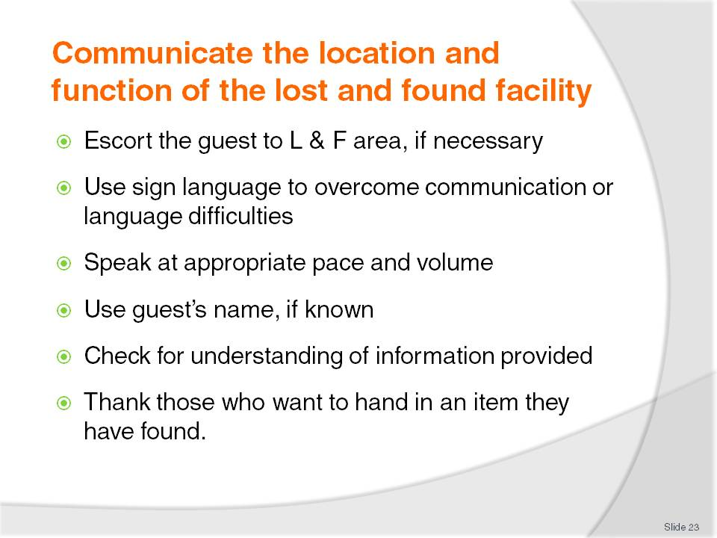
Slide No | Trainer Notes
Trainer continues to instruct trainees regarding communication and interpersonal skills to apply when advising guests/customers about the Lost and Found facilities in the workplace:
Be prepared to accompany the person to the Lost and Found area as opposed to simply providing verbal or other directions/instructions
Use sign language where there is a communication problem caused by language differences e.g. point
Speak at an appropriate pace and volume. Do not yell, do not whisper.
Use person’s name where it is known or use ‘Sir’ or ‘Madam’
Check advice/information has been understood. Ask if the person has understood or needs more information, a different explanation or another person to explain things
Thank anyone who wants to hand a found item in. Always thank people for their help, honesty and cooperation.
Class Activity – Role Plays
Trainer develops and conducts role play scenarios as follows:
Trainer plays role of staff member at a venue
A trainee plays the role of a guest
Trainee approaches ‘staff member’ and:
- (1) Asks where they can enquire if anyone has found or handed in their wallet
- (2) Asks what they should do with a bag they found in their room when they checked in
Trainer demonstrates appropriate interpersonal and communication skills when dealing with these scenarios
Role plays are observed by remaining class members for later discussion and analysis.

Slide
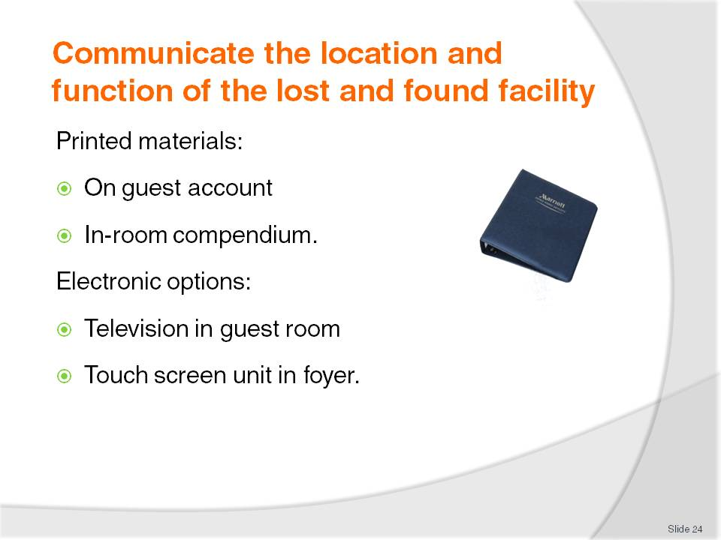
Slide No | Trainer Notes
Trainer advises trainees that most properties will have hard-copy and/or electronic options as ways of advising guests/customers about Lost and Found:
Hardcopy options:
- Guest account. A line or two is commonly included on the guest account advising them of how to contact Lost and Found after their departure if there is a need to do so
- Guest room compendium. There is usually a section in the in-room compendium advising guests:
- The venue has a Lost and Found facility
- Where it is
- How to contact it
- Attention should be paid to providing these materials in different languages to match customer/guest profiles
Electronic options:
- Through the information facility on the television in the guest room
- Via a touch screen information unit in the lobby/foyer.
Class Activity – Examination of Industry Communication Options
Trainer obtains sample guest account and in-room compendium and shares these with trainees, discussing the information provided.

Slide
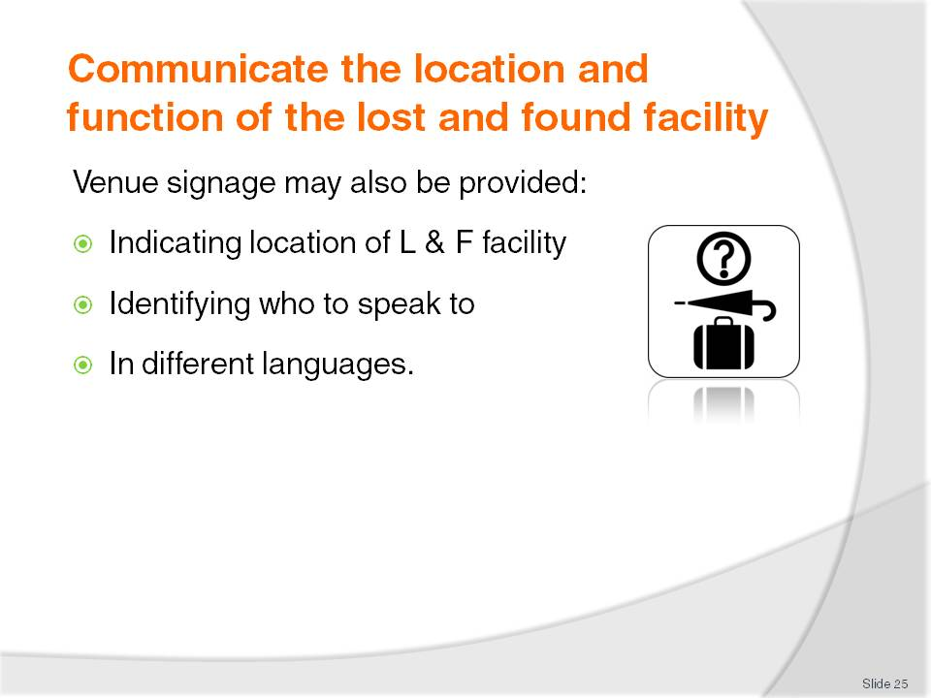
Slide No | Trainer Notes
Trainer advises trainees many venues also provide Lost and Found signage indicating to patrons:
Where the Lost and Found facility is located – by signage at the facility, and/or by use of directional arrows
Who to speak to about lost and found items
Lost and Found advice in different languages appropriate to the guest profiles of the venue.

Slide
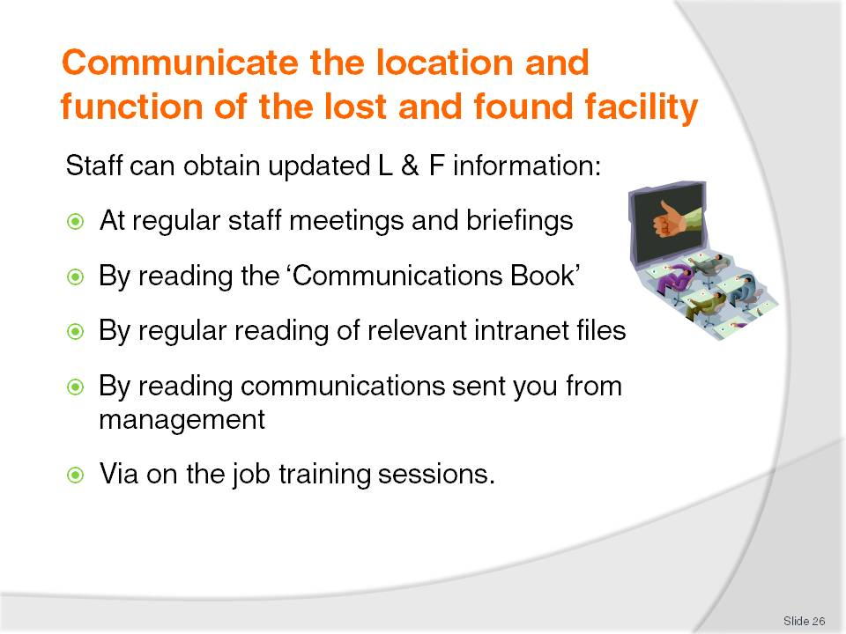
Slide No | Trainer Notes
Trainer tells trainees they can obtain updated information about internal Lost and Found procedures in their workplace:
At regular (weekly, fortnightly) staff meetings
At daily staff briefings and debriefings before work
By reading the Communications Book used by management in some venues to communicate important information to staff
By regular reading of intranet files – policies, procedures, updates, alerts
By reading all communications issued by management such as emails, memos and posters on the staff information board in the tea room, change room, recreation room
Through mandatory on the job training sessions.

Slide
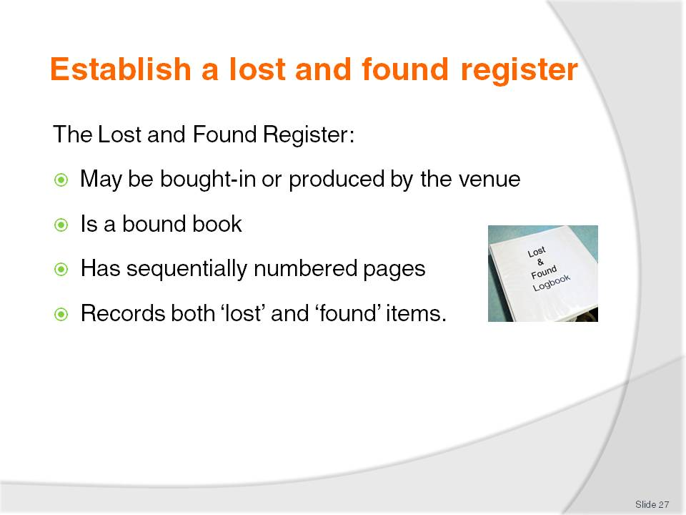
Slide No | Trainer Notes
Trainer explains to trainees all properties offering a Lost and Found facility will feature a Lost and Found register. Properties may purchase a Lost and Found Register from a hospitality supplier or prepare their own using the workplace computer.
Trainer advises trainees about the Lost and Found Register:
Can be bought from a supplier or produced in-house using the workplace computer
It is a bound book – not loose-leaf pages
Pages are sequentially numbered to assist in identifying pages and to help identify is a page has been removed
Records both ‘found’ items and details of reports regarding ’lost’ items in the one register. There is normally not a separate register for ‘found’ items and for ‘lost’ items.

Slide
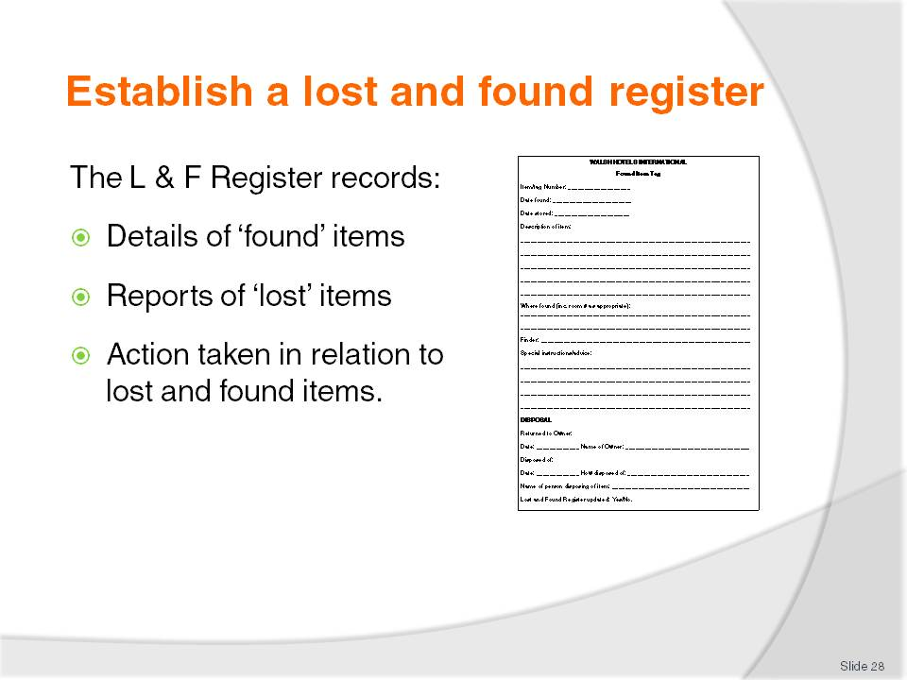
Slide No | Trainer Notes
Trainer advises trainees the Lost and Found Register records three primary types of information:
All appropriate items found on the premises by staff and/or customers and guests
Details of all items reported as lost by customers/guests
Actions taken in relation to lost and found items including:
- Efforts to find lost items – action taken by staff/the property in response to reports from guests/customers they have lost an item
- Storage of found items – identifying where items have been stored so they can be easily retrieved when a claim is made
- Details of the return of an item to its owner – identifying the owner and evidence obtain identifying the claimant as the rightful owner
- Details of disposal of found items – to prove/demonstrate what happened to unclaimed items and when this took place.

Slide
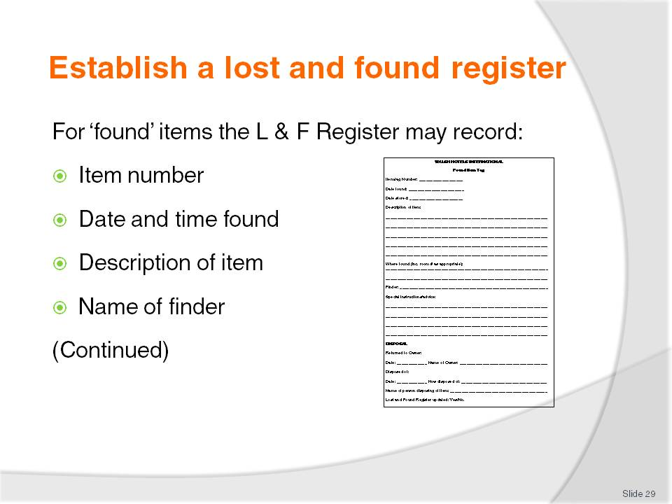
Slide No | Trainer Notes
Trainer states to trainees for ‘found items’ the Lost and Found Register will usually provide space to record:
Item number (optional). Some properties allocate every found item a number to assist with tracking
Date/time the item was found
Description of item –which is sufficiently detailed to distinguish it from other similar items
Finder – name and contact details of person who found it.

Slide
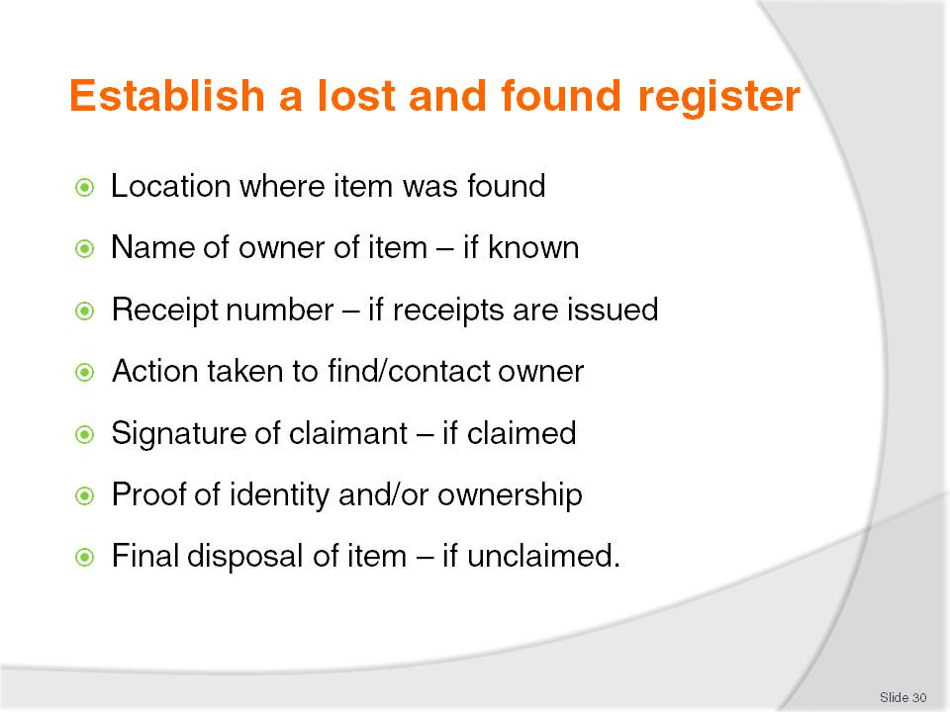
Slide No | Trainer Notes
Trainer continues to identify for trainees the information recorded in the Lost and Found Register when an item is handed in as a ‘found’ item:
Location found – name of room/area where the item was find
Name of owner/room occupant – where known
Receipt number. Some venues will issue a receipt to the finder whenever a found item is handed in. This helps maintain accountability and reduced chance of staff stealing items
Action taken to find the owner (where appropriate)
Final disposal of the item such as:
- ‘Returned to Owner’
- ‘Discarded’
- ‘Donated to XYZ’
Signature of claimant where item was returned to owner, including details of evidence presented by the claimant to prove they were the owner, such as:
- Driver’s licence number
- Passport number
- Reference to photocopied material filed for future reference.

Slide
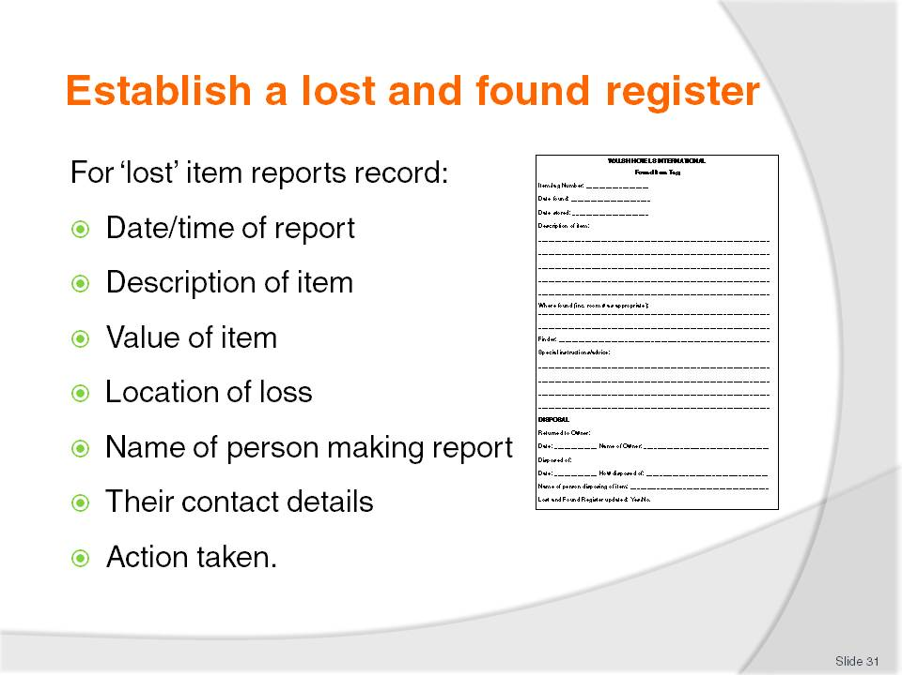
Slide No | Trainer Notes
Trainer states to trainees for items reported as lost the following details need to be recorded:
Date/time the lost report was made
Description of item in sufficient detail to allow the item to be identified
Value of the item (optional) , indicating how much the item is worth
Location where item was lost, if known
Name of person who has lost the item
Contact details of person who has lost the item
Action taken to find the lost item.

Slide
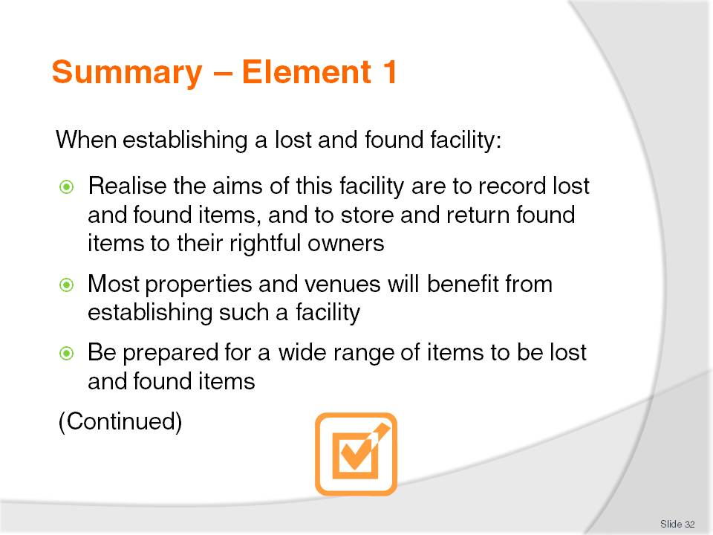
Slide No | Trainer Notes
 | Trainer provides a recap of the Element asking questions to check trainee understanding and responding to questions from trainees, as required.

Slide
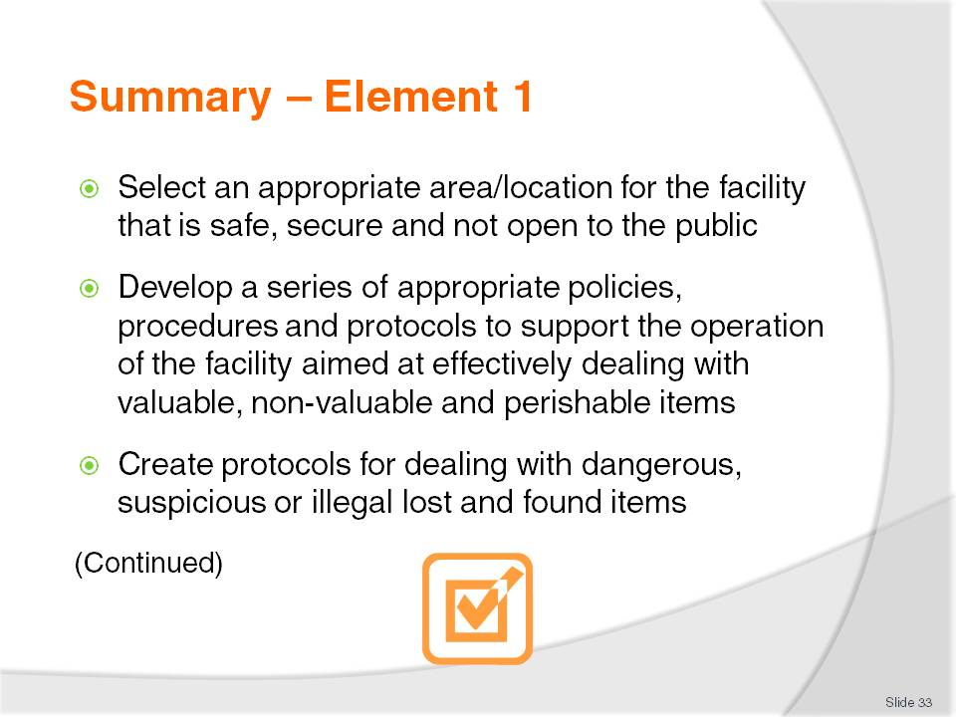
Slide No | Trainer Notes
 | Trainer provides a recap of the Element asking questions to check trainee understanding and responding to questions from trainees, as required.

Slide
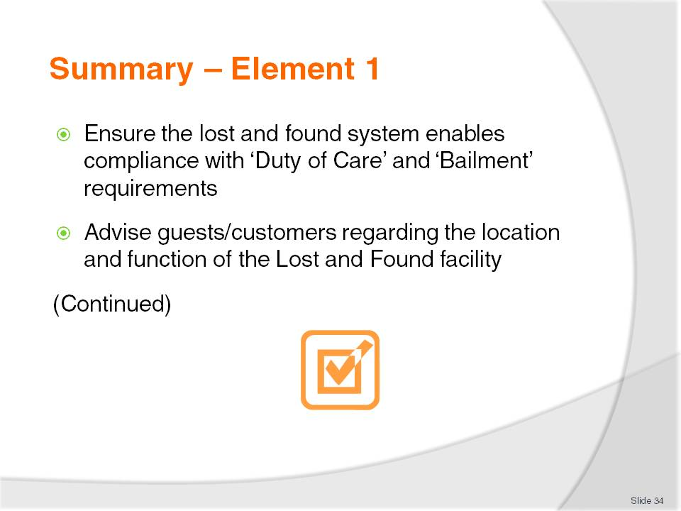
Slide No | Trainer Notes
 | Trainer provides a recap of the Element asking questions to check trainee understanding and responding to questions from trainees, as required.

Slide
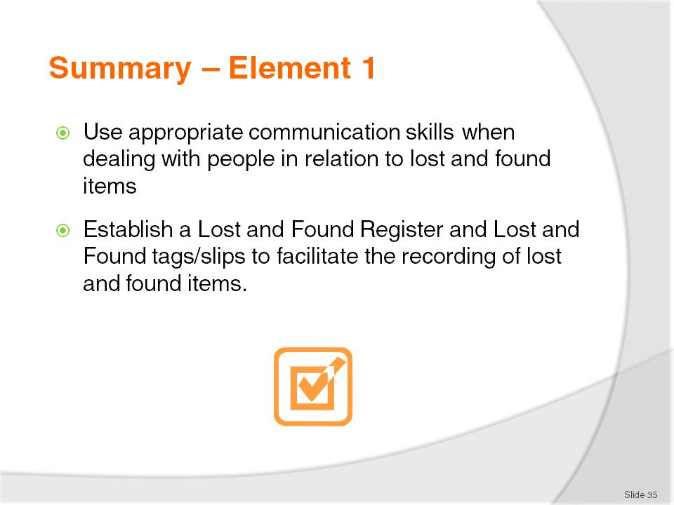
Slide No | Trainer Notes
 | Trainer provides a recap of the Element asking questions to check trainee understanding and responding to questions from trainees, as required.

Slide
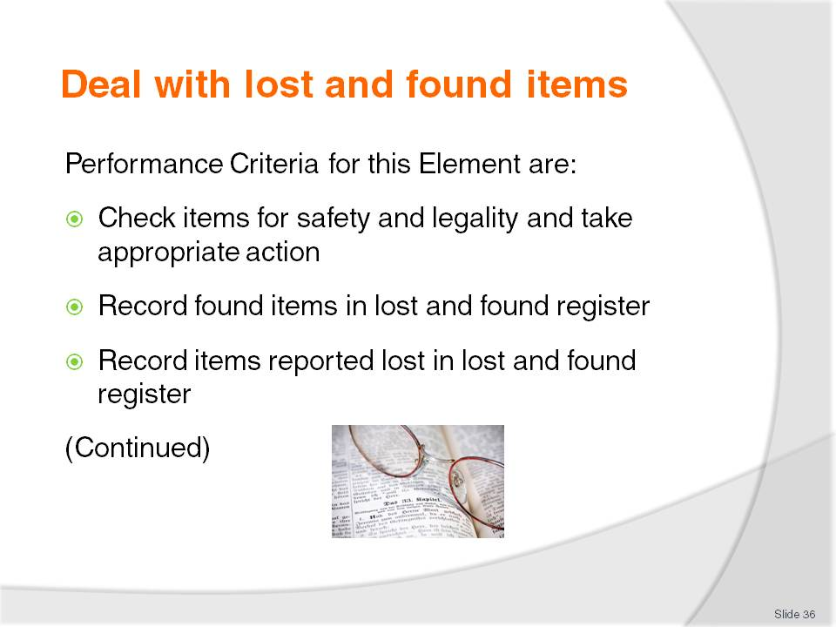
Slide No | Trainer Notes
 | Trainer identifies for trainees the Performance Criteria for this Element, as listed on the slide.

Slide
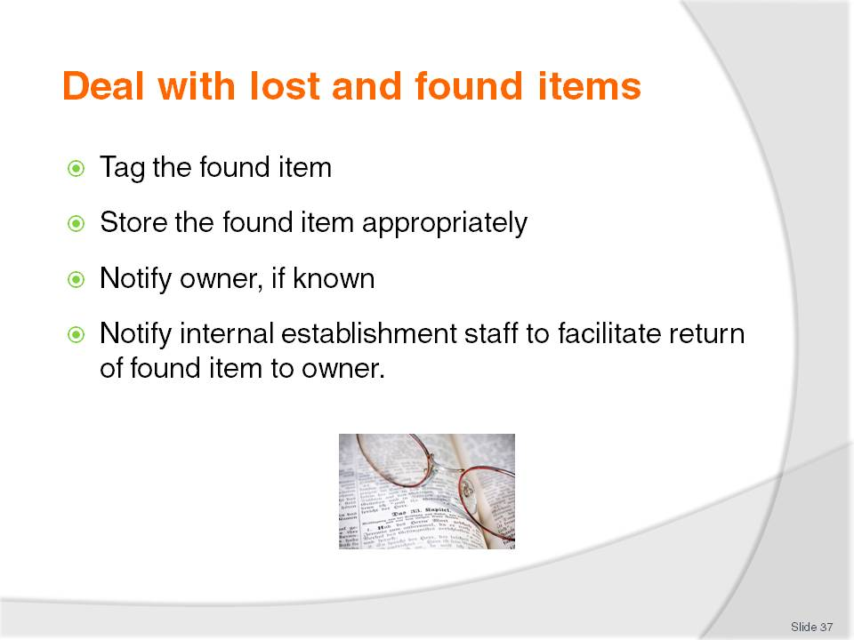
Slide No | Trainer Notes
Trainer continues to identify for trainees the Performance Criteria for this Element, as listed on the slide.
Class Activity – Discussion
Trainer asks trainees questions regarding their experiences and knowledge about dealing with lost and found items asking questions such as:
Why do you think it is important to check items before they are taken into storage as ‘lost property’/’found items’?
What checks might be involved?
What items might you not want to accept into the Lost and Found facility?
When recording information of an item that has been found, what details would you need to record?
If a guest reports an item as lost, what information would you need to capture?

Slide
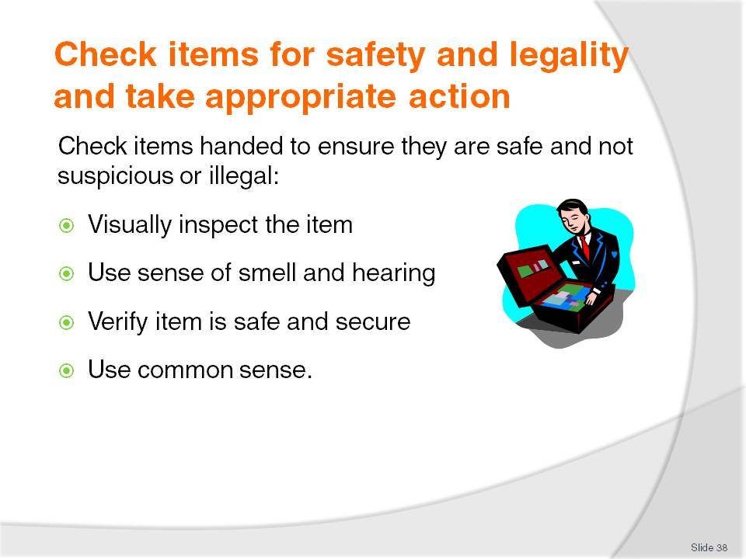
Slide No | Trainer Notes
Trainer emphasizes to trainees that all items handed in as ‘found’ items must be checked to ensure they are safe and appropriate to accept into storage. It is important all items submitted to Lost and Found must be checked to ensure they are not dangerous, suspicious or illegal.
Trainer indicates to trainees the checking of items handed involves:
Inspecting/looking at the item to look for danger signs such as:
- Sharp/jagged edges
- Broken glass
- Leaks
- A physical item that by its very nature gives rise to concern
Using the other senses to detect any smells or sounds causing concern
Making sure, to the best extent possible the item is safe and secure for handling and storage
Using common sense to determine the nature and safety of the item.

Slide
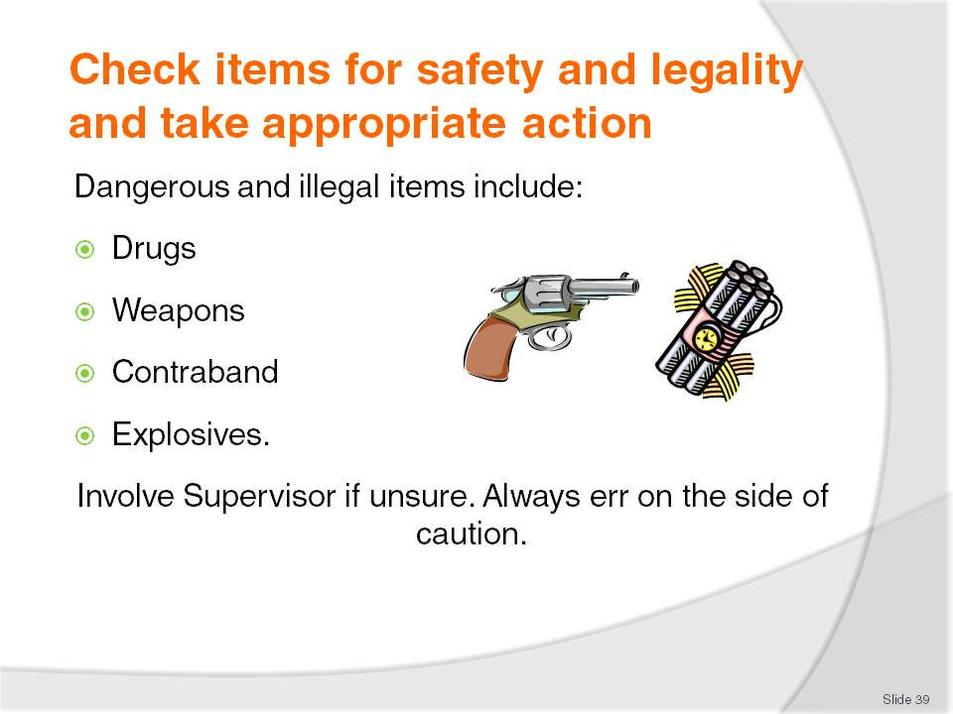
Slide No | Trainer Notes
Trainer notes to trainees that most properties will provide directions on how staff should deal with found items deemed to be dangerous, suspicious or illegal stressing to them they must comply with specific workplace procedures where these differ to what is presented.
Trainer explains to trainees ‘Dangerous or illegal goods’ include:
Drugs
Weapons
Contraband
Explosives.
Trainer suggests to trainees:
If in doubt about the nature of something handed in they should always seek assistance and always err on the side of caution
If a parcel of white powder has been handed in assume it is drugs
Items may not themselves be dangerous, but the condition or state they are in may render them dangerous. For example, an electrical appliance may be safe, but one that has exposed cords is dangerous. A tin of ‘something’ may be safe, but if it is leaking it has the potential to be unsafe. A knife may not in itself be dangerous but the sharpness of the blade together with the sharpness of its point may mean it can be described as dangerous.
Class Activity – Guest Speaker
Trainer arranges for a management level person from a venue to attend and talk to trainees about:
Protocols for checking items into their Lost and Found facility
Policies and procedures at their venue for dealing with dangerous, illegal and/or suspicious items
Personal experiences in dealing with dangerous, illegal and/or suspicious items
Advice for trainees regarding treatment of dangerous, illegal and/or suspicious items.

Slide
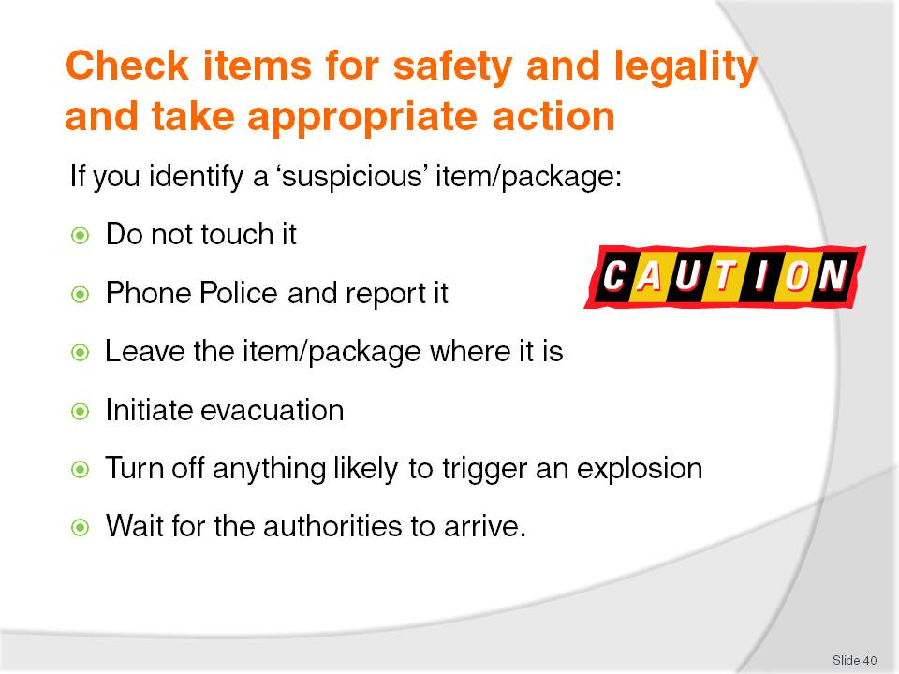
Slide No | Trainer Notes
Trainer urges trainees to be alert to identifying ‘suspicious’ items noting there is no definition of such a package but items left on their own may be deemed suspicious.
Trainer informs trainees where a suspicious package is identified, the appropriate response (subject to establishment policies and procedures) is:
Do not touch it
Phone the Police and report the finding. Stay on the line until told to hang up and answer questions asked by operator
Leave the package in the place or situation where it was discovered
Evacuate people from the immediate area. Evacuate people from a wider area depending on nature of found item. Follow the directions in Emergency Management/Evacuation Plan for the area/venue
Turn off anything likely to trigger an explosion – such as mobile phones
Wait for the authorities to arrive and deal with the item.
Class Activity – Guest Speaker
Trainer arranges for Police to attend and talk to trainees about:
Recommended protocols for dealing with suspicious items especially things not to do
How to contact Police and report a suspicious item
Determining if an item is suspicious or not
Response the authorities provide to a report of a suspicious item.

Slide
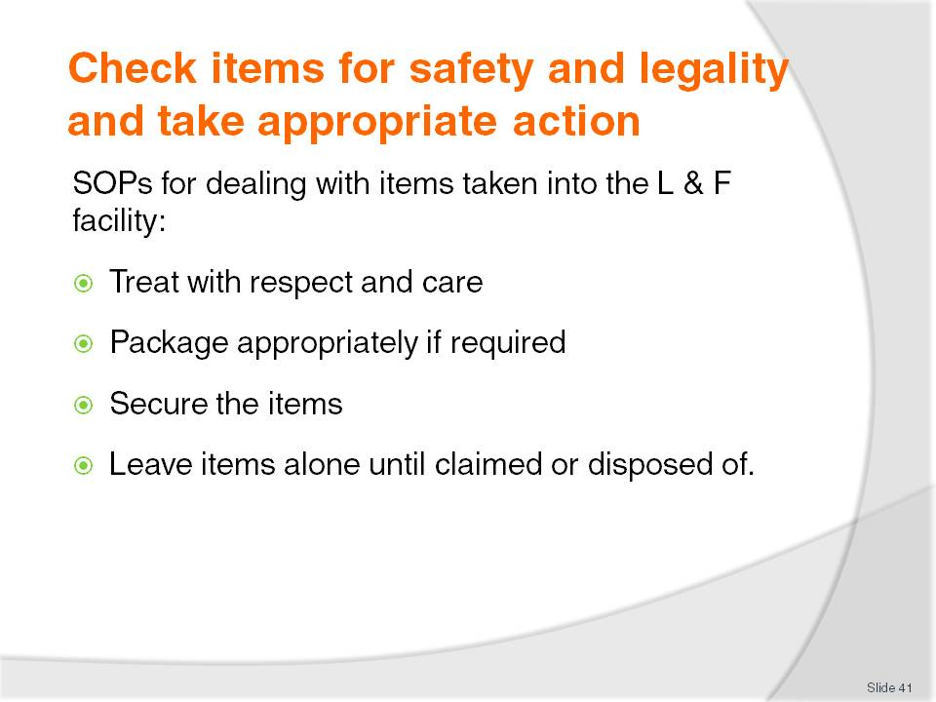
Slide No | Trainer Notes
Trainer states to trainees once items submitted as found items have been checked for safety and legality, they may be accepted and signed-in to the Lost and Found facility using the appropriate Register indicating standard practices and protocols for handling the items include:
Treating/handling items with respect and care. Treat them as personal and prized possessions
Packaging items to protect them from damage where appropriate such as when dealing with fragile items or items likely to be easily scratched/marked
Securing the items – placing them into locations to ensure they are not stolen or lost
Leaving items alone until they are claimed or need to be disposed of. This highlights that ‘found’ items cannot be used by staff or the property.

Slide
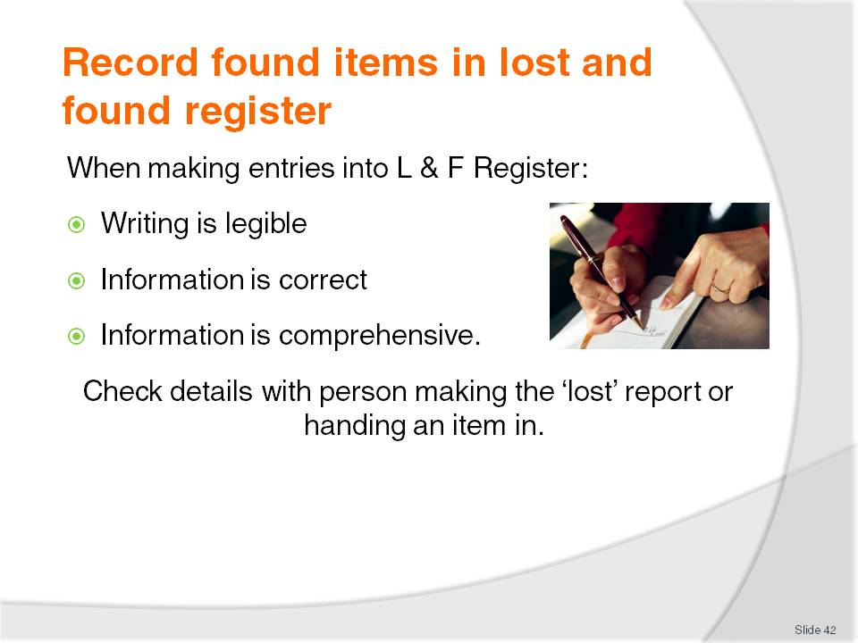
Slide No | Trainer Notes
Trainer identifies to trainees a standard requirement when a ‘found’ item is handed in is for it to be entered into the Lost and Found Register.
Trainer advises trainees when making entries into the Register they must take time to ensure:
Writing is legible – others will have to read and interpret what is written
Information is correct – double-check the entries to ensure they are accurate
Information is comprehensive. It is worth taking an extra minute to record more detail.
Trainer suggests to trainees that when all necessary details have been recorded in the Register (for both ‘lost’ and ‘found’ items) they should be verified with the person concerned (for example, the staff member/person handing in a found item or the individual reporting a lost item). Reading the details back is the best way to achieve this.

Slide
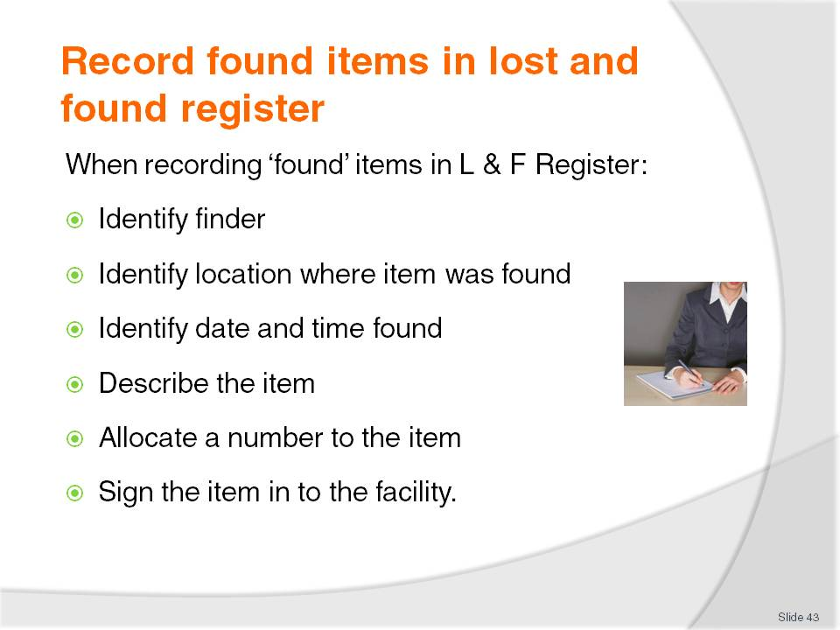
Slide No | Trainer Notes
Trainer advises trainees that when recording found items in the Lost and Found Register they should:
Identify the finder:
- Guests do not have to give their name if they find an item – it is optional, not mandatory
- Obtaining full name of finder is the preferred option
- No need to obtain date of birth
- Capture a contact number
Identify where found. It should be standard to:
- Identify the place the item was found, such as:
- Room 342
- Grand Dining Room
- Outside
- Identify the location in the place, such as:
- On the double bed
- Under Table 5 near the flower display
- Near the kiosk by the swimming pool
- Identify date and time found:
- Date – the item was found
- Day of the week – to confirm the date
- Time – using the 24-hour clock (see later slide), or AM/PM designation
- Describe the item – in detail (see next slide)
- Allocate an identifying number. This number will be:
- Entered under the appropriate heading/column in the register such as Item Number or Serial Number
- Be the same number appearing on the Lost and Found Slip/Lost and Found Tag attached to the item when it is placed into storage
- Sign the Register to indicate:
- The name of the person processing the found item so others know who to speak to if they have a query
- The details written in the Register and true and correct. The need for a signature increases accountability
- The item has been received and is now the responsibility of the property in relation to bailment and duty of care obligations.
Class Activity – Guest Speaker
Trainer arranges for a suitable experienced staff member from a local venue to attend and:
Talk to trainees about the process of accepting and recording a found item in the Lost and Found facility
Demonstrate how to record several ‘found’ items into a Lost and Found Register.

Slide
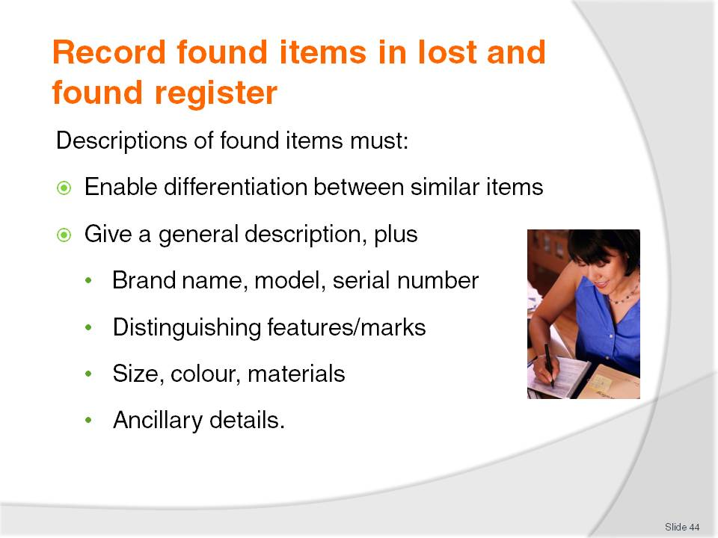
Slide No | Trainer Notes
Trainer advises trainees the description of found items need to be entered into the Lost and Found Register and on to the Lost and Found Tag (which is attached to the item when it is placed into storage).
Trainer stresses the description must be sufficiently detailed and enable differentiation between similar items. Descriptions may include, but are obviously not limited to:
General description of item such as 'gent's watch', 'briefcase', bottle of scotch
Brand name, model name/style, and serial number where possible
Distinguishing features/marks – cuts, scratches, dents, sticky tape, ribbon on suitcase handles or anything else to distinguish it from other similar items
Size, colour, shape, material out of which it is made. It is possible not all of these may apply in all cases but it can be useful to record the case is 'brown leather', the drinking glasses are 'stemmed crystal', or the painting is a 'framed rectangular' one. For example, for a bottle of spirits details would include type of spirit, brand, bottle size, whether bottle was opened or how full it was
Other information may include, as appropriate:
- It was found, for example, in a Sony bag shopping bag
- The item was still in its original packaging
- It was found in an old cardboard box.
Class Activity – Exercise in Pairs
Trainer:
Obtains or produces ‘Found item’ pages from a Lost and Found Register
A variety of ‘found’ items.
Trainer divides class into pairs and gives each pair two ‘Found item’ pages and two ‘found’ items.
One trainee plays the role of a guest/staff member who found the ‘found item’ and is handing it in. The other trainee plays the role of a staff member entering the found item into the Lost and Found Register
Roles are then exchanged so both trainees have an opportunity to record an item in the Register
Trainer reviews each entry providing feedback on the accuracy or appropriateness of each entry.

Slide
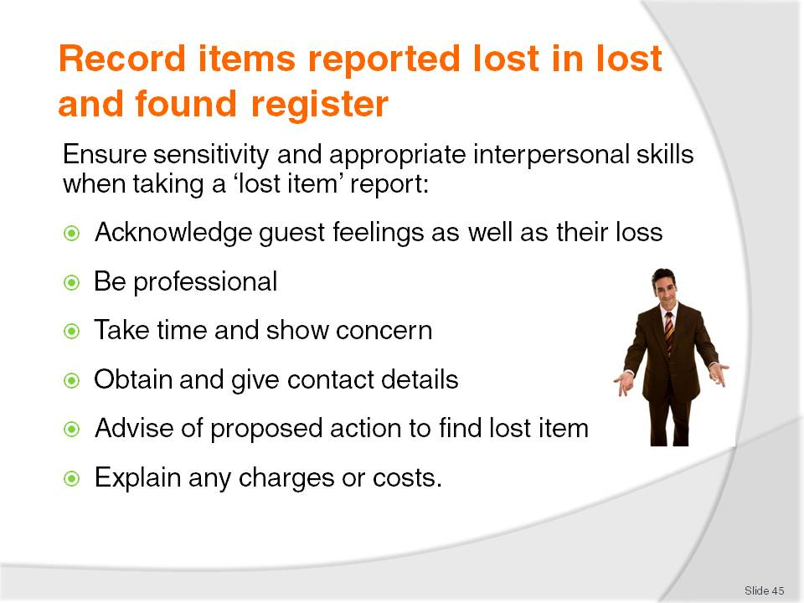
Slide No | Trainer Notes
Trainer mentions to trainees that when a guest/customer reports they have lost an item, the details of this loss must be recorded in much the same way as details of a ‘found’ item are recorded.
Trainer highlights to trainees the loss of an item is a very emotional time for a guest/customer and it is vital to apply appropriate and sensitive interpersonal skills which includes:
Acknowledging not only their loss but the way they are feeling about their loss and the inconvenience and/or distress and anxiety the loss is causing
Being professional when recording details of the lost item. This involves showing interest, asking questions to assist in identifying the item and perhaps in locating the item. It includes not rushing the customer and their report
Taking time and showing concern. It is important the customer/guest feels the property will take action to find their item and return it.
Obtaining their contact details to enable return of the item when and if found
Giving venue contact details. This may be a business card from the property with staff name and numbers on it
Advising them about action intended to recover their lost property such as searching their room, speaking to all staff on that floor, viewing the security tape for the area, checking the Lost and Found register/storage area
Explaining any charges and costs that may apply to forwarding the item to them as and when the item is found.

Slide
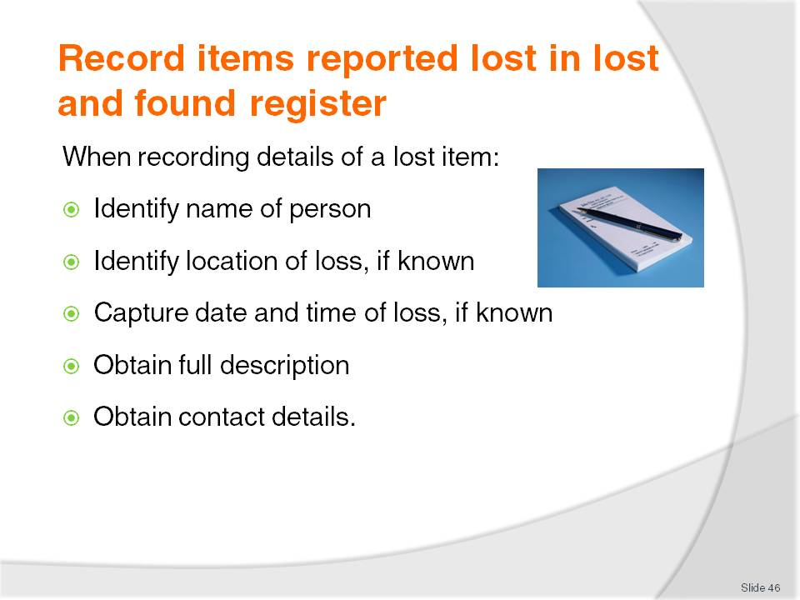
Slide No | Trainer Notes
Trainer identifies to trainees the keys to recording reports of lost items are:
Identify person who has lost the item:
- This may be a relative, friend or associate of the person especially where the item belongs to a departed guest
- No need for date of birth
Determine where the person:
- Knew they lost the item
- Thought they may have lost the item
- Last knew they had the item
- The more information, the better. Many ‘lost’ items have simply been forgotten
Capture date and time of loss, if known:
- Greater the time between loss and reporting the loss, the less chance of recovery of the item
- Be as specific as possible but be prepared for an ‘I don’t know’ answer
Obtain a full description of the item:
- Covering details already identified as being necessary when recording a ‘found’ item
- Obtain value of the item
- Be prepared for the person who lost the item not to know details about the item they have lost even if they are basic details
- Be prepared for the person to change details when making the report about the item, when it was lost, where it was lost, value
- Obtain contact details to facilitate return of the item if and when found:
- Cell phone number
- Work telephone number
- Home telephone number
- Email address
- Fax number
- Street address of home/business
- Post office box address.
Class Activity – Exercise in Pairs
Trainer:
Obtains or produces ‘Lost item’ pages from a Lost and Found Register
A variety of items to serve as the basis for making a lost report.
Trainer divides class into pairs and gives each pair two ‘Lost item’ pages and two ‘lost’ items.
One trainee plays the role of a guest who has lost an item and is making a report about it. The other trainee plays the role of a staff member entering details of the loss into the Lost and Found Register
Roles are then exchanged so both trainees have an opportunity to record a lost item in the Register
Trainer reviews each entry providing feedback on the accuracy or appropriateness of each entry.

Slide
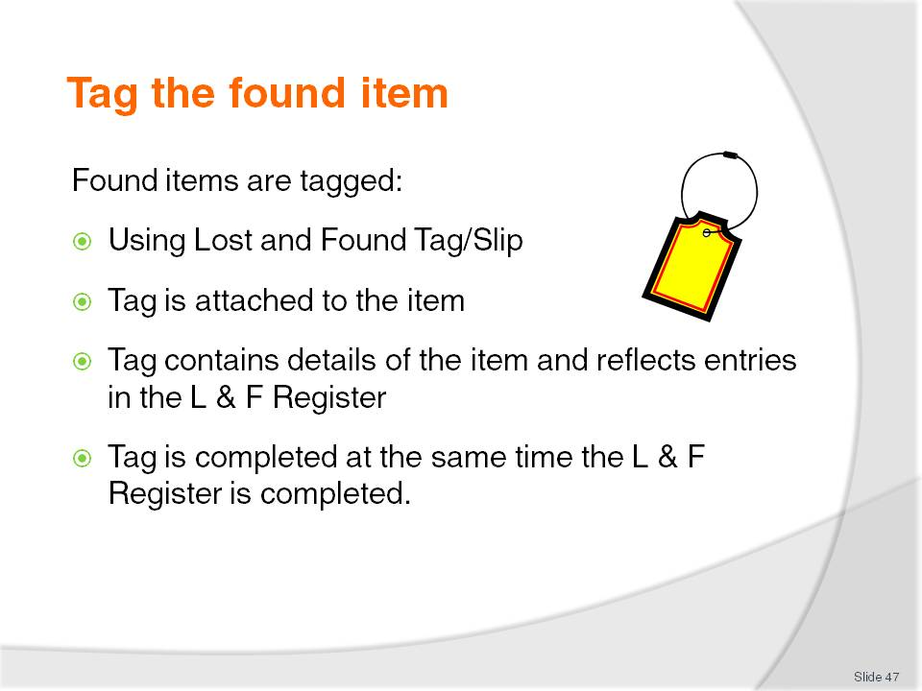
Slide No | Trainer Notes
Trainer states to trainees that once a found item has been recorded in the Lost and Found register, the item will be tagged using a Lost and Found Tag/Slip explaining:
A purpose-designed Lost and Found Tag/Slip is used. One tag is used per item. Each tag will have an individual item number as stated in the Register
Tag is attached to the item using, for example, adhesive tape, string, elastic band as appropriate for the nature of the item. Care must be taken to ensure attaching the tag does not cause damage to the item
Tag details must reflect details for the item as entered in to the Lost and Found Register to enable correct identification of each item and avoid situations where the wrong item is retrieved from storage and presented or returned to a claimant
Tag is filled in at the same time or just after the Lost and Found Register is completed and before the item is physically taken to or stored in the Lost and Found facility.
Class Activity – Individual Exercise
Trainer provides each trainee with a Lost and Found Tag/Slip (see Trainee Manual) and an ‘item’ and:
Discusses the sections on the Tag/Slip that need to be completed giving sample details that could be included
Asks trainees to complete a Tag for the item they have been given.

Slide
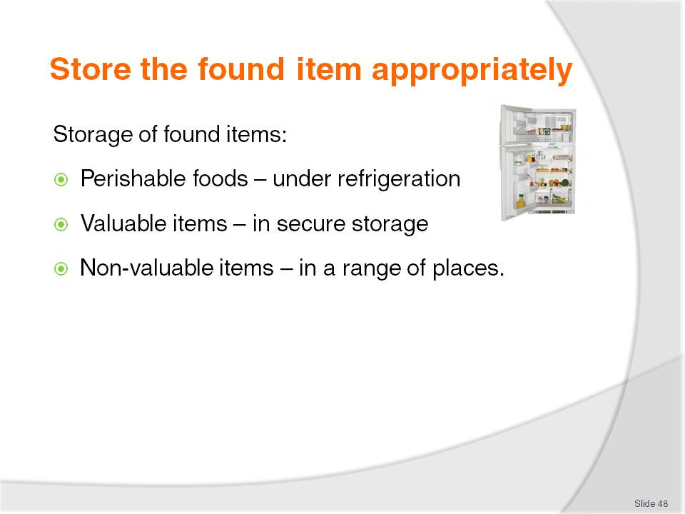
Slide No | Trainer Notes
Trainer explains to trainees that following tagging of found items, items must be stored highlighting:
Perishable foods are held under refrigeration for 24 – 48 hours according to the item and/or house policy
Valuable items are stored in secure storage to protect against theft/loss. Options can include:
- In a locked room – designated shelves in a room/cupboard may be allocated to ‘lost property’
- In a locked drawer or cupboard – designated cabinets, cupboards or drawers may be allocated specifically for the storage of found items
- In a safe
Non-valuable items are stored in a range of places:
- Same place as for valuable items
- General-purpose cupboards
- Shelves used for other stock or other purposes
- On the floor in store rooms and offices.

Slide
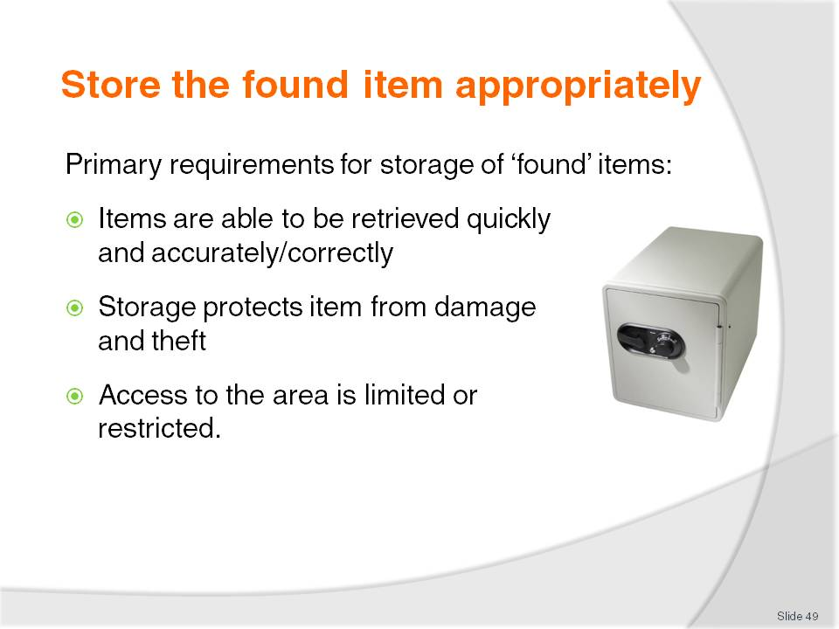
Slide No | Trainer Notes
Trainer explains to trainees there is no legal requirements regarding the type or nature of storage facilities for found items but regardless of what method or facilities are used to store found items the primary requirements are:
They can be recovered accurately and quickly when a query or claim is made
They are stored safely to protect them from damage and theft
There is limited access to the area or items from staff and customers/guests.

Slide
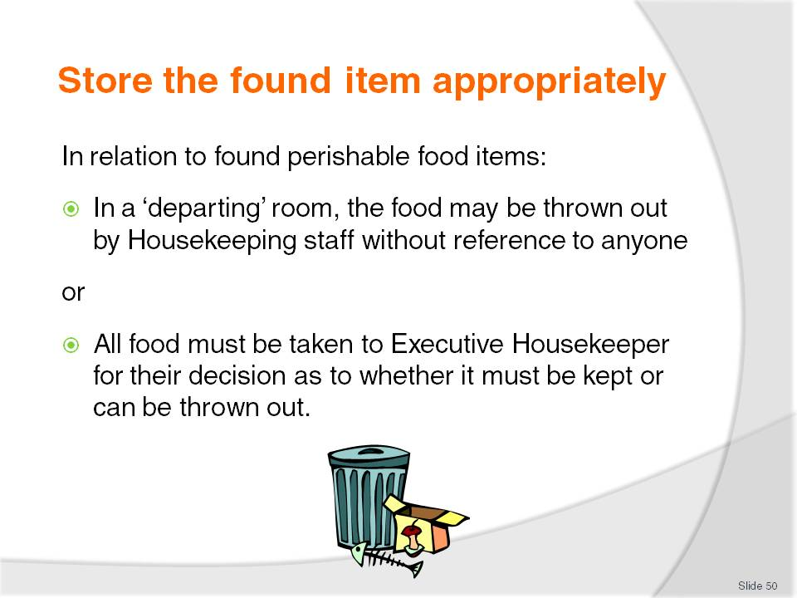
Slide No | Trainer Notes
Trainer presents points for trainees to note regarding dealing with various ‘found’ items:
Perishable food items. There are two options commonly available:
- The first option is staff and this is usually housekeeping staff/Room Attendants have discretionary powers to deal with any perishable food they find. This food may include leftover takeaway foods, a few biscuits in an open packet, or a couple of slices of cheese, a tomato and some slices of bread. Using their discretion, staff may elect – if the room is a departing room – to throw out such items. Naturally the food would be left there is the room was a 'stay' room
- The second option is the Standard Operating Procedure requiring all staff to take all found perishable food to the Executive Housekeeper's Office, and to allow them to make the decision.

Slide
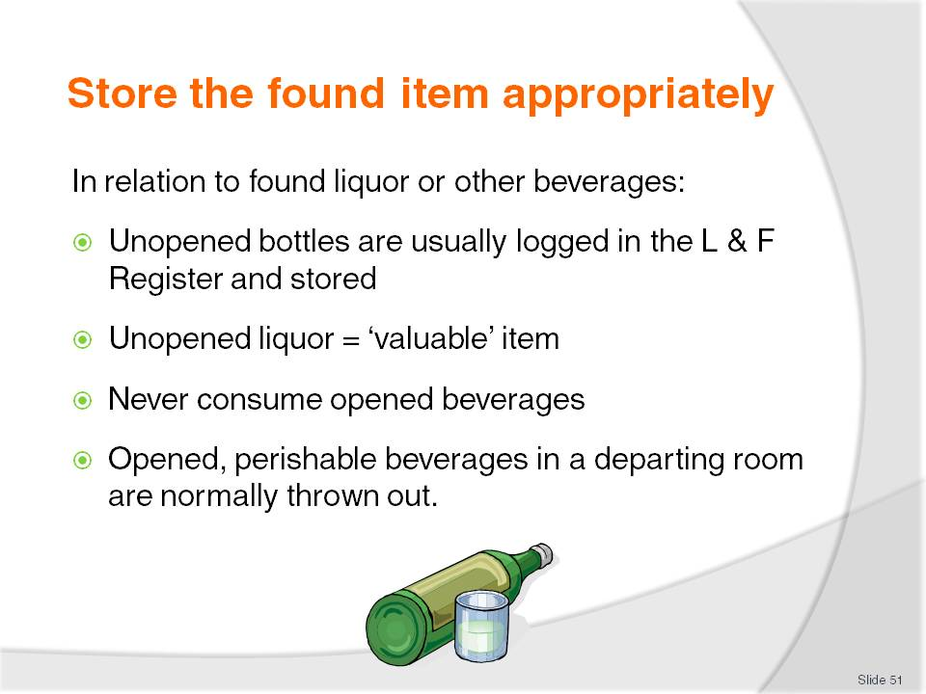
Slide No | Trainer Notes
Trainer continues to present points for trainees to note regarding dealing with various ‘found’ items:
Liquor/beverages:
- Unopened containers (bottles, cans) are logged in the Lost and Found Register
- Unopened liquor is treated as a ‘valuable’ item. That is, it is not subject to the 24/48 hour holding time
- Opened beverages must never be consumed as the contents may contain contaminants
- Unopened liquor may be stored in a liquor area. Opened liquor is commonly stored in ‘normal’ Lost and Found location
- Where Housekeeping staff find an opened perishable beverage in a departing room, standard practice is for them to be allowed to throw the item out as opposed to treating it as a ‘found’ item.

Slide
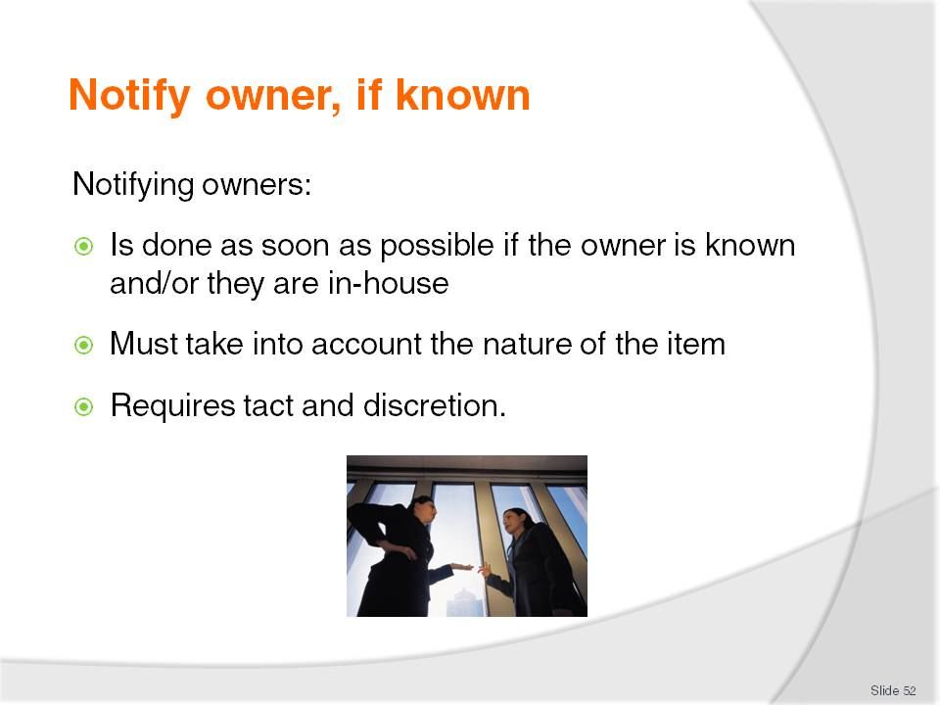
Slide No | Trainer Notes
Trainer advises trainees the intention of having a Lost and Found facility is to re-unite property with legitimate owners so when an item is found most properties will:
Contact an owner immediately and forward found ‘valuable’ items to them (or make arrangements for return) if the venue/staff know who they are and/or if the person is staying in the house
Always take into account the nature of the found item. For example, the venue will notify the known loser of the item if the item is a passport, wallet, camera, cell phone or similar (a valuable item) but would not make contact with the guest if the item was, say, an item of lingerie or an item of a ‘sensitive’ nature
Use tact and discretion to avoid causing embarrassment or problems for the guest/person whose item it is.

Slide
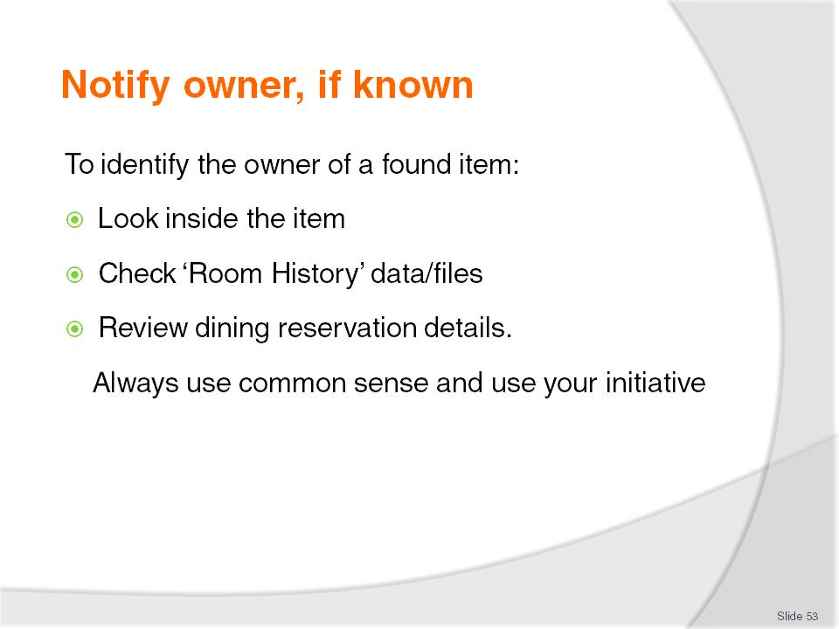
Slide No | Trainer Notes
Trainer suggests to trainees that identifying the owner of a found item will often depend on where the item was found and the type of item, presenting:
Looking inside the item (bag, passport, wallet, suitcase or similar) will often identify the person to whom the item belongs. Sometimes a name is on the outside of items
Checking internal Room History details for items found in a departed guest room, or found in a check-in room by a new guest. This will give an address and/or contact number
Reviewing the Reservation details for a dining outlet when an item has been found in a dining room to determine if a contact number for the party at the table where the item was found was obtained when the booking was made.

Slide
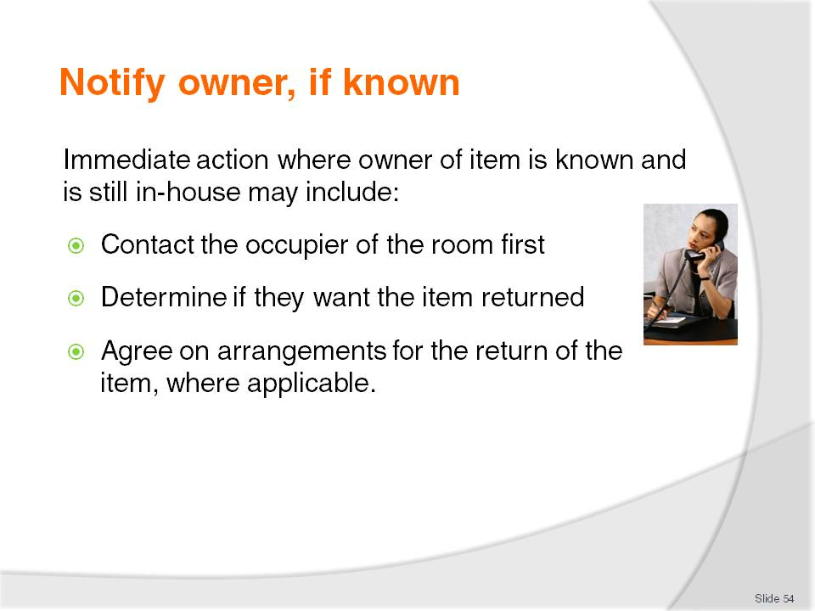
Slide No | Trainer Notes
Trainer explains to trainees that immediate action when an item has been found and the owner is known will depend on the item and establishment policies and may entail:
Where owner is still in-house
Contact the occupier of the room first by internal telephone or internal/in-room messaging system where the guest is still resident in the property
Determine if they want the item returned. Ask the guest what they would like done with the item
Agree on arrangements for the return of the item, where applicable. This may include them coming to reception to collect the item, or a porter taking it to their room.

Slide
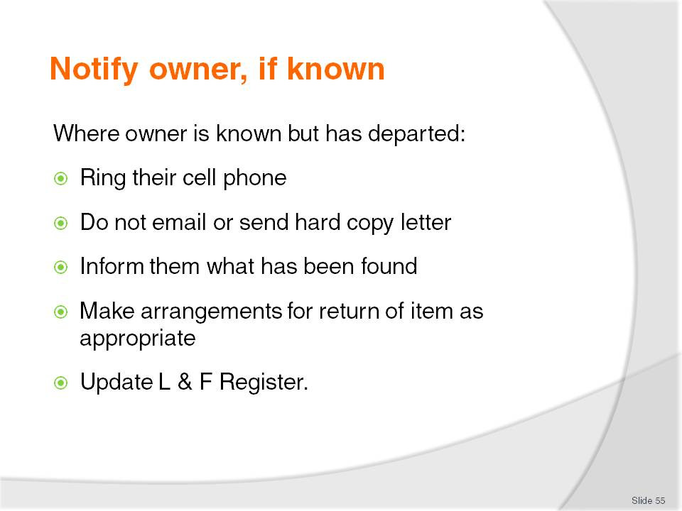
Slide No | Trainer Notes
Trainer explains to trainees that where the owner of an item is known but is not in-house (for example, they have checked out) the protocols include:
Ring their cell phone – not their home phone or business number
Never send an email or other hard copy correspondence: this may fall into the wrong hands and cause difficulties or embarrassment
Advise of the item found and the belief it is theirs and determine if the item can be thrown out or if they want it returned
Make arrangements for return of the item if required. This may involve guest coming in to collect it, or require the venue sending it to the owner, subject to agreement by the guest to pay delivery/return charges. Commonly only the actual costs incurred in remitting the item are recovered from the guest
Options for returning items will depend on size of the item, value and instructions from the guest:
- Physically taking the item to the guest in their room or wherever in the venue they happen to be at the time
- Sending the item through the mail
- Using a courier to deliver the item
- Arrangements for the owner (or a nominated person) to collect the item
The Lost and Found Register is updated to reflect any action taken regarding contact with the owner of the item. Their instructions regarding the items and action taken to return or dispose of the item and receipts appropriate to forwarding the item may be attached to the Lost and Found Register (or a designated file).
Slide
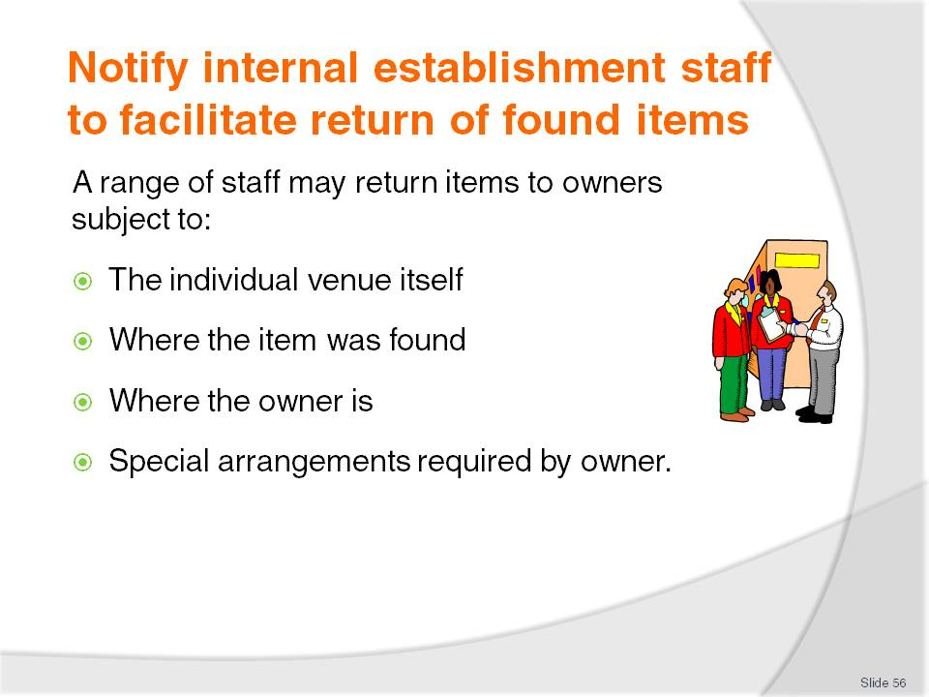
Slide No | Trainer Notes
Trainer informs trainees that the job of physically returning a found item to a guest can be the responsibility of a variety of workers. Staff responsible for returning found items to guests/customers will depend on:
The individual venue itself:
- The type of establishment where the item was found
- The size of the operation
- The structure of the business and the different roles within it
Where the item was found. If the owner can be identified and notified quickly, the finder may be responsible for the immediate return of the item
Where the owner is, that is:
- Whether the item is to be returned to a guest/customer who is on the premises and, for example, simply needs to be taken to a room
- Whether the item needs to be forwarded locally, nationally or internationally and requires payment of money, insurance, packing and arrangements for pick-up
Special arrangements or requests made by the owner – for example, insisting the item is air-freighted to them.

Slide
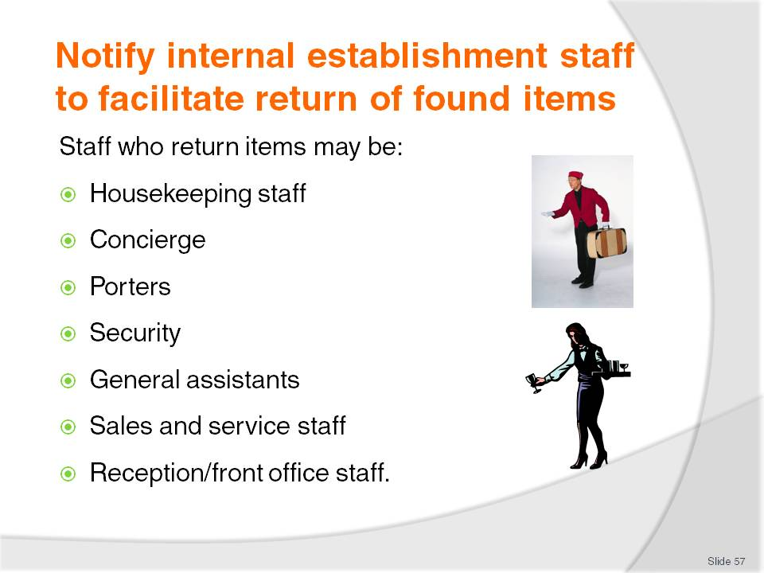
Slide No | Trainer Notes
Staff with this responsibility can therefore range from management/owner-level through to basic operational staff, and include:
Housekeeping staff – Floor Supervisors are commonly involved in this task
Concierge – the ‘Information Desk’ at the venue must always be notified about items that have been found in a hotel as many guests make this desk their first pointy of contact or enquiry
Porters
Security staff
General assistants
Sales and service staff
Reception or front office staff.

Slide
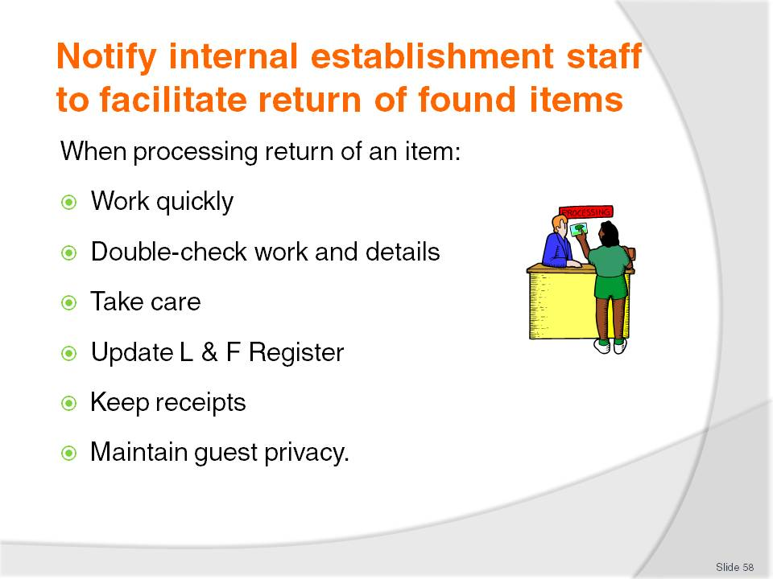
Slide No | Trainer Notes
Trainer explains to trainees that when processing the return of a found item to a guest/customer it is vital to:
Work quickly. Once the guest/customer has been advised their item has been found they will be expecting prompt service to return it
Double-check the correct item is being sent or forwarded. Read the tag/slip, and check this against the Lost and Found Register
Take care. Treat the item with respect and care when packaging it for delivery
Update the Lost and Found Register to reflect what has occurred in relation to return of the item
Keep receipts relating to delivery of the item to support charges levied on the owner, and as proof the item was sent, when it was sent and how it was sent
Ensure the maintenance of guest privacy is maintained in relation to the item itself, their contact details.

Slide
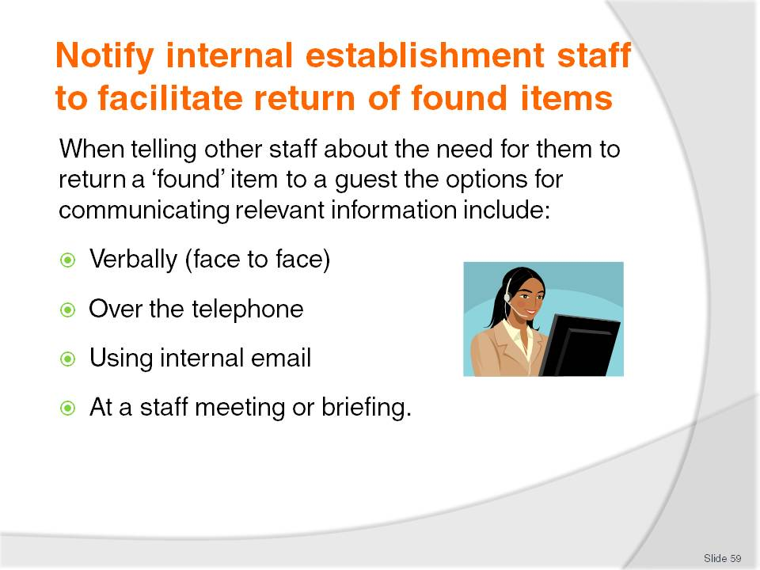
Slide No | Trainer Notes
Trainer tells trainees where another staff member will take responsibility for the return of an item, they can be informed about requirements or arrangements using the following options:
Face to- ace on a one on one basis. This is the best option as it allows checking to ensure the person knows and understands what is required, and allows clarification of issues and requirements
Over the phone – the second best option
Via email – containing all relevant details and directions
Verbally at a staff briefing – supported by relevant hard-copy information (names, addresses).

Slide
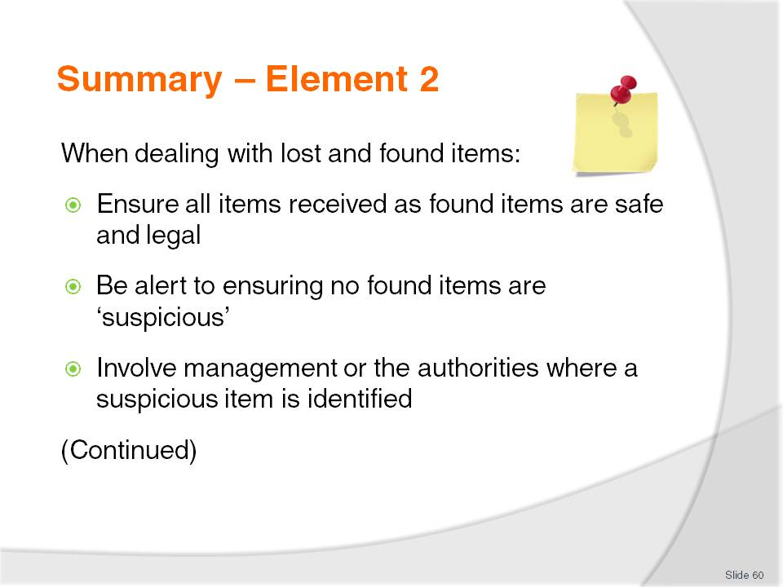
Slide No | Trainer Notes
 | Trainer provides a recap of the Element asking questions to check trainee understanding and responding to questions from trainees, as required.

Slide
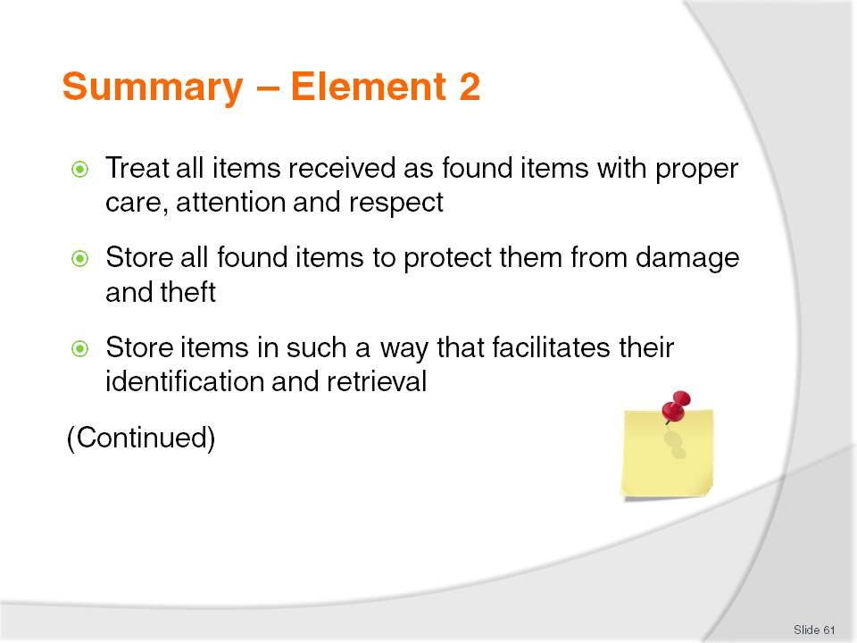
Slide No | Trainer Notes
 | Trainer provides a recap of the Element asking questions to check trainee understanding and responding to questions from trainees, as required.

Slide
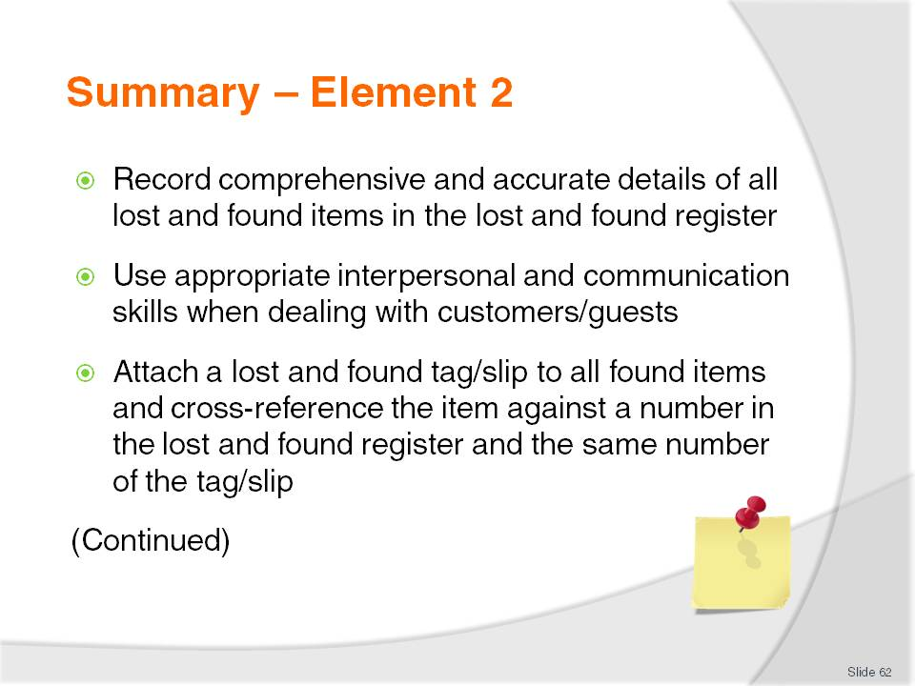
Slide No | Trainer Notes
 | Trainer provides a recap of the Element asking questions to check trainee understanding and responding to questions from trainees, as required.

Slide
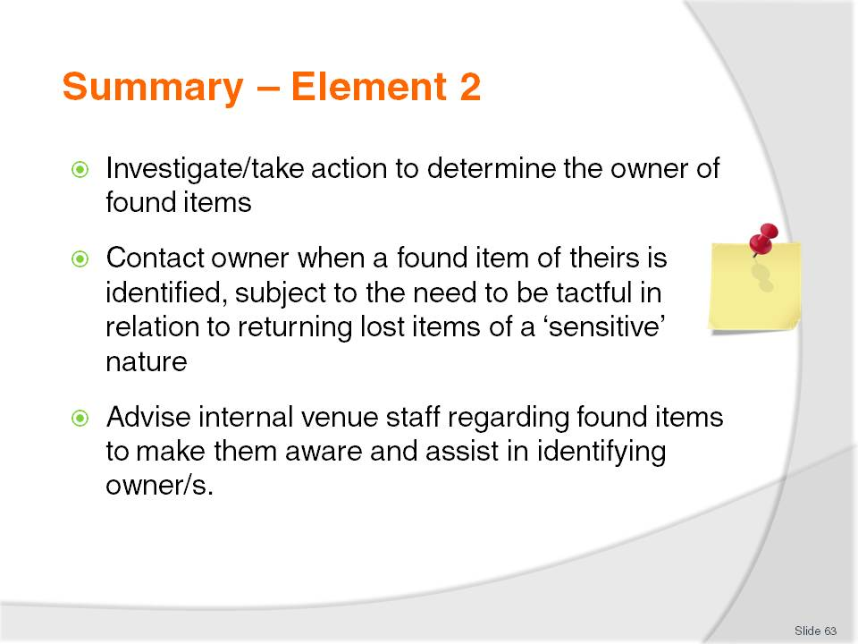
Slide No | Trainer Notes
 | Trainer provides a recap of the Element asking questions to check trainee understanding and responding to questions from trainees, as required.

Slide
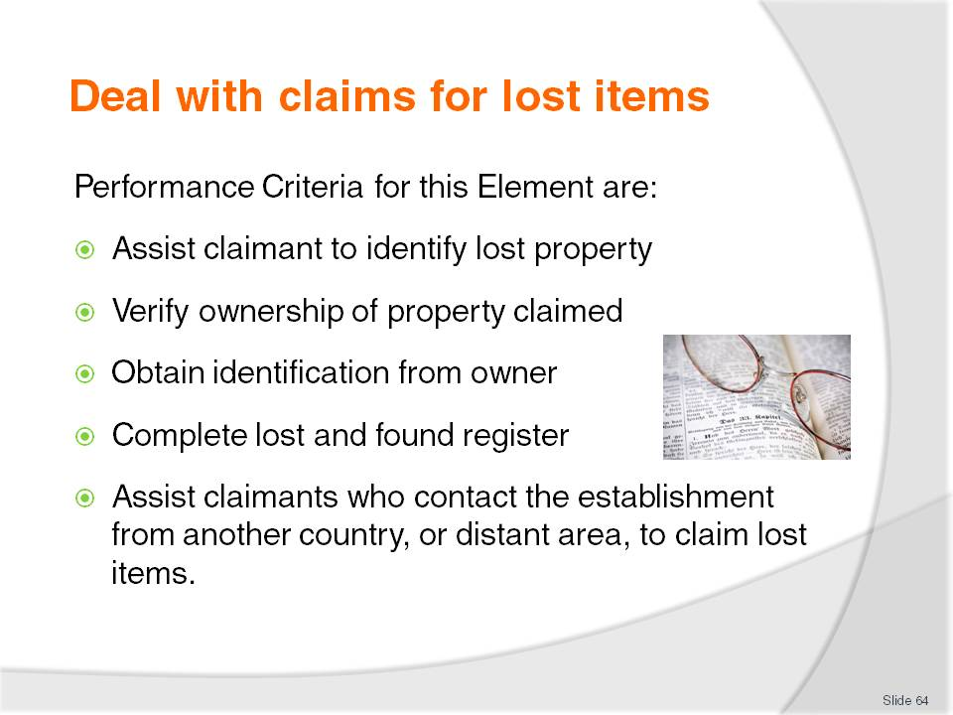
Slide No | Trainer Notes
Trainer identifies for trainees the Performance Criteria for this Element, as listed on the slide.
Class Activity – Discussion
Trainer asks trainees questions regarding their experiences and knowledge about dealing with claims for lost items:
How could a person convince you a lost item is theirs?
What evidence would you accept as proof of ownership of an item handed in as a ‘found’ item?
How might you update the Lost and Found Register to reflect the return of an item to its owner?
What challenges do you think might be involved in returning a lost item that is found to an international guest?
What charges do you think might be involved in returning an item to an international guest?

Slide
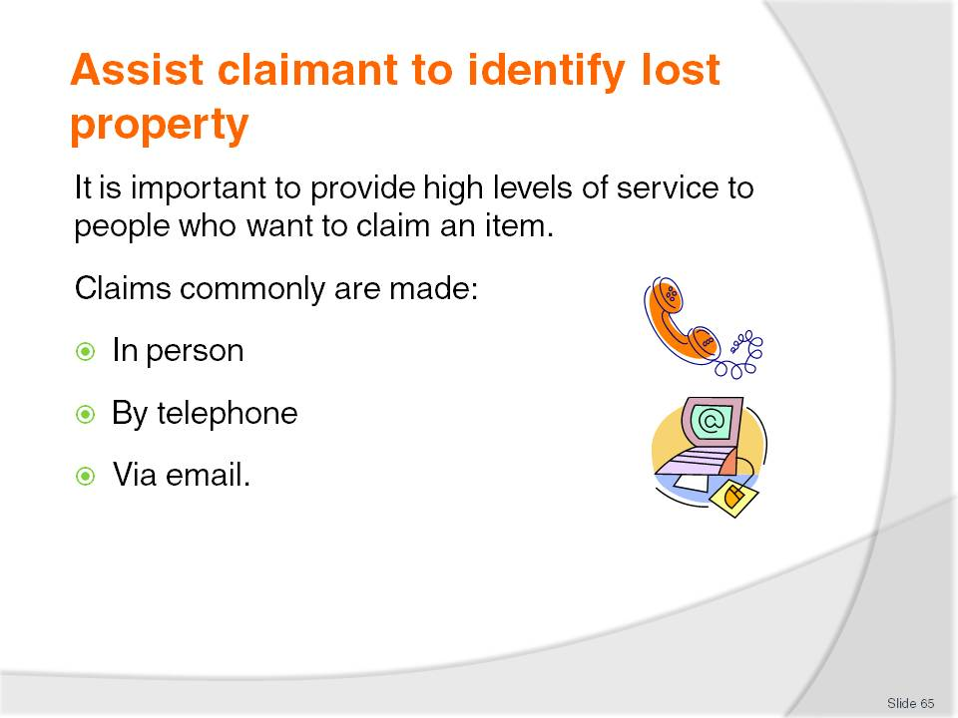
Slide No | Trainer Notes
Trainer introduces this section by stating that when a person makes a claim for a found item it is important to provide high levels of service to assist this person. People who have lost items will commonly contact the venue to determine if the item has been found:
In person – walking into the venue to make an enquiry
By telephone – calling the venue to see if their item has been handed in
Via email – writing to ask if a nominated item has been found.

Slide
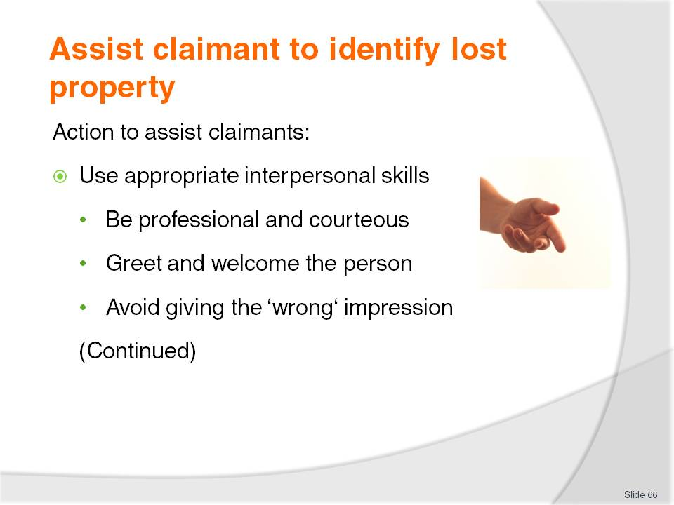
Slide No | Trainer Notes
The basic requirements when a person arrives in person to claim an item they have lost and which has been found are:
Use appropriate interpersonal skills:
- Deliver lost and found services with the same care, courtesy and professionalism as all other services delivered by the venue
- Greet and welcome the person the same as a paying customer/guest
- Never:
- Give the person the impression providing lost and found services is a chore or an interruption to other workplace activities
- Give the person the impression they are being done a favour by helping them get back their lost property
- Treat the person as if they were trying to do something illegal. Check they are not attempting to claim something that is not theirs but never adopt the attitude of interrogating/a claimant as if they were a criminal.

Slide
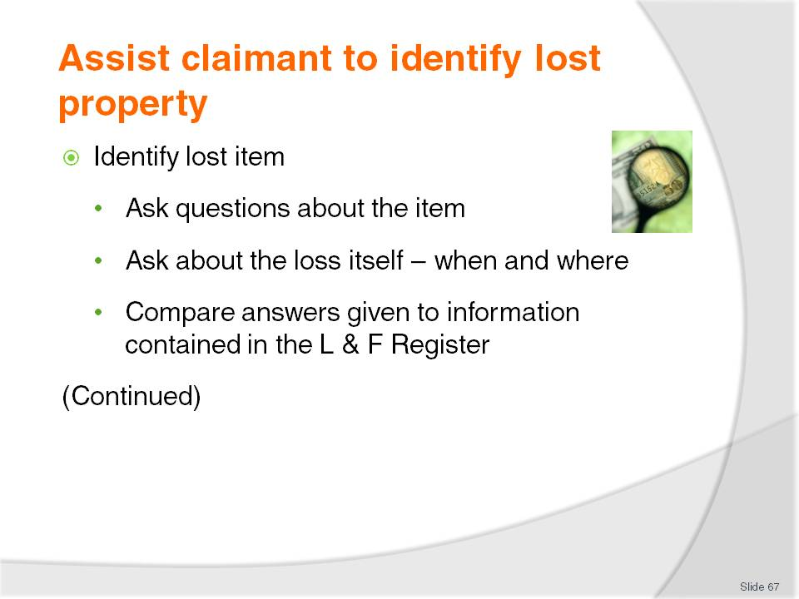
Slide No | Trainer Notes
Trainer continues to advise trainees regarding action to take when assisting a claimant:
Identify lost item:
- This is the first step when determining whether or not the person has a legitimate claim on the item they are seeking to obtain. Ask the person to answer some basic questions to identify the item they are seeking to claim:
- What is the item? Ask them to provide a brief yet detailed description of the item. If the item is a bag, suitcase or similar, also ask them to describe the contents
- Where was the item lost? Ask them to explain where they lost the item or where they believe they last had possession of the article
- When did they list the item or become aware they had lost the item? Ask them for the day, date, and time
- What is the value of the item? Ask them how much the item is worth. This is only a legitimate question when the value of the item was recorded when the item was reported as lost
- Who are they? Ask them their name and for proof of identity (see later slides for more detail)
Compare answers given by the claimant to the information contained in the Lost and Found Register to identify the item (see next slide) and determine if their answers are correct, and/or to determine if the person making the claim is attempting to make a false claim.
Slide
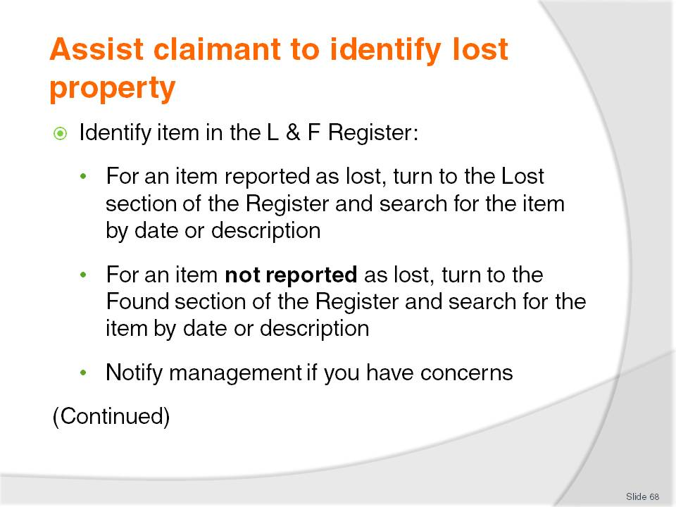
Slide No | Trainer Notes
Trainer continues to advise trainees regarding action to take when assisting a claimant:
Identify item in the Register:
When the person has provided a description of the item, attempt to locate the item in the Lost and Found Register.
Identifying and returning a reported Lost item
Where the claimant is seeking to claim an item reported as lost:
- Turn to the Lost items section of the Lost and Found Register to identify if a report was made about the item
- Does the information provided by the claimant align with what is recorded?
- If the information provided matches what is in the Register, proceed to process the claim
- Where answers are different to the information contained in the Lost and Found Register, involve management and advise them of concerns.
Identifying and returning a Found item
Where the claimant is seeking to claim an item not reported as lost:
- Turn to the Found items section of the Lost and Found Register and look for an item matching the details provided by the person
- Again, if the information provided matches what is in the Register, proceed. If not, involve management/Supervisor.
Slide
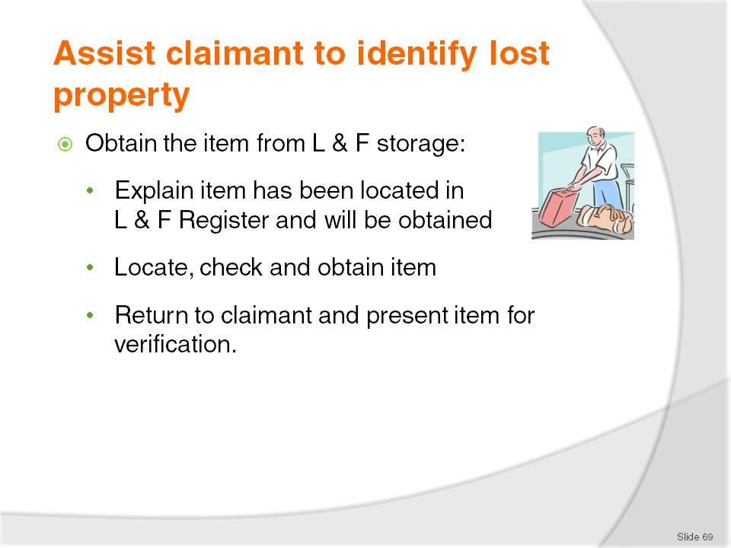
Slide No | Trainer Notes
Trainer continues to advise trainees regarding action to take when assisting a claimant:
Obtain the item:
- Using the information in the Register and the sequential number listed against the item:
- Explain to the claimant that the item has been located in the Register and it will be retrieved for them
- Excuse self and go to the Lost and Found storage
- Locate the items using the number of the item as listed in the Register to find the Lost and Found Tag/Slip
- Verify the item actually matches the item described
- Return to the claimant and:
      - Allow the claimant to view the item
      - Ask the claimant to verify it is theirs – or not
      - Ask the claimant to describe the contents – where applicable
Most claimants are honest about claiming an item. If an item presented to them is not theirs they will in the vast majority of cases state it is not the correct item but trainees should be alert to visual cues indicating the item presented to claimants is not theirs.

Slide
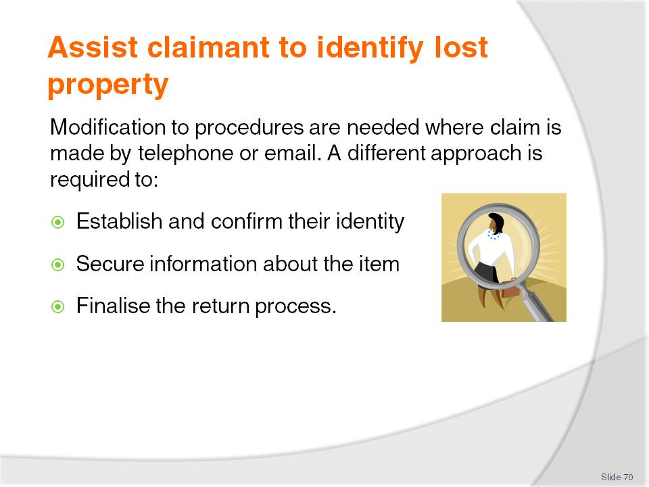
Slide No | Trainer Notes
Trainer advises trainees the procedures as presented will need to be modified where the person telephones the venue or sends an email. For example, when a person telephones the venue or sends an email regarding a lost item they may deal with them over the telephone/email to:
Establish and confirm their identity and address/contact details
Secure information regarding the description and value of an item, when and where it was lost and whether or not it was reported as lost/stolen
Arrange for them to call in to the venue to view the item (if the item has been found) and complete the claim process
Arrange for another person to identify and collect the item on their behalf
Determine the method of return of the item to the person who may live a long way away or in an overseas country.

Slide
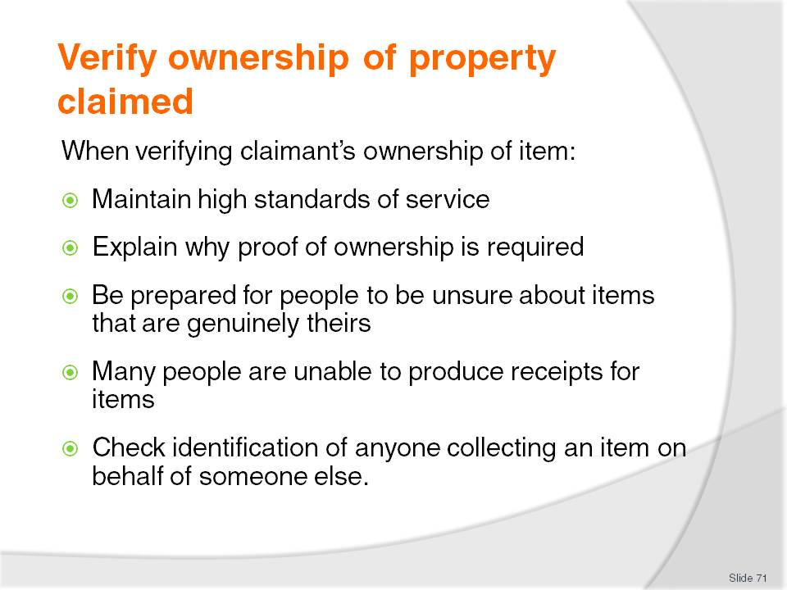
Slide No | Trainer Notes
Trainer explains to trainees that once the claimant has stated the item they have been shown is theirs, the next step is to verify the claimant is the genuine owner of the property.
Trainer suggests to trainees when verifying ownership of an item it can be useful to bear in mind:
Keep up the excellent standards of service levels. Maintain positive and appropriate interpersonal skills. Be nice to people – ask them questions as opposed to interrogating them
Explain action taken. Explain it is company policy to have to ask questions to determine ownership so the item can only be claimed by its true owner. Make them aware this is for their benefit
Not everyone will have 100% recall. People often forget aspects about their own items even though they see these items every day. Not being able to describe an important or obvious detail does not necessarily mean the person is not the rightful owner
Most people are unable to provide undeniable proof of ownership. Most people will not have, for example, a receipt for the item or some other legal document showing they have title for the item. This means using other means to determine whether or not they are the owner
Many found items are claimed on behalf of the owner by a person authorised to do so by the legitimate owner. This means a need to verify their identification.
Slide
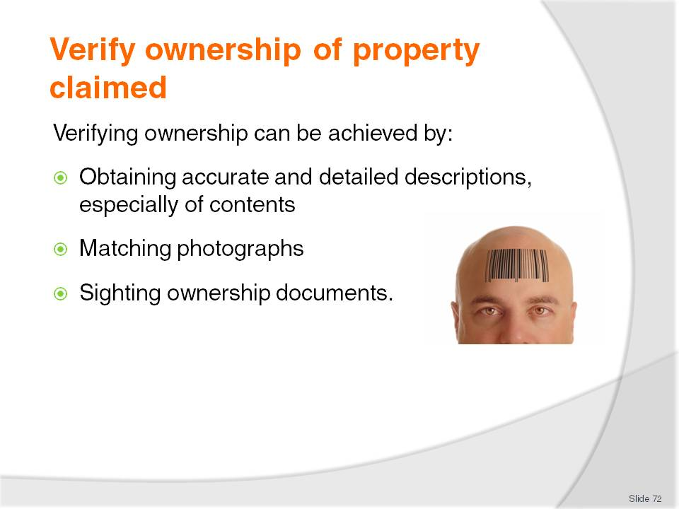
Slide No | Trainer Notes
Trainer recommends to trainees methods to verify legitimate ownership of property claimed can include:
Obtaining an accurate description of the item:
- This can be done by asking questions such as:
- ‘How much money is in the wallet?’
- ‘What make is the watch?’
- ‘What brand or make is the computer?’
It can also be achieved by the owner:
- Providing extra information such as ‘There is a scratch on the inside of the case, about six cms long, near the top of the case’, or ‘There is a red ink stain inside the front cover’
- Showing a photograph of them with the item
Matching photographs:
- Where the item being claimed contains photographic evidence of the claimant, this should be used as a way of determining the legitimacy of the claimant. For example:
- Check wallets and bags for photographic identification of the owner
- Where the item contains a passport or photo ID driver’s licence (or similar), use these as a means of proving the identity of the claimant
- When checking photographs:
- Use common sense. Photographs are not always good portrayals of the individual. The photographs may have been taken some time ago and the person may have changed their look, hair style or hair colour
- Use the same attention to detail as when checking identification for other purposes such as service of alcohol and entry to the premises
Sighting ownership documents:
- It is relatively rare for people to be able to provide ownership documents for items they are claiming but it does sometimes occur (such as when claiming items they have recently purchased duty free, or at a local store/business)
- Sighting or checking ownership documents may mean visually seeing:
- Title for the goods
- Receipts
- A credit/debit card transaction document.

Slide
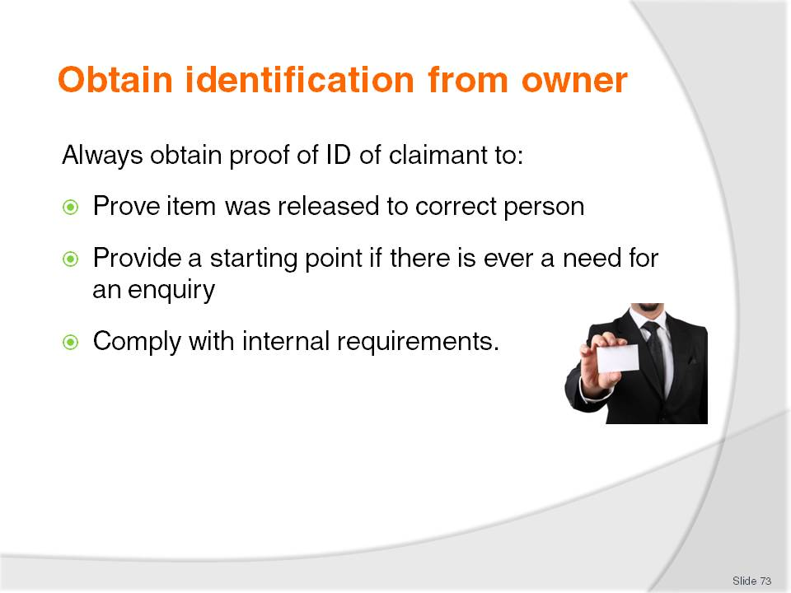
Slide No | Trainer Notes
Trainer explains to trainees that it is also necessary when returning an item to a guest to obtain evidence of who they are so this can be recorded in the Lost and Found Register.
Trainer indicates to trainees they must always obtain proof of who the item is released to:
Prove the item was correctly released to the right person if evidence of this is ever required
Provide a starting point for enquiry if, for example, the item is released to the wrong person and the rightful owner subsequently makes a claim for the item
Comply with internal requirements such as the establishment policies and procedures relating to returning items to owners.

Slide
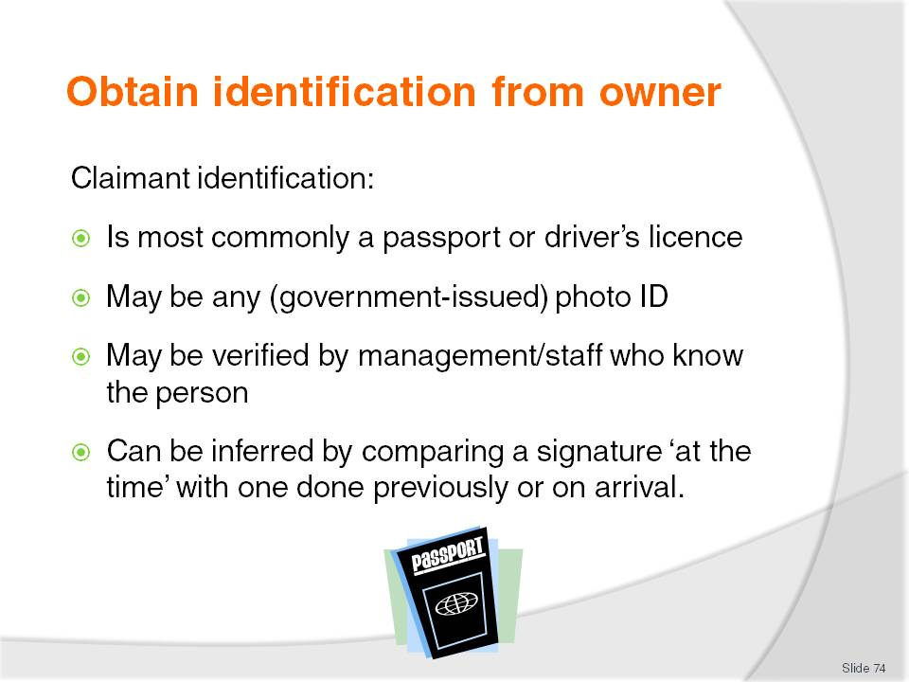
Slide No | Trainer Notes
Trainer tells trainees that where the claimant is the owner of the item the most common identification to obtain from the person is:
Driver’s licence
Passport.
Trainer further advises trainees that, while the majority of people will have at least one form of this identification, not all people will, and if faced with a claimant with no driver’s licence or passport they should:
Ask for some other form of photographic identification – this may be a government issued ID, a workplace-based form or a community-based membership card
Involve other staff/management who know the claimant and who can vouch for who they are
Ask them to sign a form and compare this to the Registration Form they completed on arrival at the venue (where applicable).

Slide
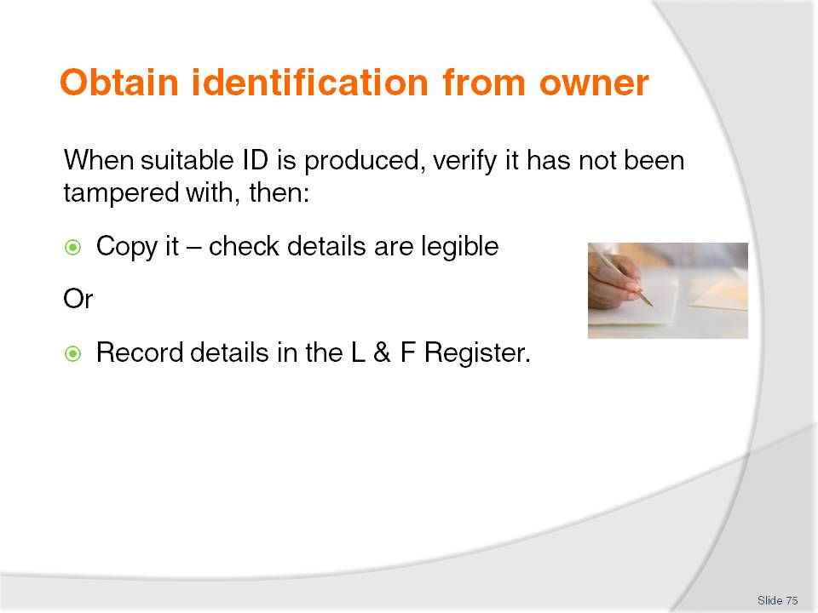
Slide No | Trainer Notes
Trainer states to trainees that when they have been presented with suitable identification from the owner they should:
Check it to ensure it is legitimate and has not been tampered with or has had important aspects altered
Copy it – for filing in the Lost and Found Register/filing system. Check all details are present and legible.
Trainer highlights to trainees it is not acceptable to simply sight suitable identification without capturing proof of it.
Trainer further advises trainees if it is not possible to obtain a photocopy of the identification they should:
Detail the type/nature of the identification – such as (for example) ‘Work ID XYZ organisation’, ‘XYZ Membership card’
Capture relevant ID details such as:
- Name the ID was issued in
- Any address/es for the organisation and/or claimant
- Any applicable dates – ‘Valid till xx/xx/xx’.

Slide
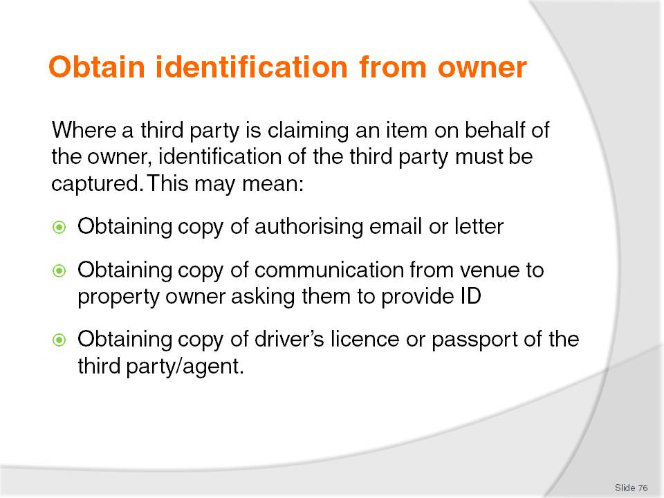
Slide No | Trainer Notes
Trainer indicates to trainees where a third person has been authorised by the owner to act as their agent to make a claim on their behalf, obtaining identification may involve:
Obtaining hard-copy proof (an email, or letter) from the owner authorising the agent/other person to claim the item
Obtaining copy of request from the venue to the owner asking the claimant to furnish identification
Obtaining personal identification of the third-party claimant/agent such as passport or driver’s licence as proof of identity.
Trainer states to trainees the above evidence should also be copied and filed in the Lost and Found Register/filing system in the same way the identification of the actual owner is filed/processed.
Class Activity – Guest Speaker
Trainer arranges for an appropriately experienced venue staff member to attend and talk to trainees about:
Venue policies and procedures for handling face to face claims for lost property
Venue policies and procedures for handling telephone claims for lost property
Venue policies and procedures for handling email claims for lost property
What they deem acceptable evidence of ownership of items
What they deem acceptable proof of identification of claimants
How they process claims where a third party claims an item on behalf of the owner of the item
How they determine whether or not they will return or release an item to a claimant
How they deal with refusing to release or return an item to a claimant.

Slide
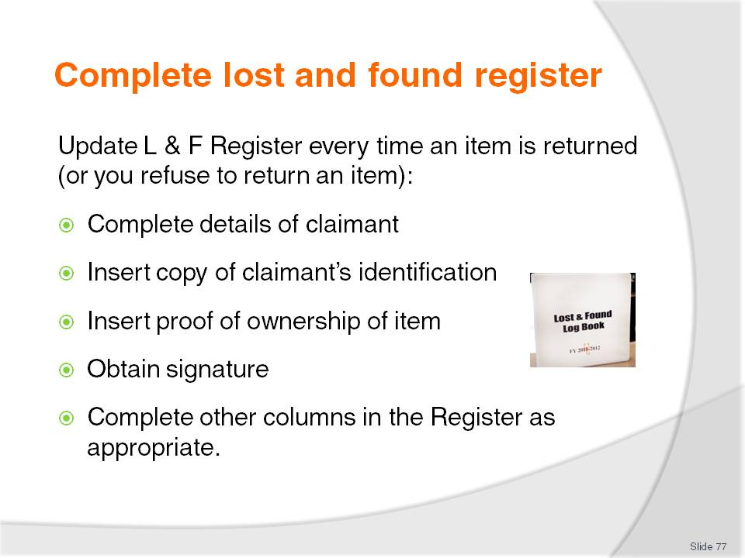
Slide No | Trainer Notes
Trainer emphasizes to trainees that the Lost and Found Register is the central document for lost and found items and must be referred to and updated whenever a claim is made for lost property. It must even be updated where a claim for an item is made, but is refused.
Trainer indicates to trainees when returning an item to a claimant they may need to:
Complete details of claimant – name and contact details
Insert identification of article/s used to identify claimant – passport, driver’s licence including relevant details (number of item, expiry date) or copy of same
Insert identification of article/s used as claimant’s proof of ownership of the item – photograph, receipt
Obtain a signature from the claimant – verifying they have received the item released to them
Fill in other Register columns as appropriate to the particular Register being used and/or the requirements of additional house policies.
Class Activity – Role Play
Trainer plays the role of staff member assisting a guest to claim a lost item.
Trainee plays the role of a guest claiming a lost item.
Trainer briefs the trainee regarding description of the item lost, and the details of the loss, how and when it was lost.
Trainer arranges for a suitable item to be available and tagged as the lost item.
Trainee approaches trainer and makes enquiries about the lost item and trainer leads the trainee/’guest’ through the claim procedure as outlined.
Remaining trainees observe the role play.
A discussion and analysis is held on completion of the role play to evaluate the processes.
Role play may then be repeated with a different item, using two trainees to play role of ‘staff member’ and ‘guest’.

Slide
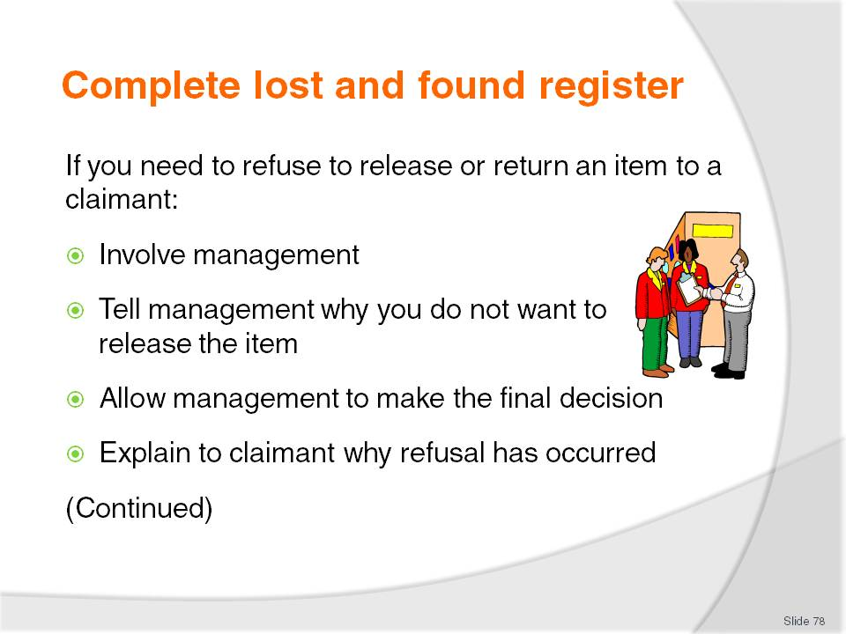
Slide No | Trainer Notes
Trainer suggests to trainees when they determine an item should not be returned to a claimant they should:
Involve management. Involving management demonstrates the seriousness of the situation and allows them to take charge
Explain reasons to management. Highlight the factors indicating why it would be unwise to return the item to the claimant
Allow management to assess the situation. They may decide to give the item to the claimant
Politely explain to the claimant why the refusal is being made highlighting this action is being take to safeguard property of the rightful owner.

Slide
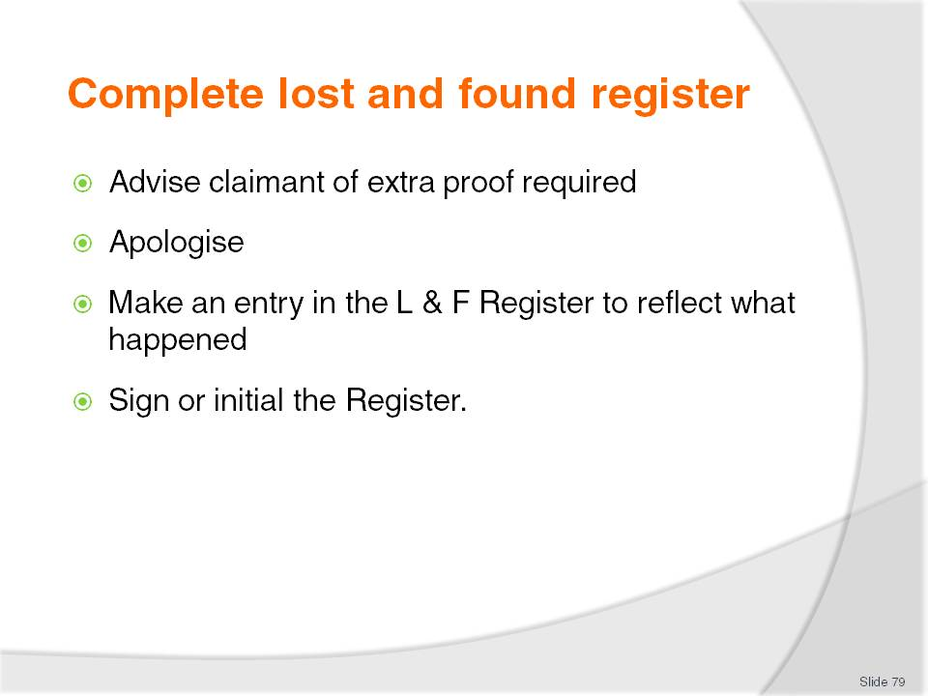
Slide No | Trainer Notes
Trainer continues to provide advice to trainees regarding the refusal of an item to a claimant:
Advise about what extra proof the claimant needs to provide to enable release of the item to them (such as more or better proof of identification and/or ownership)
Apologise for the inconvenience. Be genuine and re-state the refusal is in their best interests to protect their property from being given to the wrong person
Make an entry in the register reflecting what the claimant has been told. A separate piece of paper may need to be added to the Register
Sign or initial the Register and management should also sign/ or initial the Register as proof of their involvement.

Slide
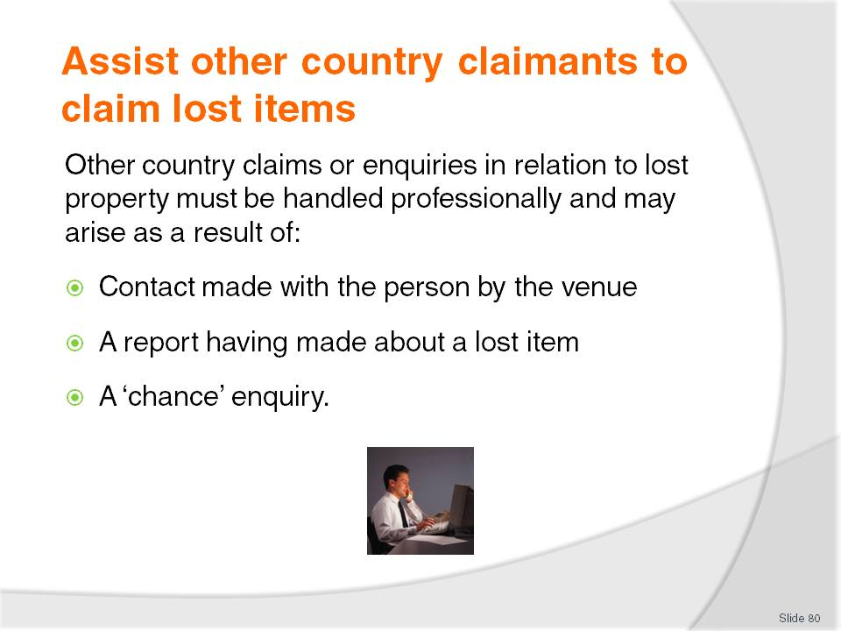
Slide No | Trainer Notes
Trainer informs trainees that where people contact the venue from another country (or a distant location) they are expected to assist them claim lost items emphasising the same care, attention and professionalism must be paid to these claimants as is paid to face to face claimants.
Trainer tells trainees that people from overseas or another country making enquiries about lost property may contact the venue to claim a lost item:
In response to contact made with them by the venue – mentioning a found item
Following up on a report made – when they reported a lost item while they were at the venue
By chance. This is arguably the most common type of contact and occurs when the individual discovers they have lost an item and contacts the venue hoping it has been handed in. In reality, they often really do not know where or when they lost the item.

Slide
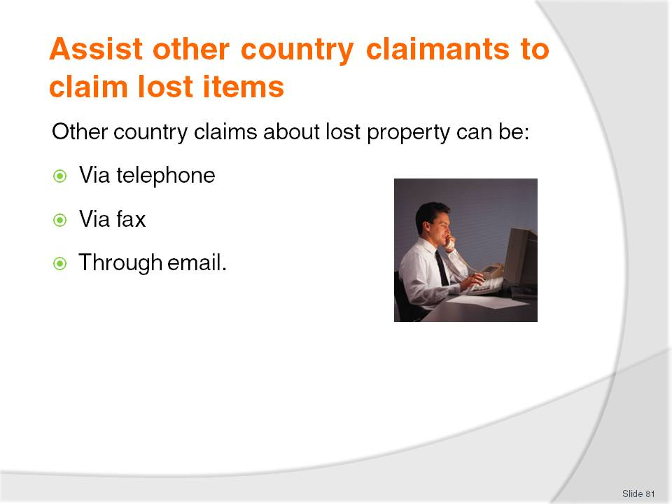
Slide No | Trainer Notes
Trainer advises trainees the methods of communication when dealing with other-country lost property claims can be:
Via telephone. This is the most preferable medium as it is directs and allows for questions with immediate answers, and the use of follow-up questions
Via facsimile/fax. This is a useful medium but one restricted in nature due to its limitations regarding two-way communication. A fax may be the start of a telephone or email exchange
Via email. This is a relatively useful but potentially drawn out option. It can allow photographs to be sent and received. Some properties are web-cam enabled to introduce a face to- ace element but transmission quality can make identification difficult at times.

Slide
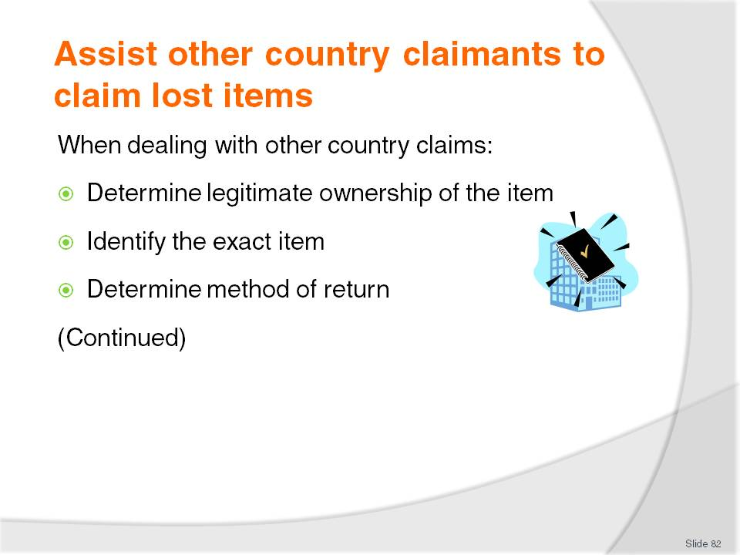
Slide No | Trainer Notes
When talking to a person from another country or a distant area regarding their claim for a lost item, all the checks and verifications mentioned earlier in these notes must be undertaken. The fact they are not dealing with the claimant face to face does not allow them to apply a lesser standard of proof, ownership or identity.
Trainer indicates to trainees the factors to be addressed include:
Determining legitimate ownership of the items claimed. This may be achieved by a combination of:
- Asking the claimant to forward required, acceptable, or identified evidence
- Researching internal documents or records such as Guest History, and/or Rooming List
- Obtaining detailed description of items, when and where they were lost and their value to the best extent possible
Identifying the exact item so as to guard against a similar, but incorrect item, being forwarded
Determining guest’s preferred method of having the item returned. This will often depend on the nature of the item (such as whether it is big/heavy or small/light and taking into account how expensive it is, and the sentimental nature of the article). Options include:
- Mail – with further options relating to insurance, priority delivery, express post
- Courier
- Air
- Other options may exist (for example, return by sea/boat or private vehicle) but these are not commonly used or offered as alternatives.

Slide
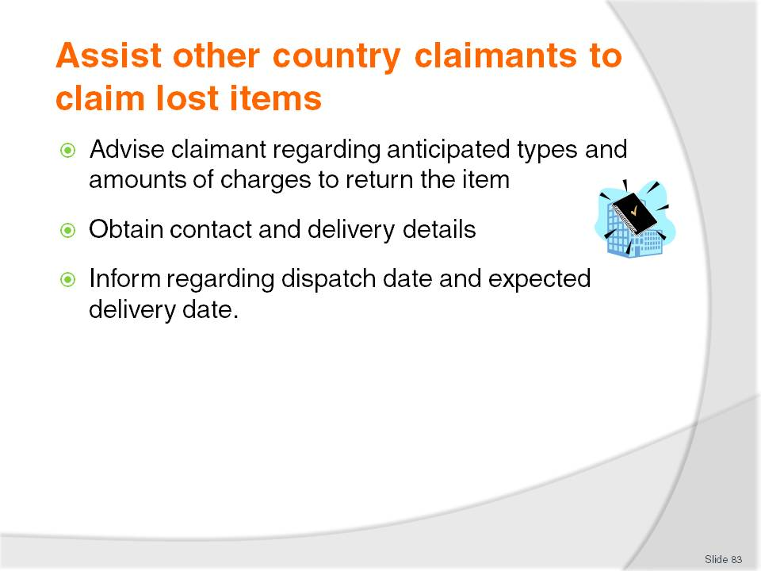
Slide No | Trainer Notes
Trainer continues advising trainees about how to process other country enquiries regarding lost property:
Advising claimant the venue will process the return but will require payment for expenses entailed in return of the item. These expenses are usually limited to direct expenses (packaging, wrapping, insurance, fees and charges) but do not normally include a component for ‘time and trouble’ taken to return the item. Where known the venue will inform the claimant of the estimated cost to return the item but (because no charge is levied for ‘time and trouble’) it is not common practice to obtain quotations for remitting the item and forwarding these quotes to the claimant
Obtaining relevant contact details of the claimant for delivery of the item. A check may be made to ensure these details are the same as the claimant’s details already recorded in the internal Guest History. This is a one way of ensuring items are sent to their rightful owners
Informing claimant regarding date/time the item will be dispatched so claimant can have an idea of when to expect the item.

Slide
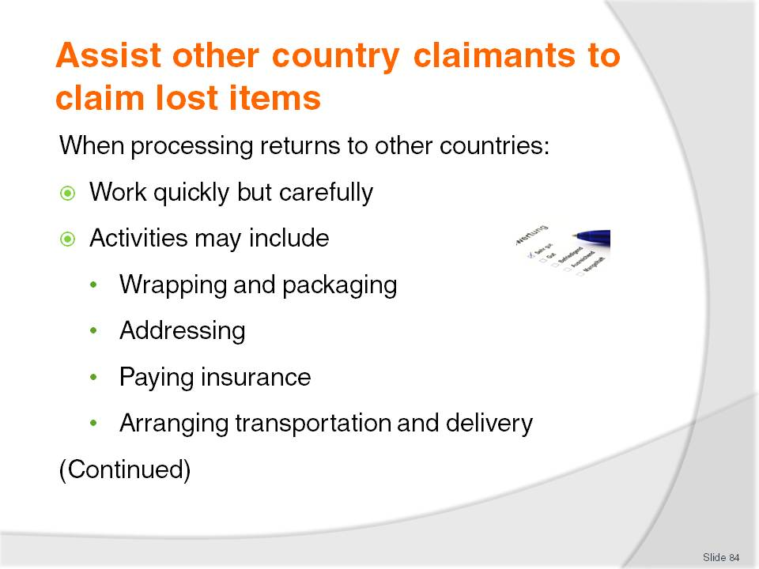
Slide No | Trainer Notes
Trainer explains to trainees when arrangements for the return of an item to another country have been finalised they must process the return of items in accordance with agreed arrangements:
It is important to work quickly but to ensure, at the same time, the item being returned is not damaged
Processing may involve:
- Wrapping and packaging the item to protect it during transit
- Addressing the item/package to the agreed address
- Selecting and paying for appropriate/agreed insurance as agreed or required by the owner
- Notifying a carrier or courier to collect the item.

Slide
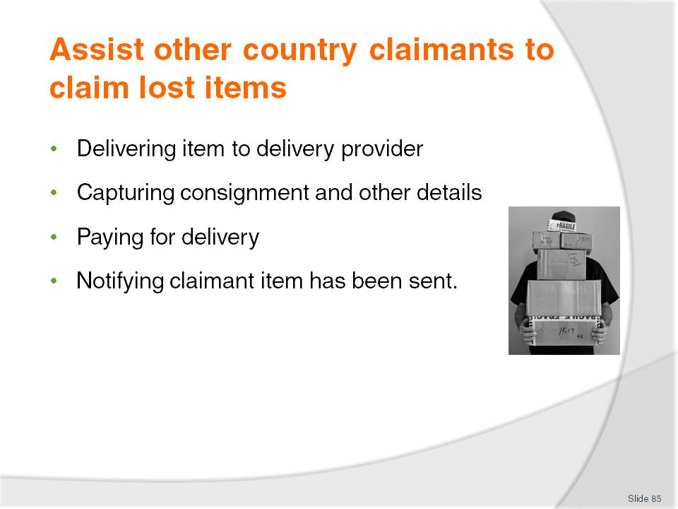
Slide No | Trainer Notes
Trainer continues to provide to trainees an outline of the activities potentially involved in returning a ‘lost property item’ to another country:
Taking the item to a carrier/courier or delivery service where they cannot attend to collect the item
Capturing consignment details, number, expected delivery date/time and/or delivery route including details of any online tracking service offered by the carrier
Paying for the return of the item and obtaining receipt
Notifying claimant the item has been sent and providing relevant tracking details and/or delivery information.
Class Activity – Guest Speaker
Trainer arranges for a suitable courier or transport company to attend and talk to trainees about:
The delivery services they provide with reference to how these may be applicable to returning lost items to other countries and remote or distant areas
How packages must be wrapped and packaged
Additional services available such as insurance, use of special containers, tracking, express delivery, door-to-door delivery, guarantees and/or warranties
Sample costs for delivery to various countries/destinations for a range of weights
Documentation involved and information required before items can be sent.
Slide
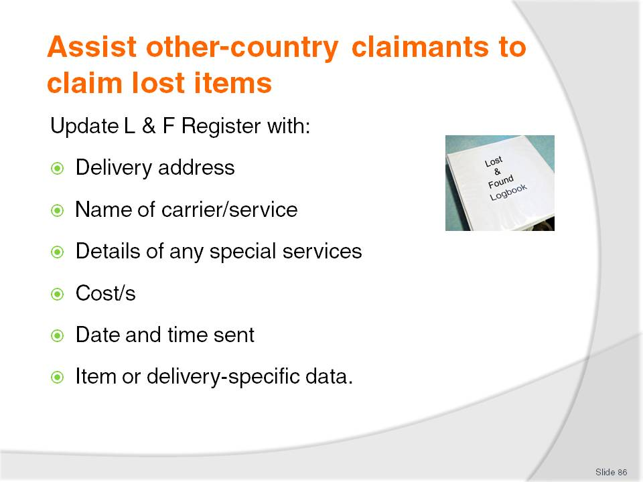
Slide No | Trainer Notes
Trainer reminds trainees about the central role of the Lost and Found register. This Register must again be updated when an item is returned to another country, distant or remote location. There is generally a requirement to include information to identify:
Delivery address for the item
Name of carrier or service used to deliver/return the item
Details of any special service such as express post, insurance
Cost – identifying and quantifying every cost paid by the venue and to be recovered from the claimant
Date and time sent for use as a reference point for tracking and determining delivery date
Details of any item/delivery-specific data such as consignment number, delivery receipt number.

Slide
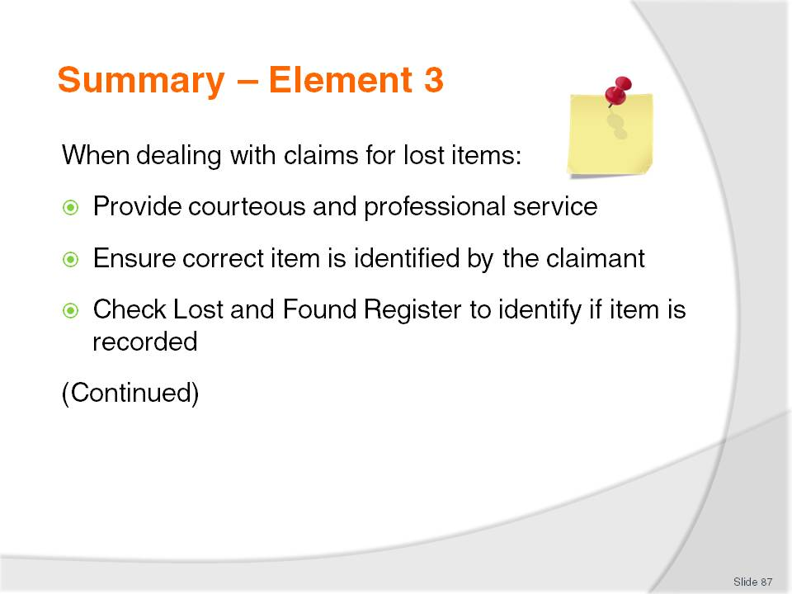
Slide No | Trainer Notes
 | Trainer provides a recap of the Element asking questions to check trainee understanding and responding to questions from trainees, as required.

Slide
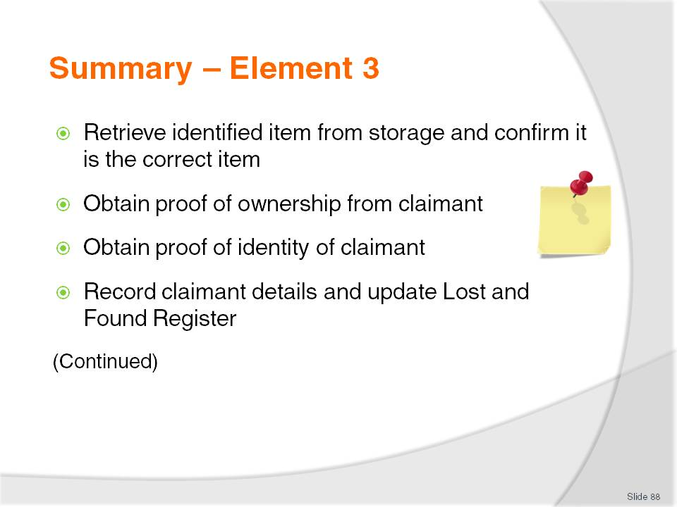
Slide No | Trainer Notes
 | Trainer provides a recap of the Element asking questions to check trainee understanding and responding to questions from trainees, as required.

Slide
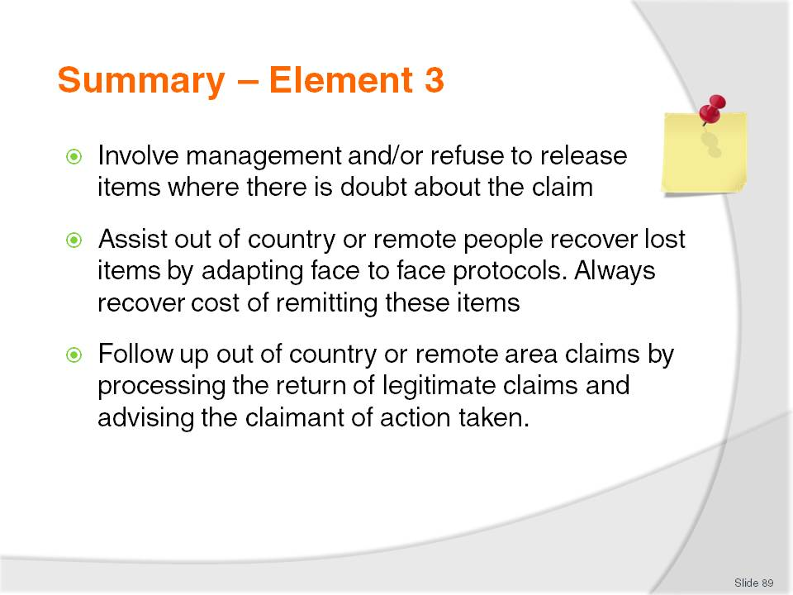
Slide No | Trainer Notes
 | Trainer provides a recap of the Element asking questions to check trainee understanding and responding to questions from trainees, as required.

Slide
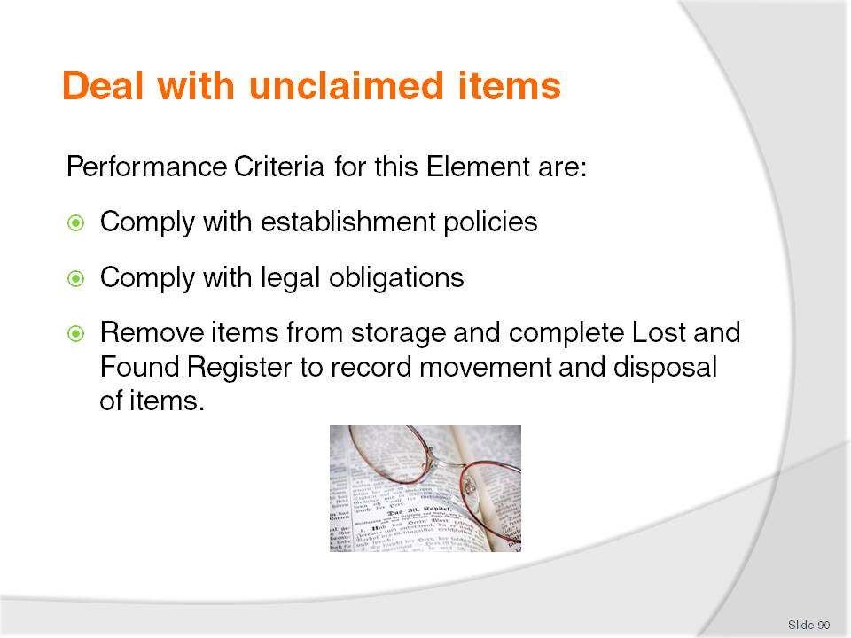
Slide No | Trainer Notes
Trainer identifies for trainees the Performance Criteria for this Element, as listed on the slide.
Class Activity – Discussion
Trainer asks trainees questions regarding their experiences and knowledge of dealing with unclaimed items in a Lost and Found facility:
How long are valuable items commonly stored in a Lost and Found facility before they are disposed of?
If valuable items are not claimed, how might they be disposed of?
What establishment policies might be involved when disposing of found items?
What do you think is meant by the expression ‘theft by finding’?
When an item is disposed of, what updates to the Lost and Found Register do you think would need to be made?

Slide
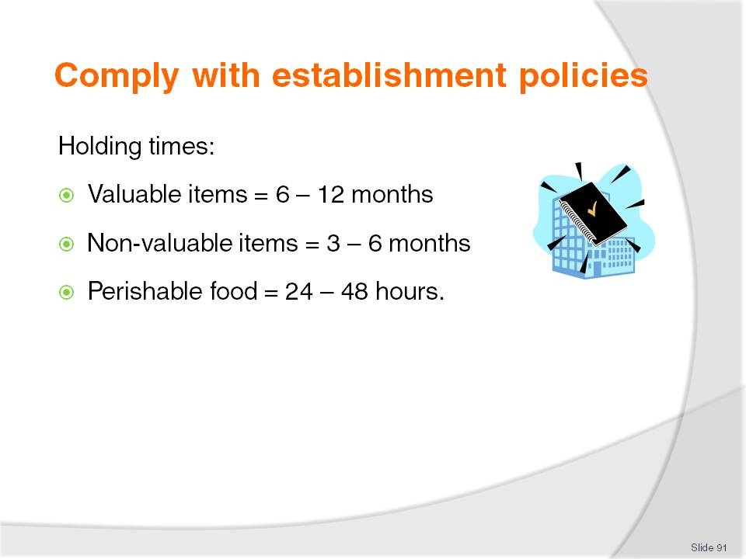
Slide No | Trainer Notes
Trainer states to trainees that when dealing with unclaimed lost and found items it is vital establishment policies are followed. These house policies will comply with legal requirements and demonstrate adherence to appropriate business ethics.
Trainer introduces to trainees the concept of ‘holding times’ for found items. This policy will specify the length of time a property will retain an item before disposing of it, based on the classification of the item:
Valuable items
Valuable items are held for between 6 – 12 months
Valuable items are held longer because there is a greater chance the owner will eventually make a claim for them.
Non-valuable items
Non-valuable items are commonly held for 3 – 6 months
If the establishment has a guest library, unclaimed books may be entered into the library.
Perishable food
Where perishable food is held, it is usually kept for 24 – 48 hours only
Many venues immediately throw out all open bottles of drink, and all opened food found in a departed guest room/refrigerator.
Class Activity – Handout and Discussion of Policy
Trainer obtains sample house policy for a relevant venue and:
Distributes to class
Discusses requirements
Explains rationale for policy requirements.

Slide
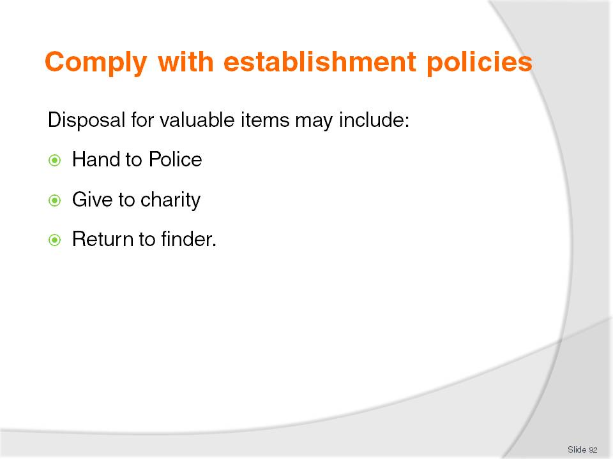
Slide No | Trainer Notes
Trainer explains to trainees that venues will have a ‘Disposal’ policy for found property indicating this policy dictates what happens to found items if they are not claimed.
Trainer tells trainees that unclaimed valuables are treated differently to other items because of their importance and/or value and after their designated holding period has elapsed, valuable items may be:
Handed in to Police. This is the recommended procedure and ensures no complications or subsequent legal action.
Given to charity. This option demonstrates corporate citizenship on behalf of the venue and enables the property to prove staff did not benefit from someone else’s loss
Returned to the person who found them. This is not recommended for items where personal details of the owner are present.
- Returning items to the finder may be policy only for valuable items of ‘lesser value’
- Note that police often retain an item that is handed in for a certain period (say, six months) and then return it to the person or organisation who handed it in. The item may then be given to the finder.

Class Activity – Handout and Discussion of Policy
Trainer obtains sample house policy for a relevant venue and:
Distributes to class
Discusses requirements
Explains rationale for policy requirements.

Slide
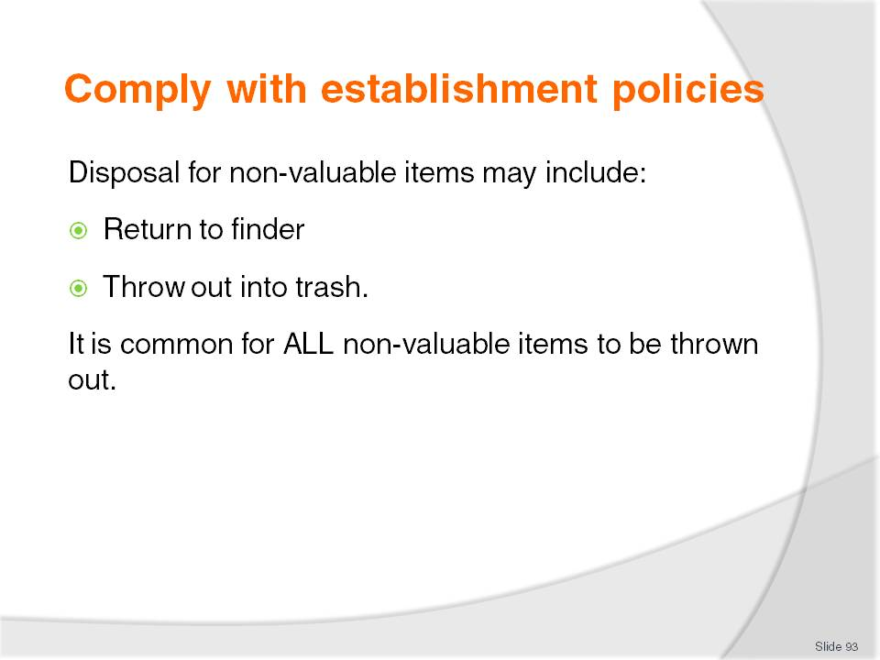
Slide No | Trainer Notes
Trainer explains to trainees the house policy regarding disposal of non-valuable items following expiry of their holding time may be:
Finder may be offered the item. This means the staff member who finds the item may be given the option of keeping the item
Where the finder of a non-valuable item is a member of the public or a guest, the item is usually thrown out. The time and trouble involved in contacting the guest is not worth the effort unless a specific promise to do so was made at the time the item was handed in and recorded in the Lost and Found Register
The item is thrown out into the trash. Some properties have a SOP all non-valuable items must be thrown out: nothing can be given to staff. This avoids potential problems relating to the venue failing to discharge its Duty of Care.
Class Activity – Handout and Discussion of Policy
Trainer obtains sample house policy for a relevant venue and:
Distributes to class
Discusses requirements
Explains rationale for policy requirements.

Slide
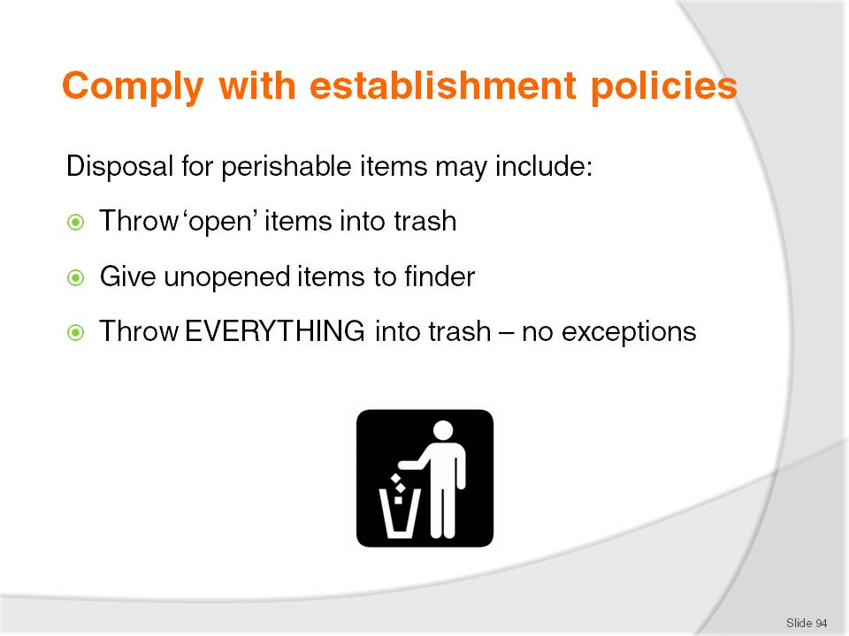
Slide No | Trainer Notes
Trainer highlights to trainees the disposal of perishable items may be:
Open or partially used perishable items are thrown out. Staff are not allowed to consume open or partially used items. Venues often require this in order for them to discharge their duty of care for their staff. This policy potentially protects staff from eating or drinking poisoned or otherwise contaminated food or drink
Unopened perishable items may be given to staff. This generally applies only to items in a sealed container (bottle, can, packet) where the seal or package has not been compromised
Unopened perishable items may be thrown out. Many properties have this as a standard requirement to protect staff (refer Duty of Care obligations).
Class Activity – Handout and Discussion of Policy
Trainer obtains sample house policy for a relevant venue and:
Distributes to class
Discusses requirements
Explains rationale for policy requirements.

Slide
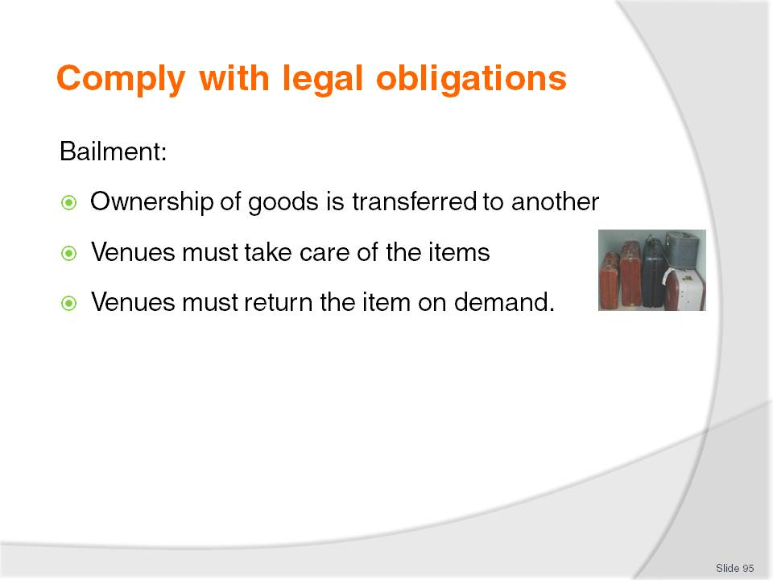
Slide No | Trainer Notes
Trainer tells trainees it is imperative all legal requirements are complied with when disposing of found items in order to protect the venue and individual staff against criminal prosecution and/or civil action.
Trainer reminds trainees regarding ‘Bailment’. It is the legal position where the ownership of goods is transferred from one person to another when an item is handed in to the venue as a found item. Venues are under an obligation to:
Look after the item to maintain it in the original condition it was in when it was found
Return the item on demand when claimed by the rightful owner.

Slide
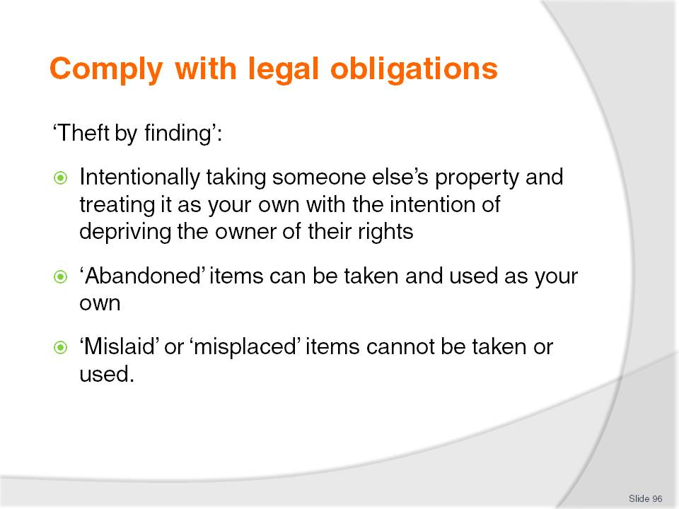
Slide No | Trainer Notes
Trainer advises trainees it is possible staff or members of the public, guests or customers who take items found in the venue for their own use could be guilty of an offence called ‘Theft by finding’. ‘Theft’ involves deliberate intent to permanently deprive the rightful owner of their legal right to their goods.
Abandonment
Trainer explains to trainees:
Items can only be taken for personal or private use if they have been ‘abandoned’. That is, if they have been deliberately left with the intention by the owner of relinquishing legal title or ownership of the goods
‘Losing’ an item accidentally does not fall under the definition of abandonment
To avoid a charge of ‘theft by finding’ the finder is required to take reasonable action to identify and locate the finder. If an item has been handed in to the Lost and Found facility at a venue and the venue has tried to contact the owner, then this requirement may have been fulfilled.
Mislaid property
Trainer explains to trainees:
Property cannot be seen to be ‘abandoned’ if it is simply mislaid or misplaced. This relates to items placed somewhere by the owner who then forgets to pick the item up again when they leave. For example, a guest may leave their handbag or wallet at a POS register or at Reception when paying an account or checking out and forget to pick it up when they depart. This item is deemed to be neither lost nor abandoned but ‘mislaid’
Such items must be regarded, for the purposes of the venue as ‘lost’ and handed in to the Lost and Found facility.

Slide
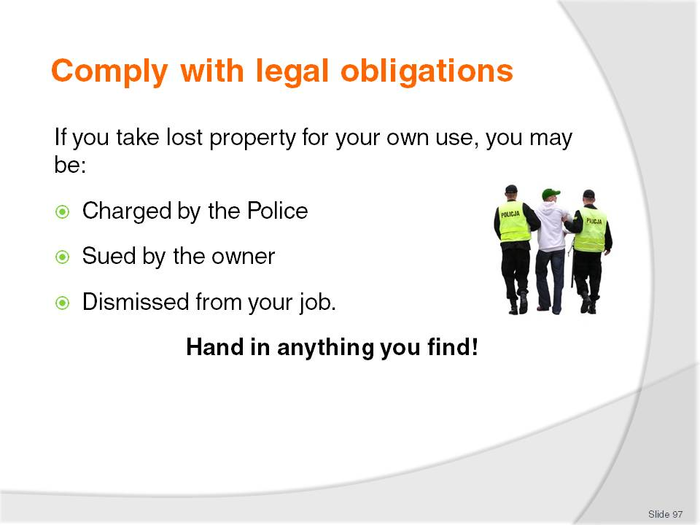
Slide No | Trainer Notes
Trainer highlights to trainees the possible ramifications if they take found property and treat it as their own. They may be:
Charged by the Police with a crime (theft by finding)
Sued by the rightful owner of the item so as to be reimbursed for the value of the item involved
Dismissed from work for failing to comply with policies and procedures.
Trainer stresses to trainees the lesson in all this is to avoid potential legal and employment-related problems, they must always hand in anything they find:
At work, hand things in to the Lost and Found facility or Supervisor
Outside work, hand items in to the Police.
Class Activity – Guest Speaker
Trainer arranges for Police or legal advisor to attend class and talk to trainees about:
Specific country legislation and requirements relating to legal issues involved in staff and venues dealing with lost and found property with special attention to addressing:
- Bailment
- Theft by finding
- Conversion
- Possible criminal charges including:
- Evidence required for such charges
- Possible defences available
- Possible penalties
- Civil action from people who have lost items:
- Likelihood of action
- Evidence required
- Possible outcomes of successful actions.

Slide
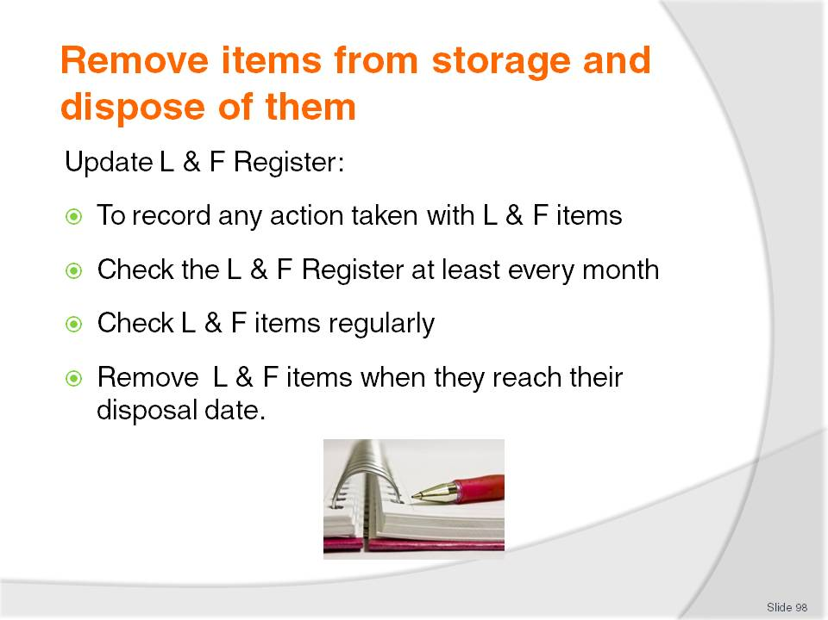
Slide No | Trainer Notes
Trainer emphasizes to trainees that whenever an item stored in the Lost and Found facility is returned to its owner or otherwise disposed of, the Lost and Found Register must be completed to record the action taken.
Trainer explains to trainees they should comply with house requirements in this regard which may include:
The Lost and Found Register should be checked every month (according to internal policy) to determine which items have reached their designated holding time
Checking items daily is not required, and checking on a weekly basis is not common. A check every two weeks or monthly can suffice
All items reaching or exceeding their designated storage or holding time should be removed from storage and disposed of according to house/establishment policies.

Slide
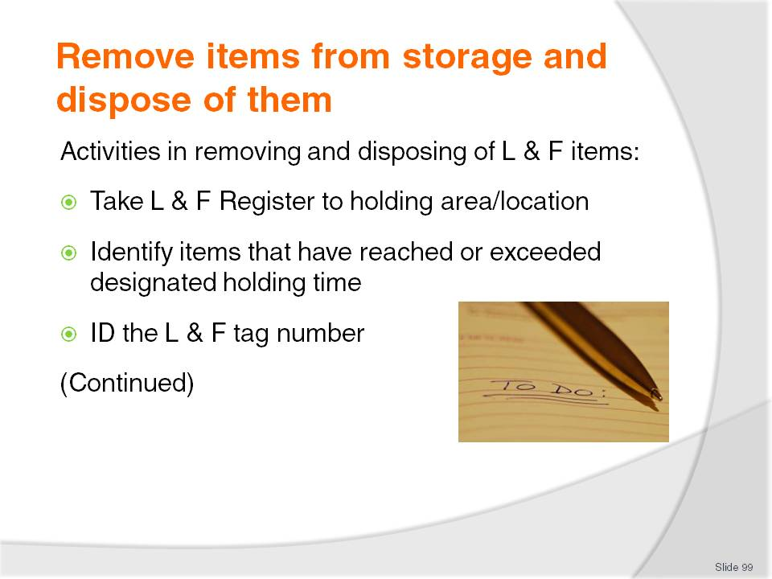
Slide No | Trainer Notes
Trainer explains to trainees activities involved in removing and disposing of items from the Lost and Found facility that have reached their designated holding time include:
Take the Lost and Found Register to the storage area if it is not already located in that area
Read the Register to identify items exceeding their holding times. Use the ‘Date’ column as the reference point coupled with knowledge of venue holding times
Obtain the Lost and Found Tag number for the item reading it from the Register and ensuring the correct item is being selected. Always double-check the item chosen really is the one to be actioned.

Slide
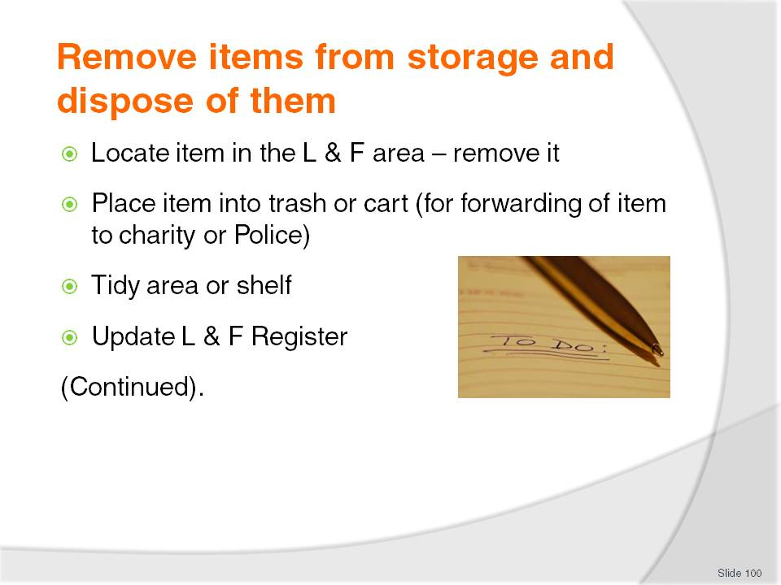
Slide No | Trainer Notes
Trainer continues to explain to trainees the activities involved in removing and disposing of items from the Lost and Found facility that have reached their designated holding time:
Locate the item in the Lost and Found facility and physically remove it from the shelf, cupboard or wherever it is located or stored
The item may be placed directly into a trash container (where it is to be disposed of) or into a cart where it is to be forwarded to the Police, a charity or a person
Tidy or rearrange the Lost and Found facility, shelves or area to reflect the items removed and make room for future items
Update the Lost and Found Register. This may require you to (depending on venue requirements and/or columns in the Register):
- Enter the date
- Enter how the item was disposed of or where it was sent to
- Signature or initial of person performing the task
Note: some properties require a line to be drawn through all items disposed of to make it easier to identify the items no longer in storage.

Slide
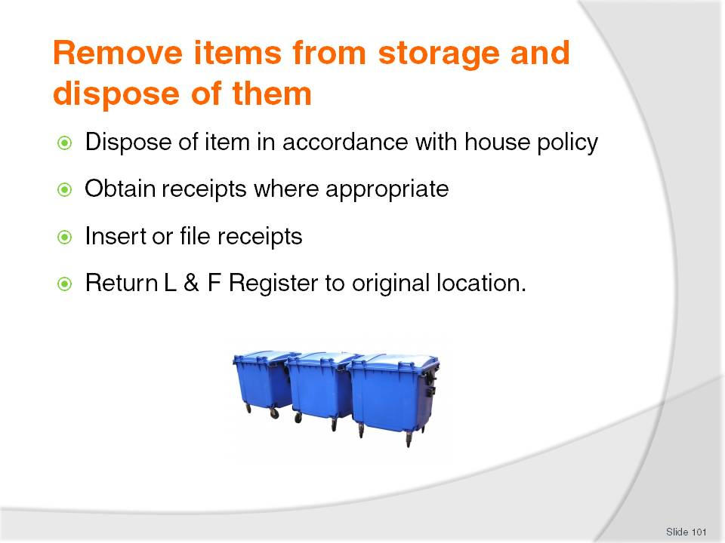
Slide No | Trainer Notes
Trainer continues to explain to trainees the activities involved in removing and disposing of items from the Lost and Found facility that have reached their designated holding time:
Deal with the item as appropriate:
- Throw items to be disposed of into the trash
- Give items to designated people, as identified
- Hand in items to the Police
- Deliver items to the charity
Obtain receipts for items where appropriate:
- Police will provide a receipt for all items handed in
- Many charities will provide some written record of donations
Insert receipts and other appropriate written records into Lost and Found Register (or other appropriate filing system) as proof of correct disposal
Remember it is not enough to do the right thing. There is also a need to be able to prove it was done
Return the Lost and Found Register to its original location (where applicable) so it can be used by others when needed.
Class Activity – Small Group Exercise
Trainer arranges:
A Lost and Found Register with a range of entries in the Found items section
A simulated Lost and Found facility with items reflecting the entries in the Found items section of the Lost and Found Register (immediately above).
Trainer advises trainees regarding items that have reached their disposal date and asks them to ‘dispose’ of those items and update the Lost and Found Register to reflect the action taken.

Slide
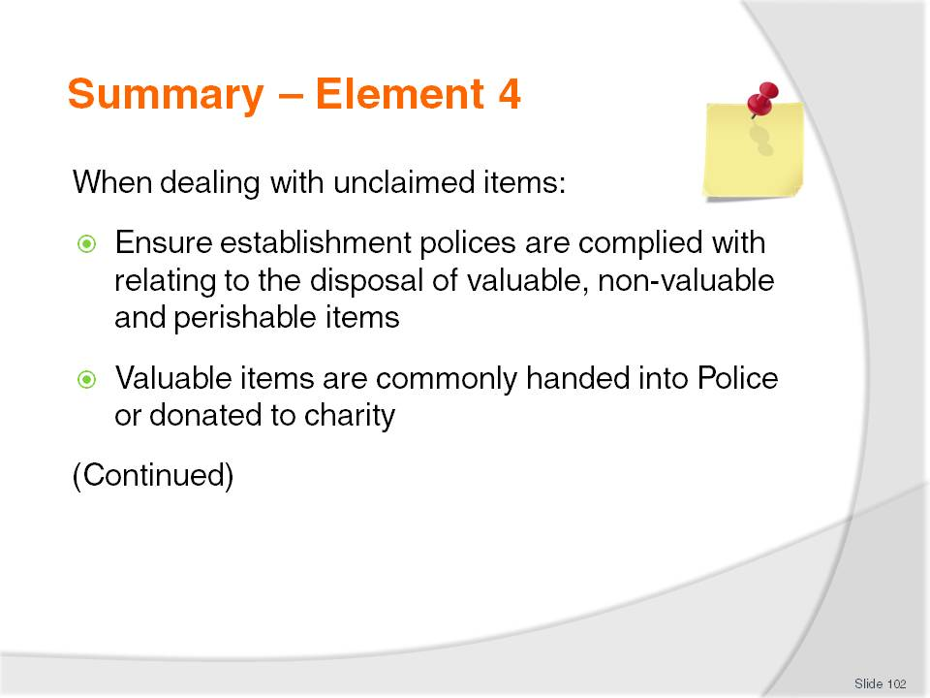
Slide No | Trainer Notes
 | Trainer provides a recap of the Element asking questions to check trainee understanding and responding to questions from trainees, as required.

Slide
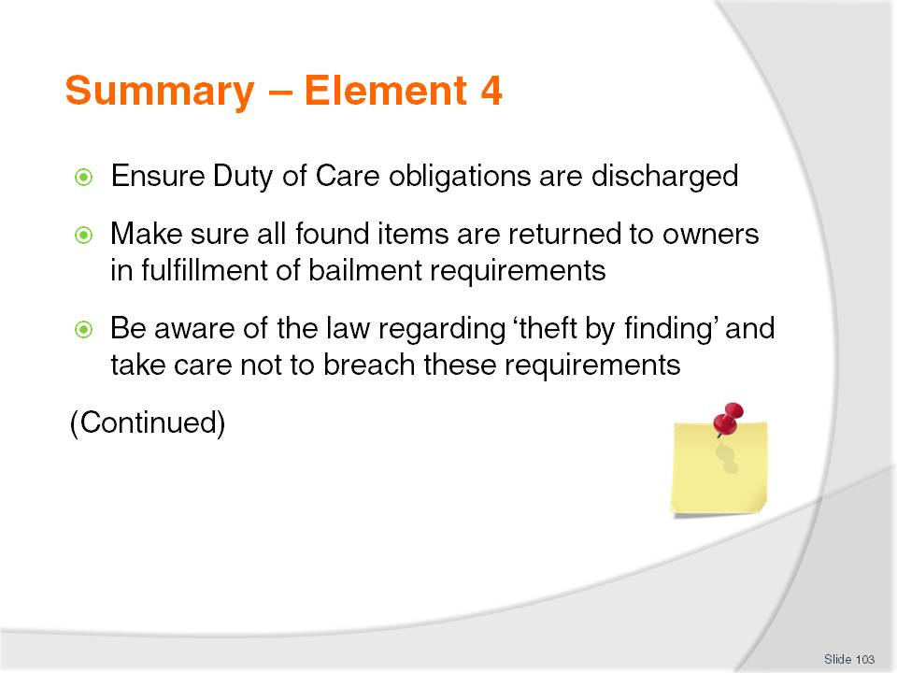
Slide No | Trainer Notes
 | Trainer provides a recap of the Element asking questions to check trainee understanding and responding to questions from trainees, as required.

Slide
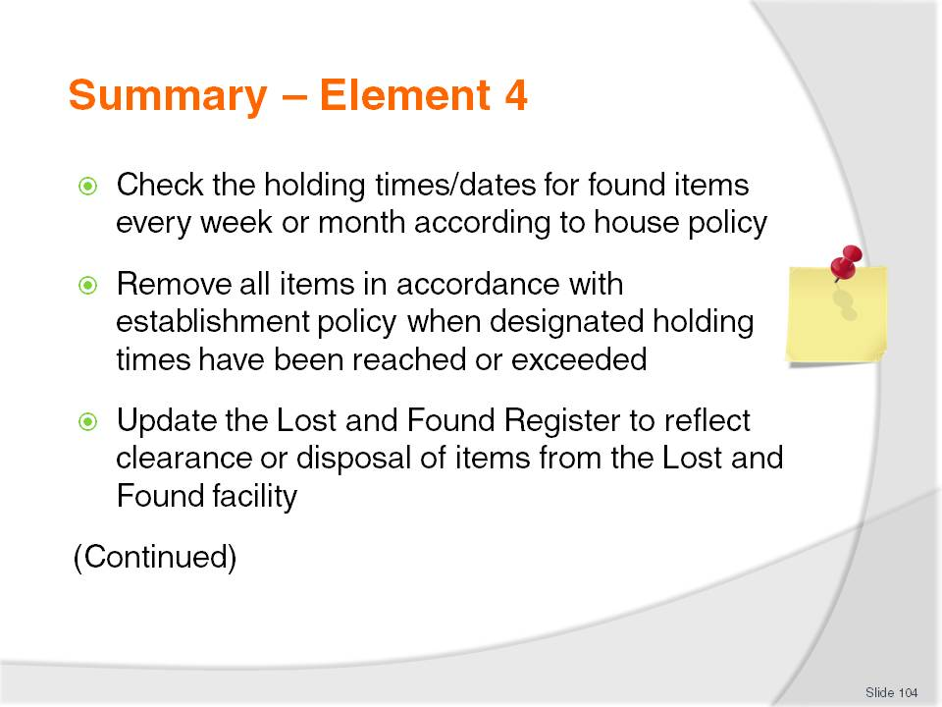
Slide No | Trainer Notes
 | Trainer provides a recap of the Element asking questions to check trainee understanding and responding to questions from trainees, as required.

Slide
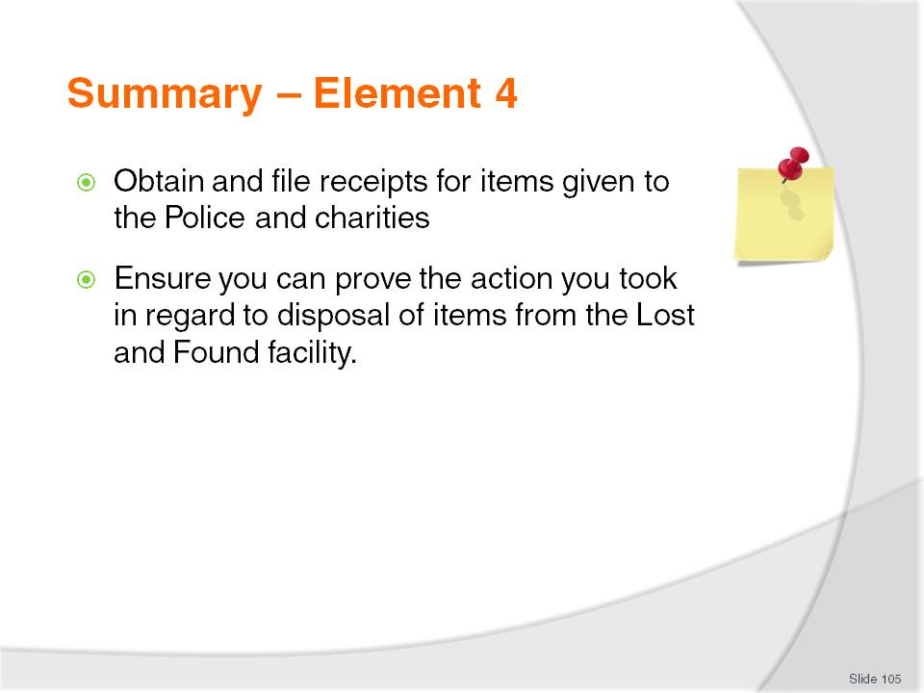
Slide No | Trainer Notes
Trainer provides a recap of the Element asking questions to check trainee understanding and responding to questions from trainees, as required.
Trainer thanks trainees for their attention and encourages them to apply course content as required in their workplace activities.

Recommended training equipment
Computerised Reservation System
Local legislation relating to bailment, theft, receiving stolen property, abandonment of property, mislaid property, processing of lost and found items
A range of items that can be used as the focus for processing (tagging, recording and returning) lost and found items – items should include:
- Food
- Beverages
- Valuable items
- Non-valuable items
- Items of sensitive nature.
Sample venue-specific items such as:
- Staff handbooks/manuals – with lost and found section
- Workplace lost and found posters
- Lost and Found Register
- Lost and found policies and procedures
- Receipt books – for found items handed in
- Lost and found slips/tags
- Guest room advice/compendiums relating to in-house lost and found facilities
- Guest account featuring lost and found advice, or contact details of venue
- ‘With compliments’ letter/card
- Registration form.
Adhesive tape, string and elastic/rubber bands – for attaching tags to items
Telephone
Sample identification documents
Computer with Internet access and webcam or similar proprietary facility – for role plays/practice dealing with guests reporting/claiming lost property by telephone (from other countries/overseas).

Instructions for Trainers for using
PowerPoint – Presenter View
Connect your laptop or computer to your projector equipment as per manufacturers’ instructions.
In PowerPoint, on the Slide Show menu, click Set up Show.
Under Multiple monitors, select the Show Presenter View check box.
In the Display slide show on list, click the monitor you want the slide show presentation to appear on.
Source: http://office.microsoft.com
Note:
In Presenter View:
You see your notes and have full control of the presentation
Your trainees only see the slide projected on to the screen
More Information
You can obtain more information on how to use PowerPoint from the Microsoft Online Help Centre, available at: http://office.microsoft.com/training/training.aspx?AssetID=RC011298761033
Note Regarding Currency of URLs
Please note that where references have been made to URLs in these training resources trainers will need to verify that the resource or document referred to is still current on the internet. Trainers should endeavour, where possible, to source similar alternative examples of material where it is found that either the website or the document in question is no longer available online.

Appendix – ASEAN acronyms
AADCP | ASEAN – Australia Development Cooperation Program.
ACCSTP | ASEAN Common Competency Standards for Tourism Professionals.
AEC | ASEAN Economic Community.
AMS | ASEAN Member States.
ASEAN | Association of Southeast Asian Nations.
ASEC | ASEAN Secretariat.
ATM | ASEAN Tourism Ministers.
ATPMC | ASEAN Tourism Professionals Monitoring Committee.
ATPRS | ASEAN Tourism Professional Registration System.
ATFTMD | ASEAN Task Force on Tourism Manpower Development.
CATC | Common ASEAN Tourism Curriculum.
MRA | Mutual Recognition Arrangement.
MTCO | Mekong Tourism Coordinating office.
NTO | National Tourism Organisation.
NTPB | National Tourism Professional Board.
RQFSRS | Regional Qualifications Framework and Skills Recognition System.
TPCB | Tourism Professional Certification Board.







